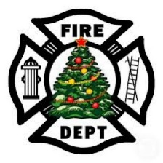
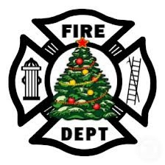
Holden Fire Department
Holiday Party
Department members & significant others

December 17th at 6:00pm

Ladd’s Restaurant
64 Barre-Paxton Rd.
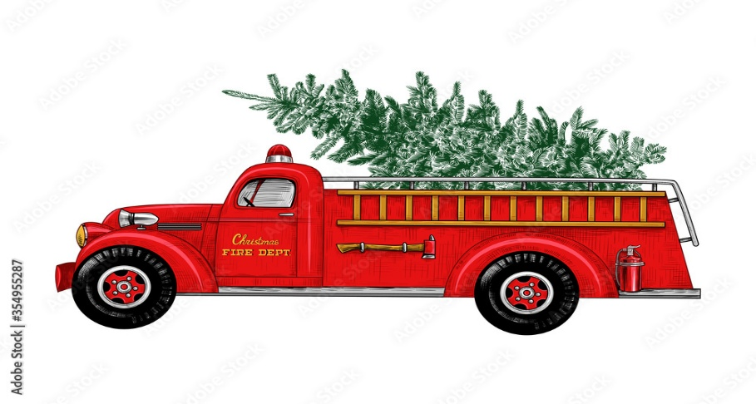
Rutland, MA

Entrées are per person & includes sides & dessert
Prime rib - $32
Haddock - $26
Chicken parmesan - $25

Must pay in advance and RSVP through Venmo @ HAFF-HAFF by December 11.
Leah & Laura will collect cash if you do not Venmo

