­

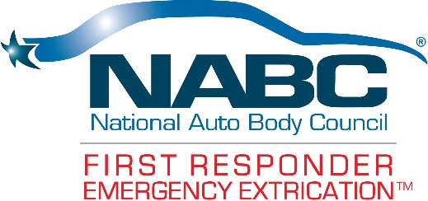

.

**EXTRICATION EVENT l September 16, 2023**

**WHAT YOU’LL LEARN:**

* **HANDS-ON EXTRICATION INFORMATION**: Newer model vehicles will be on hand for extrication practice - Where, When and Why to cut and pry will be covered in numerous accident scenarios.
* **NEW METALS AND MATERIALS**: Boron Steel, high-strength steel (HSS), aluminum/alloys. Learn fact from fiction on these materials and how to deal with them while extricating.
* **ELECTRIC & HYBRID VEHICLES:** Safety and extrication procedures while working with hybrid and electric vehicles.
* **AIRBAGS & RESTRAINT SYSTEMS**: The focus of the supplemental restraint system (SRS) portion will be on how the systems operate and safety at the scene.

**

# *BRING YOUR BUNKER GEAR.*

**SALVAGE VEHICLES DONATED BY:**

**S**

**WHEN: September 16th 9 a.m. to 1 p.m.**

**Lunch will be provided**

**WHERE: Wagner Certified Collision Center**

**700 Plantation Street**

**Worcester, MA 01605**

**REGISTRATION:**

**Jim Condon**

**508 581 5678**

**INSTRUCTORS PROVIDED BY:**