*C:\Users\jhanna\AppData\Local\Microsoft\Windows\Temporary Internet Files\Content.IE5\LE4P6T6Z\MC900340286[1].wmf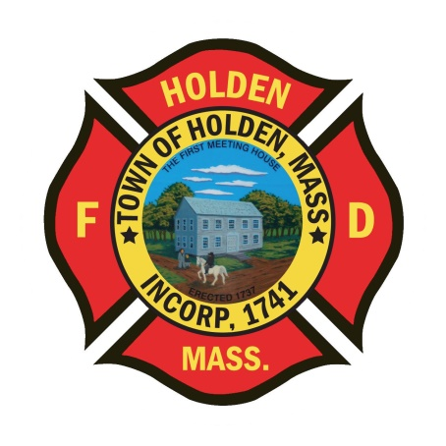* 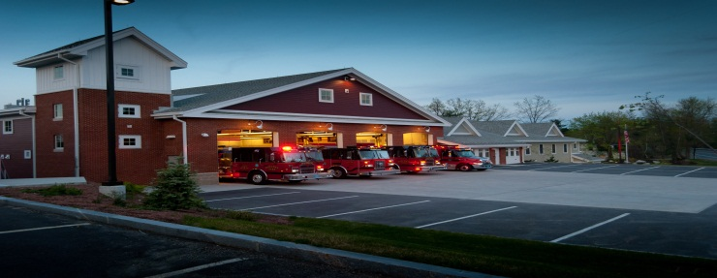

DEPARTMENT UPDATES

10/22/22 –10/28/22

**The Extinguisher**

FF Rob Walters graduated from the Massachusetts Firefighting Academy Springfield Campus today. This is the culmination of his 10 week recruit program and celebrates the hard work in completing the program. Congratulations Rob!!

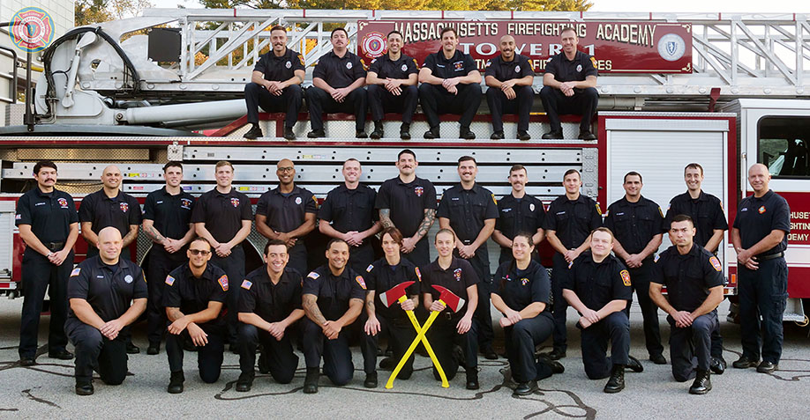

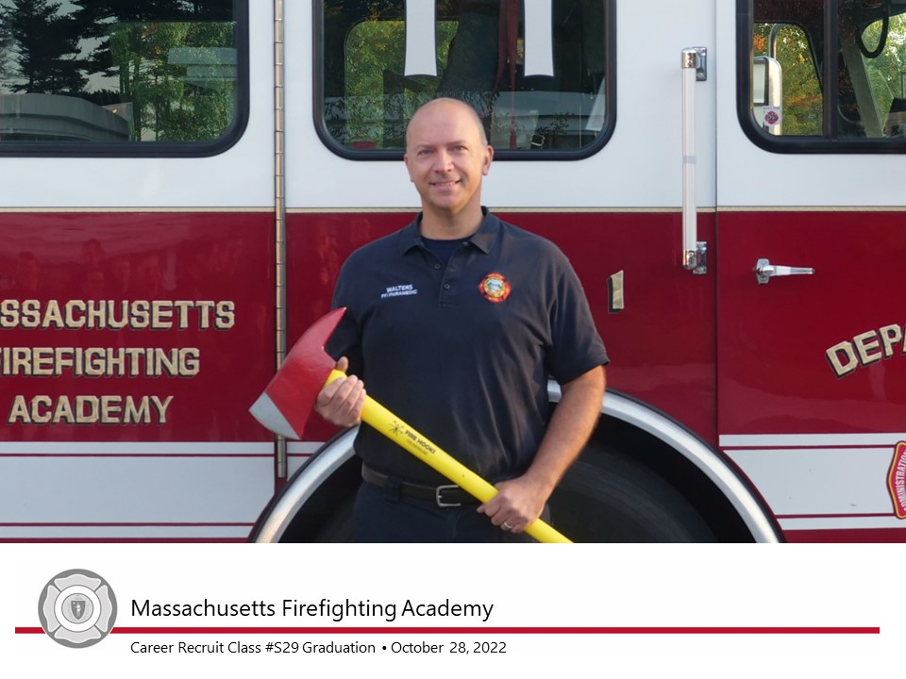

Reminder this Saturday is “Halloween Trunk or Treat” at the PSB. This was a great even last time it was held. Please spread the word for the event and hope to see everyone there!! Times are 530p-830p.

Reminder that that in conjunction with the 4 regional dispatch towns, we have made the decision that we will only be doing 1 tone test per day and it will be at 18:30 hours. The dispatchers have asked crews to hail dispatch and wait for a response before sending your message. This will ensure that they get what you are communicating, especially if they are on the phone or one of the other 7 radios that they monitor.

SAVE THE DATE – The Holden PD will be holding a 5K road race to help raise funds for the Police K9 program on Sunday 11/20. The race will start and end at Seven Saws Brewery on Industrial Drive. Sounds like a fun day for some exercise and craft beer! We will pass along the information once we have all the details.

Vehicles

1. Engine 2: The installation of the headsets has started with Eng 2 and will continue with the other Engines and Tower. Operation manuals and policies will be distributed shortly.

Training

1. No Updates

Stations

1. Adams Road: Still no updated timeline for the DPW to move out of the building. They are awaiting equipment to put their new building online.