*C:\Users\jhanna\AppData\Local\Microsoft\Windows\Temporary Internet Files\Content.IE5\LE4P6T6Z\MC900340286[1].wmf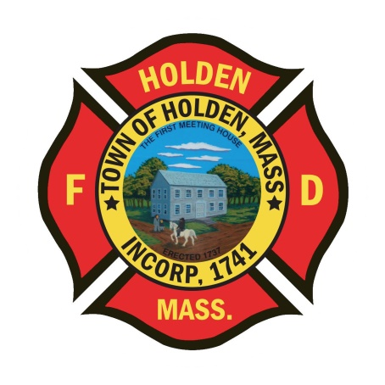* 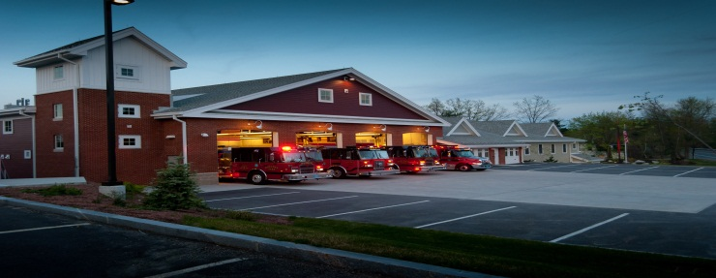

DEPARTMENT UPDATES

9/2/22 –9/9/22

**The Extinguisher**

Our annual SAFE Open House is scheduled to be held on Saturday 10/15. We will be holding it in person for the first time since 2019, so the kids should be thrilled to come to the station and see all of our equipment! Keep an eye out for staffing needs for the day.

The department will be hosting a Fire Department Ball to be held at the Manor in West Boylston on 10/22 at 18:00. Dinner will be a 3 course buffet and attire will be either Class A or semi-formal. For more information, contact Leah or Laura in the Administration office.

Please use caution with apparatus when approaching the railroad bridge on Reservoir Street. Mass DOT has restricted the travel lanes and shifted/narrowed them due to some issues with the bridge. Be aware of the change. Mass DOT is also still working on the drainage project on Main Street near Boyden which is also restricting travel.

The annual Sterling Fair is being held this weekend. Our UTV will be on site all weekend and not available in town. With Sterling resources tied up with the fair and West Boylston down an ambulance, mutual aid requests could increase.

Vehicles

1. Engine 2: The electrical problem was repaired by TriState Truck on 9/8. Hopefully this is the final fix of this problem. *There is an electical issue that we are dealing with. The last 2 times the vehicle has malfunctioned, the fire truck gods miraculously fixed the issues before mechanics could diagnose the problem. Some issues were found/ corrected that may or may not be related. We are currently running the truck (in service). If the truck starts with the errors, please immediately contact Deputy Smith or DPW Mechanic Adam Roy.*
2. UTV: A problem with the ignition was found during the use at the details last weekend. Parts were purchased and installed this week, should be all set.
3. Engine 1: An air leak was found, repaired by DPW. A small radiator leak was identified with no real active drip. Keep an eye on the area under the vehicle in case it worsens.

**Equipment**

1. LT Naiman is finalizing the process of evaluating transport ventilators for a new replacement that was approved in our FY23 capital. We should have a decision on which model/brand will be purchased soon.

Fire Prevention

1. The new DPW facility is close to completion. All of the systems are online including the Fire Alarm, Sprinkler and Fuel Island supression system. The building access keys have been updated in the Knox Boxes, the only exception at this point is the big glass entrance doors to the office space which do not have the master lock installed yet. The entry gates are still not operational, if you need to get through to respond for a call, there is a switch located on the left side near the electrical box which will raise the gate.

Training

1. Live Fire Training: Our participation in the combined training with Paxton, Rutland and West Boylston has been canceled. We determined that with the large number of participants that 2 dates was not enough for us to get the best benefit out of it. We will be scheduling either the Worcester or Auburn facility for just our department, dates are being determined and we will keep you updated.

Stations

1. PSB- Still awaiting the moldings and some electrical upgrades to be finished. Most of the renovation has been completed.
2. Station 2- A water leak was found in the office area, B&G was made aware and went up on the roof to remove the standing water.