*C:\Users\jhanna\AppData\Local\Microsoft\Windows\Temporary Internet Files\Content.IE5\LE4P6T6Z\MC900340286[1].wmf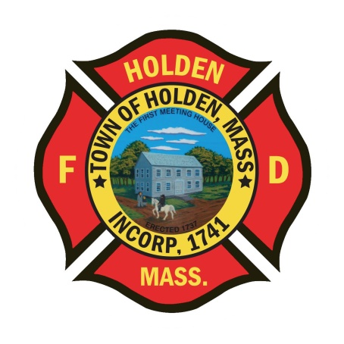* 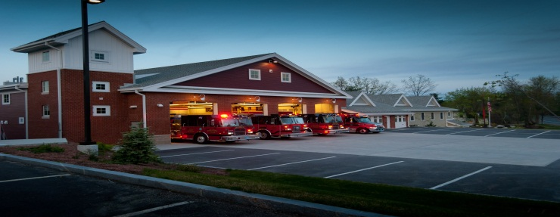

DEPARTMENT UPDATES

8/12/22 –8/19/22

**The Extinguisher**

Early Monday morning, the department responded to a report of smoke in the area of the town dump on River Street. After searching for a short time, a brush fire was found in the area of the Town Forest off of Harris Street at the sand pit used by Paquette. It appears that the fire itself had been burning for some time and it was in need of extensive overhaul, including the removal of a stump pile with an excavator. All crews worked hard and did a great job. The size of the area necessitated mutual aid from Rutland, Sterling, Paxton, Princeton and West Boylston with various forestry units and tankers. Upwards of 15,000 gallons of water was trucked in and used to extinguish the fire. While crews were tied up there, the Paxton ambulance and Boylston engine in coverage responded to multiple calls.

With the extended drought that we are experiencing throughout the state, brush fires have been on the rise and we could see the season extending into the fall. These calls are labor intensive and require a lot of staff, so response to the all call is very important for these types of responses.

Over the last few weeks we had access to train in a house at 700 Mason Road prior to it’s demolition. This week, crews trained on Tuesday and Wednesday doing RIT drills, firefighter rescue and roof ventilation. It was a great opportunity for those who attended to get some work with ladders, RIT packs and some extended chainsaw time. We don’t get the opportunity to do these hands on types of trainings very often. Training is the most important function a firefighter can continue to do during a career. It is the base of your knowledge and provides growth to keep you current on your skills and keep you safe on the fireground. Thank you to Captain Poznanski, Captain Mouradian and all of the othter firefighters who helped make this training a success.

**Personnel**

1. LIV Golf Tournament: Details have been awarded and updated in the ePro schedule program.
2. Holden Days will be held next Saturday. Still looking for help staffing the day. Contact the Deputy if interested in any part.

Vehicles

1. F2: Tires have been serviced at Hoey Tire.
2. E2: Amdor will be here on Monday to replace the bad sensors and work on the roll up doors.
3. Squad 2: Plow has been serviced/repaired by the DPW and it is ready for the upcoming winter season.

**Equipment**

1. The officers are in the process of reviewing the Check it inventory and checklist program. We understand that this program has not been rolled out the proper way over the last couple of years. We are working with their support to build it out so that it suits our needs and will work to train individuals in how it works.

Fire Prevention

1. The new DPW facility is close to completion. All of the systems are online including the Fire Alarm, Sprinkler and Fuel Island supression system. The building access keys have been updated in the Knox Boxes, the only exception at this point is the big glass entrance doors to the office space which do not have the master lock installed yet. The entry gates are still not operational, if you need to get through to respond for a call, there is a switch located on the left side near the electrical box which will raise the gate.

Training

1. Live Fire Training: The department will co-host live fire training to be held at the Worcester Fire Training Facility. The training will be held on 10/2 and 10/16 with both Rutland and Paxton Fire. As a reminder, all department members will need to attend one of these sessions to satisfy the live fire training requirement. Currently, ISO, which is the organization that reviews the department and issues our protection classification ratings does not recognize live fire training in an acquired structure. That reduces the amount of makeup or alternative live fire trainings that can be used to satisfy this requirement.

Stations

1. PSB- The installation of the tile floor is still ongoing. Hopefully to be completed this weekend.