*C:\Users\jhanna\AppData\Local\Microsoft\Windows\Temporary Internet Files\Content.IE5\LE4P6T6Z\MC900340286[1].wmf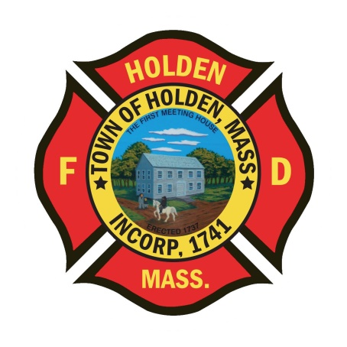* 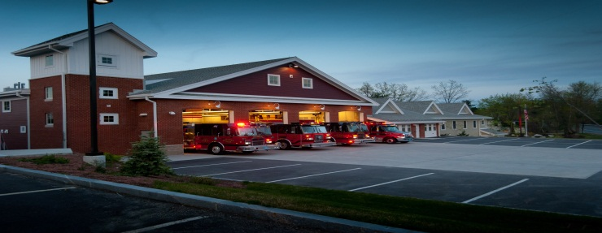

DEPARTMENT UPDATES

7/29/22 –8/05/22

**The Extinguisher**

I would like to congratulate FF/Paramedic Mark Rogers who graduated from the Massachusetts Firefighting Academy Career Recruit Program Class 303 this morning. Good luck on a safe and happy career in the fire service.

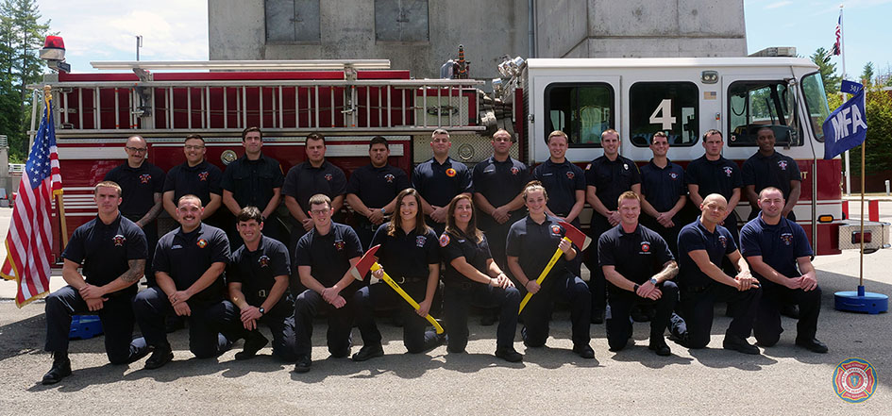

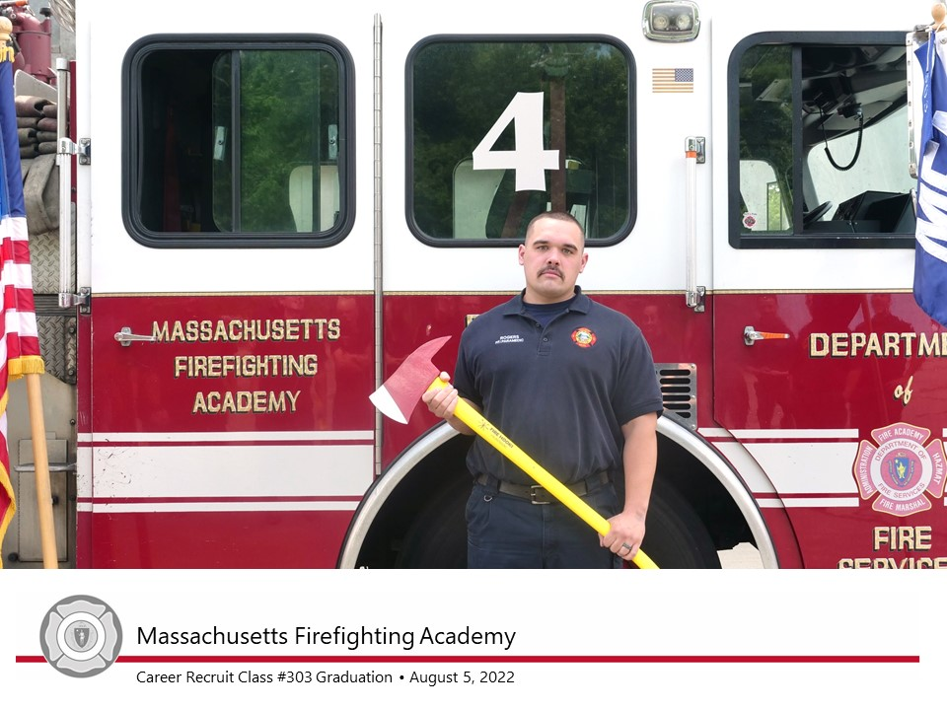

It is going to be another hot and humid weekend. For all shifts, the uniform of the day until Monday will be Class C, department t-shirts. Make sure to stock the coolers and keep an ample supply of water available on the apparatus for rehab.

*Just an FYI, Rutland’s Ladder is out of service until further notice.*

**Personnel**

1. LIV Golf Tournament: Details have been opened for bidding on ePro for department members who are HFD ambulance qualified EMT’s and Paramedics. Details are onsite at the International Golf Course in Bolton, 08:00-18:00 9/1-9/4. Details will be awarded Friday 8/12 after noon.
2. As you are aware, Holden Days will be held on Saturday 8/27. We will be providing our typical displays of fire equipment, EMS equipment and SAFE items. We will also look to staff the EMS bikes too. Any members interested in working 07:30-14:30 or any part of the day please let me know. Would like to get at least 6 – 7 department members. So far I have heard from 1 member.
3. Our callback percentage is very low on all calls at this point, especially since we entered the summer months. As I write this, we have a recall for a mutual aid brush fire with 1 Captain in for the recall. Attendance needs to be stepped up or we will need to take a look at our operations entering next year.

Vehicles

1. Please regulary check the service intervals for the ambulances and support vehicles. If the service reminder is within 20 hours or 250 miles, please notify the Deputy so we can schedule the PM.

**Equipment**

1. Floating Forestry Pump: Pump has been returned to service. Under no circumstances should the spark plug be removed (advice from the repair shop).

Stations

1. PSB- The installation of the tile floor is ongoing, hopefully we will see completion by early next week.

Other

1. Coal Kiln Road in Princeton, which is what our Mason Road turns into at the town line, will be closed for thru traffic starting on 07/25 for a bridge project. The will try to maintain a lane of travel for emergency vehicles but that is not guaranteed. Plan according when responding to calls in this area.