*C:\Users\jhanna\AppData\Local\Microsoft\Windows\Temporary Internet Files\Content.IE5\LE4P6T6Z\MC900340286[1].wmf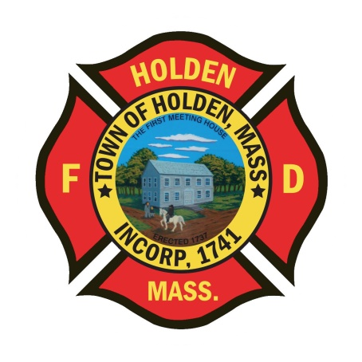* 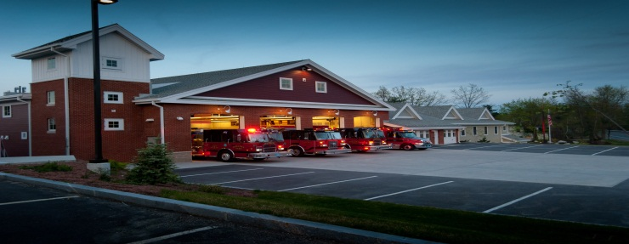

DEPARTMENT UPDATES

7/22/22 –7/29/22

**The Extinguisher**

I would like to take this opportunity to announce that FF/Paramedic Ethan Naiman has been promoted to Lieutenant effective 8/7/2022. LT. Naiman has been with the Holden Fire Department since 2014, becoming our EMS Coordinator in 2017. He will be assigned as the Shift Officer for Group 2 and continue his role as EMS Coordinator. Please join me in congratulating Ethan on his new position.

FF/Paramedic Mark Rogers will be graduating from the Massachusetts Firefighting Academy Career Recruit Program on Friday 8/5 at 11am in Stow. It would be great to see a good showing of department members to support Mark as he celebrates this accomplishment.

**Personnel**

1. LIV Golf Tournament: As of now, we will be covering details on Thursday through Sunday, 9/1-9/4. The details will be noon to 6p on Thursday and 8a-6p on the other days but end time will be dictated by crowd size for the after events. There will be 2 members for each detail along with our UTV. Shortly, we will be posting sign ups for these details, to qualify you must be cleared on our department ambulances as we will be doing some EMS. More information to follow as we get closer.
2. As you are aware, Holden Days will be held on Saturday 8/27. We will be providing our typical displays of fire equipment, EMS equipment and SAFE items. We will also look to staff the EMS bikes too. Any members interested in working 07:30-14:30 or any part of the day please let me know. Would like to get at least 6 – 7 department members.
3. Our callback percentage is very low on all calls at this point, especially since we entered the summer months. With call volumes up, we need more people to respond back on all calls so that we can adequately staff incidents. For call members, if you know you will be unavailable due to a vacation, let your officer know.

Vehicles

1. Please regulary check the service intervals for the ambulances and support vehicles. If the service reminder is within 20 hours or 250 miles, please notify the Deputy so we can schedule the PM.
2. E2 has been returned, E1 is back at Station 2.
3. F2 alternator has been replaced and it is back in service.

**Equipment**

1. Floating Forestry Pump: During the weekly check today, the pump had an issue with the spark plug housing and is out of service awaiting repair.

Stations

1. PSB- The installation of the tile floor is scheduled to start Monday 8/1. This is estimated to take about 7-8 days to complete.

Other

1. Cold Kiln Road in Princeton, which is what our Mason Road turns into at the town line, will be closed for traffic starting on 07/25 for a bridge project. The will try to maintain a lane of travel for emergency vehicles but that is not guaranteed. Plan according when responding to calls in this area.