*C:\Users\jhanna\AppData\Local\Microsoft\Windows\Temporary Internet Files\Content.IE5\LE4P6T6Z\MC900340286[1].wmf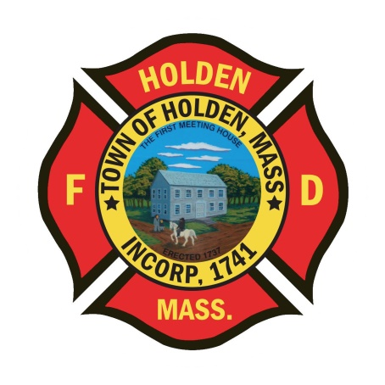* 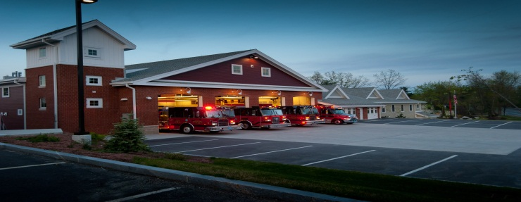

DEPARTMENT UPDATES

7/9/22 –7/22/22

**The Extinguisher**

This version of the weekly update is for 2 weeks, thought we sent it out but it didn’t make it last Friday! We have been in the midst of the first string of 90 degree days for most of this week. As we all know, heat related emergencies can aflict the best of us, even when we feel that we are properly hydrated. Make sure that you drink a lot of fluids when working at calls, especially if you are wearing your PPE.

Last week, the department provided mutual aid coverage for the Auburn Fire Department as they mourned the loss of LT. Paul Wood, who passed away unexpectedly. A big thank you to those who came in to staff A2 and the Tower so that we could help out over the course of 3 days.

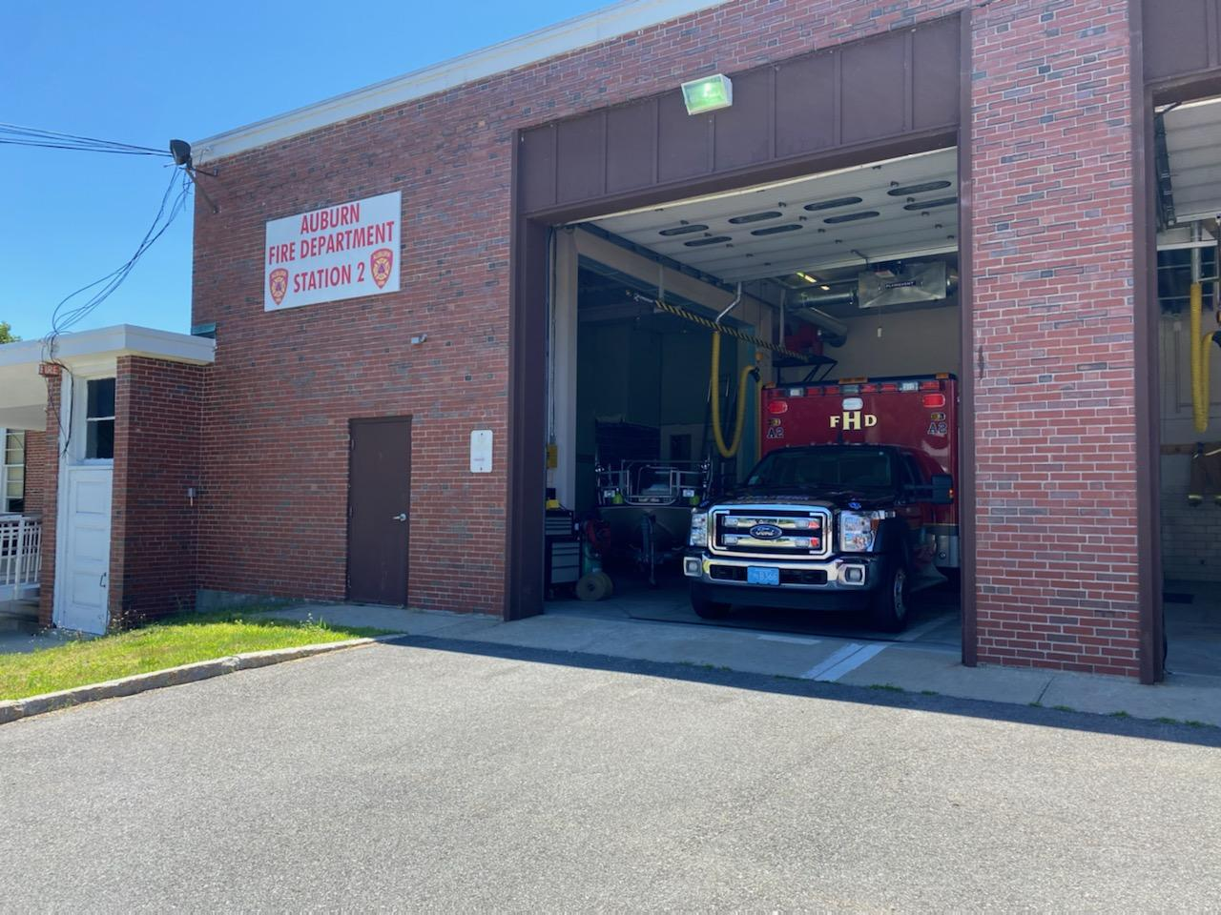

As we help out our brothers and sisters at AFD, it is a good time to remember that as Firefighters, we are all at a higher risk for health problems. Studies have shown that the fire service is at a high risk for heart disease, cancer and respiratory issues. The fire service has taken steps to try and reduce these risks but a positive step to stay healthy is to get an annual physical.

**Personnel**

1. LIV Golf Tournament: As of now, we will be covering details on Thursday through Sunday, 9/1-9/4. The details will be noon to 6p on Thursday and 8a-11p on the other days but end time will be dictated by crowd size for the after events. There will be 2 members for each detail along with our UTV. Shortly, we will be posting sign ups for these details, to qualify you must be cleared on our department ambulances as we will be doing some EMS. More information to follow as we get closer.
2. The assessment center for the LT. position was held on Monday 7/18. It was a day long process with multiple stations, some with outside management and Chief level participants. All of the candidates did a great job and we hope to announce the promotion early next week.
3. Schedule Alert!!! – Holden Days will resume this year on 8/27. After 2 years away, we will be taking part as in the past with apparatus and SAFE displays. Mark your calendars early and come in for a fun day!
4. Our callback percentage is very low on all calls at this point, especially since we entered the summer months. With call volumes up, we need more people to respond back on all calls so that we can adequately staff incidents. For call members, if you know you will be unavailable due to a vacation, let your officer know.

Vehicles

1. E3- Engine 3 was OOS for electrical issues that was preventing the truck from starting. A replacement electrical part was being installed by DPW today, 7/22.
2. F2- The intermittent electrical issues were found to be a faulty alternator. The parts were removed and sent out for repair on Monday. We will send out a message when the truck is back in service.
3. E2 is out of service at TriState Truck in Shrewsbury after being towed by Direnzos. There is an issue within the computer system and transmission sensors that will need to be addressed. E1 has been relocated to HQ to run in its place.
4. Please regulary check the service intervals for the ambulances and support vehicles. If the service reminder is within 20 hours or 250 miles, please notify the Deputy so we can schedule the PM.

**Equipment**

1. Floating Forestry Pump: During the weekly check today, the pump had an issue with the spark plug housing and is out of service awaiting repair.

Stations

1. PSB- The installation of the tile floor is scheduled to start the first week in August. This is estimated to take about 7-8 days to complete.

Other

1. Cold Kiln Road in Princeton, which is what our Mason Road turns into at the town line, will be closed for traffic starting on 07/25 for a bridge project. The will try to maintain a lane of travel for emergency vehicles but that is not guaranteed. Plan according when responding to calls in this area.