*C:\Users\jhanna\AppData\Local\Microsoft\Windows\Temporary Internet Files\Content.IE5\LE4P6T6Z\MC900340286[1].wmf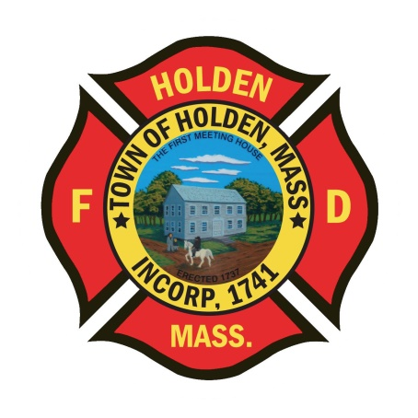* 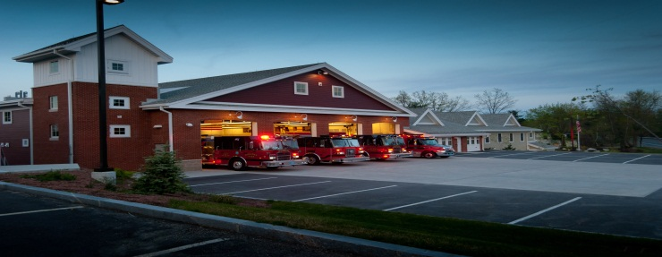

DEPARTMENT UPDATES

7/1/22 –7/9/22

**The Extinguisher**

I hope everyone had a great 4th of July weekend but now summer is officially over! Not really, but it does feel like it sometimes. Over the first 6 months of 2022 we have been extremely busy totaling 1368 emergency responses. This continues to be a 20% increase over the number of calls to this point last year, when we were at 1168 through 6/30. Here is a breakdown of the calls through the end of June:

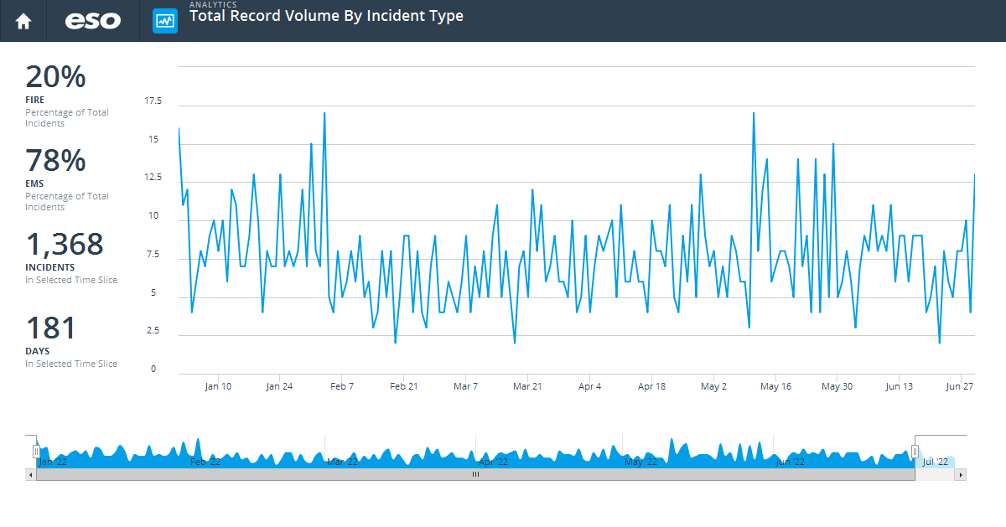

|  |  |
| --- | --- |
|  | Total |
| (11) Structure Fire | 21 |
| (13) Mobile property (vehicle) fire | 1 |
| (14) Natural vegetation fire | 5 |
| (15) Outside rubbish fire | 1 |
| (16) Special outside fire | 1 |
| (32) Emergency medical service (EMS) incident | 1,070 |
| (34) Search for lost person | 2 |
| (38) Rescue or EMS standby | 1 |
| (40) Flammable gas or liquid condition, other | 1 |
| (41) Combustible/flammable spills & leaks | 8 |
| (42) Chemical release, reaction, or toxic condition | 8 |
| (44) Electrical wiring/equipment problem | 2 |
| (46) Accident, potential accident | 1 |
| (48) Attempted burning, illegal action | 3 |
| (50) Service call, other | 4 |
| (51) Person in distress | 3 |
| (52) Water problem | 9 |
| (53) Smoke, odor problem | 2 |
| (54) Animal problem or rescue | 2 |
| (55) Public service assistance | 19 |
| (56) Unauthorized burning | 2 |
| (57) Cover assignment, standby at fire station, move-up | 11 |
| (60) Good intent call, other | 18 |
| (61) Dispatched and canceled en route | 45 |
| (62) Wrong location, no emergency found | 1 |
| (63) Controlled burning | 2 |
| (65) Steam, other gas mistaken for smoke | 8 |
| (70) False alarm and false call, other | 3 |
| (73) System or detector malfunction | 33 |
| (74) Unintentional system/detector operation (no fire) | 62 |

**Personnel**

1. Sunday will mark the last working shift for FF/Paramedic David Russo. As of 7/15, Dave will be retiring from the Holden Fire Department and the fire service after a nearly 17 year career. Over the last 11 years, he has made great contributions to the department. Serving as EMS Coordinator from 2012-2017, Dave brought many new innovations through training and equipment to our EMS service which enhanced our skill level and increased quality patient care. I would like to take the opportunity to thank him for all his hard work and wish him a long happy, healthy retirement and success in his future endeavors.
2. With the open position created by FF/P Russo’s retirement, the department has hired Karl Doane from Spencer. Currently, Karl is an EMT-Basic who is in the final stages of his Paramedic program through Anna Maria College. He will be starting on Monday 7/18 with a week of orientation and then will be assigned to the Day Impact 2 schedule.
3. We will be holding the Assessment Center for the Career LT position on Monday 7/18. All applicants should have received an email from me outlining areas of preparation for the process. If you applied and did not receive the information, please contact me.
4. Schedule Alert!!! – Holden Days will resume this year on 8/27. After 2 years away, we will be taking part as in the past with apparatus and SAFE displays. Mark your calendars early and come in for a fun day!
5. Our callback percentage is very low on all calls at this point, especially since we entered the summer months. With call volumes up, we need more people to respond back on all calls so that we can adequately staff incidents. For call members, if you know you will be unavailable due to a vacation, let your officer know.

Vehicles

1. Ambulance 2 – will be going to Pete’s to have the tire leak repaired at some point next week.

**Equipment**

1. No new updates

Stations

1. PSB UPDATE: No new updates.