*C:\Users\jhanna\AppData\Local\Microsoft\Windows\Temporary Internet Files\Content.IE5\LE4P6T6Z\MC900340286[1].wmf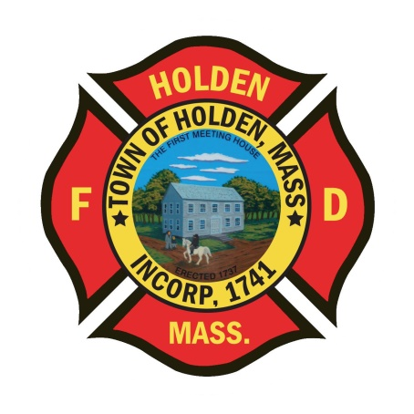* 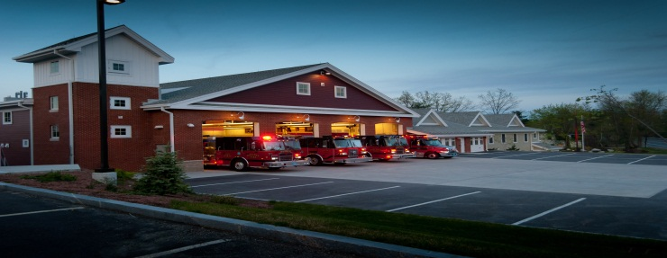

DEPARTMENT UPDATES

6/24/22 –7/1/22

**The Extinguisher**

As we enter into the long holiday weekend, I would like to take this opportunity to wish all department members a happy and safe 4th of July!



On Monday, July 4th, FF Casper will be taking Engine 1 to participate in the Fitchburg fire truck parade. E1 will be out of service for that period of time.

**Personnel**

1. Health Insurance – Just a reminder that the new health plans under BCBS/HMO Blue started as of today, 7/1/22. Any questions, please contact the Town Mangers office.
2. Schedule Alert!!! – Holden Days will resume this year on 8/27. After 2 years away, we will be taking part as in the past with apparatus and SAFE displays. Mark your calendars early and come in for a fun day!

Vehicles

1. Engine 2 –*Parts have arrived, DPW will be installing shortly.* Awaiting parts for the DEF system which is causing the check engine light to stay on. Any issues with the engine operation, notify the Deputy.

**Equipment**

1. The new 1 ¾ hoseline has been ordered.
2. We are still awaiting delivery of the Setcom headsets so that we can schedule installation in the department vehicles.

Stations

1. PSB UPDATE: ServPro has completed the HVAC duct cleaning of the entire PSB. The DPW has completed replacement of the ceilling tiles. We are now awaiting an install date for the tile in the dayroom.