*C:\Users\jhanna\AppData\Local\Microsoft\Windows\Temporary Internet Files\Content.IE5\LE4P6T6Z\MC900340286[1].wmf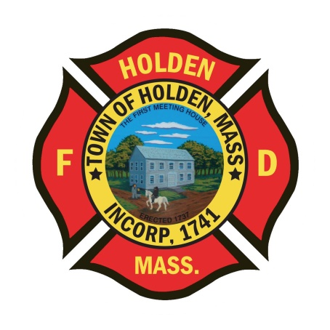* 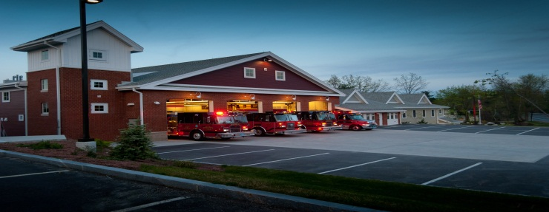

DEPARTMENT UPDATES

6/17/22 –6/24/22

**The Extinguisher**

Congratulations again to all of our EMS providers on another American Heart Association Mission: Lifeline® EMS Gold Plus achievement award. According to the AHA, “this award is given to agencies that demonstrate a commitment to treating patients according to the most up-to-date research-based practices as outlined by the American Heart Association”. Earlier this week, the department held our quarterly M&M rounds and we reviewed a number of cases. In these reviews were two patients in cardiac arrest who were saved by our staff. This just adds to the high quality of care that every provider here at HFD provides to our patients on a daily basis.

Congratulations to the Holden Fire Muster team on their championship victory at the Wachusett Muster which was held in Rutland last Saturday. It was an impressive showing and again showed our teams dominance over the other departments.

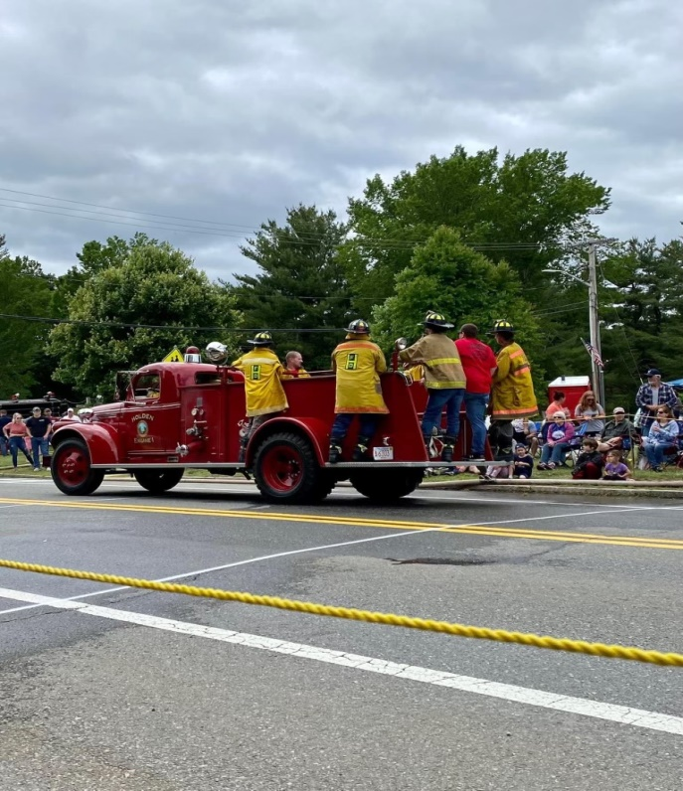

As we near the end of the fiscal year, please do not make any purchases without notifying either myself or the Deputy. This is for all purchases whether online or on a department account. We need to account for any outstanding bills and PO’s need to be completed if the item won’t be in by 6/30.

**Personnel**

1. Health Insurance – Just a reminder that the new health plans under BCBS/HMO Blue start on 7/1/22. This will take the place of the expiring FCHP plan that you currently have. Any questions, please contact the Town Mangers office.
2. Schedule Alert!!! – Holden Days will resume this year on 8/27. After 2 years away, we will be taking part as in the past with apparatus and SAFE displays. Mark your calendars early and come in for a fun day!

Vehicles

1. Engine 2 – In sevice after work at Tri-State. Awaiting parts for the DEF system which is causing the check engine light to stay on. Any issues with the engine operation, notify the Deputy.
2. Forestry 2 – We have had some recent battery charging issues, please keep an eye on it.
3. A3 will be getting new front tires in the next couple of weeks.

**Equipment**

1. The department is in the process of looking at new 1 ¾” attack line to replace our current stock which is approaching 10 years old. The week, we have loaded the 150ft crosslay on E2 with a new brand that is lighter than the current hose. If you have a chance, take a look at it and see how it compares.

Stations

1. PSB UPDATE: ***Attention to all department members,*** ServPro will be on site beginning Monday 6/27 through Friday 7/1 to do an extensive cleaning of all the HVAC ducts in the PSB. There may be some interruption in the HVAC operations and with accessibility to areas of the building while they are working. Please make every effort to stay out of the areas where they are working.