*C:\Users\jhanna\AppData\Local\Microsoft\Windows\Temporary Internet Files\Content.IE5\LE4P6T6Z\MC900340286[1].wmf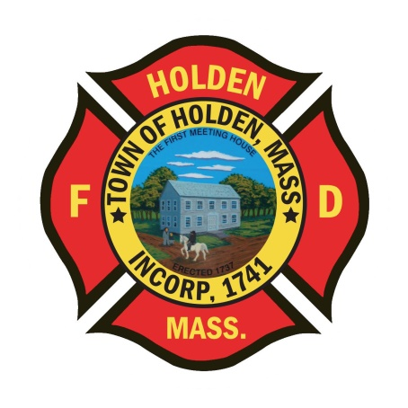* 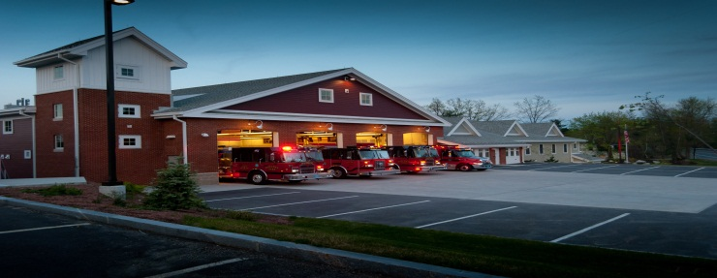

DEPARTMENT UPDATES

6/10/22 –6/17/22

**The Extinguisher**

I hope everyone had a great week; the department has been just as busy as always. Over the last week, we have been averaging just under 10 calls for service per day.

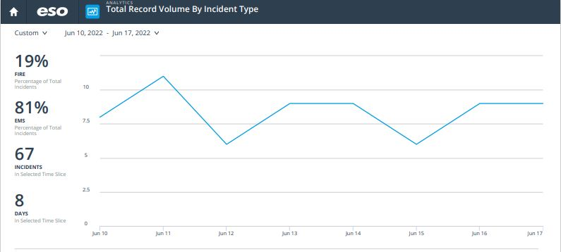

As we enter into another long weekend, I would like to take this opportunity to wish all the Holden Fire dads a Happy Father’s Day. Enjoy the time with your families and have a great day! Along with it being Father’s Day weekend, Town offices will be closed on Monday in observance of the new Federal holiday Juneteenth. This also includes the fire administration office.

This week, the Town Manager’s office held the annual employee appreciation picnic at Trout Brook. The town recognized department members on some milestone anniversaries:

Captain Andy Miller – 20 years

Captain Josh Poznanski – 15 years

Leah Frances Wood – 15 years

FF Dave Russo – 10 years

FF Joe Sposato – 5 years

FF Chris Galkowski – 5 years

Thank you all for your years of dedicated service to the Holden Fire Department and the citizens of the community.

Today, Saturday 6/18, the Holden Fire Muster Team is taking part in the 95th Annual Wachusett Firefighter’s Muster. The event will take place in Rutland center and is a fun time. Rutland is also celebrating their Tercentennial so the common will have food trucks selling both food and beverages. The event starts at 11am and parking is available at the Rutland schools. Come out and support our muster team!

As we near the end of the fiscal year, please do not make any purchases without notifying either myself or the Deputy. This is for all purchases whether online or on a department account. We need to account for any outstanding bills and PO’s need to be completed if the item won’t be in by 6/30.

**Personnel**

1. For career members – June is the annual physical fitness exam. The dates have been scheduled for 6/21 with an alternate date of 6/23 both starting at 08:00. To be eligible, a physician signed physical wellness form must be on file with the Chief.
2. Schedule Alert!!! – Holden Days will resume this year on 8/27. After 2 years away, we will be taking part as in the past with apparatus and SAFE displays. Mark your calendars early and come in for a fun day!

Vehicles

1. Engine 2 – In sevice after work at Tri-State. Awaiting parts for the DEF system which is causing the check engine light to stay on. Any issues with the engine operation, notify the Deputy.
2. Forestry 2 – We have had some recent battery charging issues, please keep an eye on it.

**Training**

1. Reminder: EMS training, M&M Rounds are scheduled for Monday at 18:00. The Zoom link is as follows - <https://umassmed.zoom.us/j/91362310131?pwd=cDkwRHhnNEh4N3dENlczcWtacnlSUT09>

Stations

1. PSB UPDATE: Ceiling tiles have been installed over the week. We are awaiting the tile floor and a date for the install. ServPro is still on for the duct cleaning at the end of this month.