*C:\Users\jhanna\AppData\Local\Microsoft\Windows\Temporary Internet Files\Content.IE5\LE4P6T6Z\MC900340286[1].wmf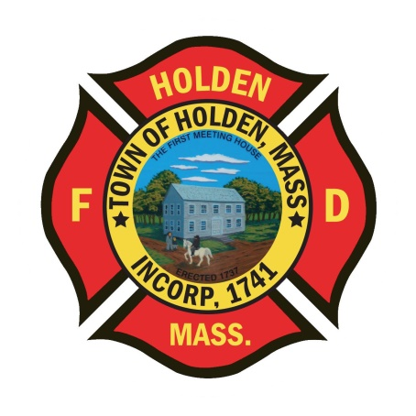* 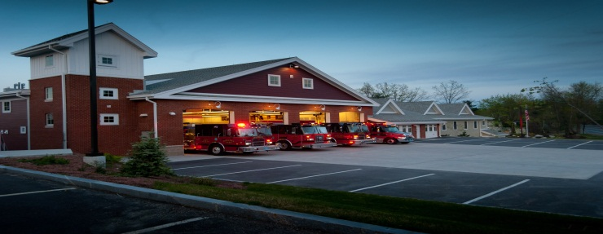

DEPARTMENT UPDATES

6/3/22 –6/10/22

**The Extinguisher**

Over the last week we have been steady on calls, totaling 56 responses. To date, we are seeing a 20% increase over last calendar years numbers. Last year our volume increased 20% over 2020, so we continue to have an increased work load. It is very important for staff to respond back on all-calls to ensure that we can get apparatus on the road; otherwise at some point we will need to start relying on automatic mutual aid for even the routine fire responses, especially when the duty staff is on other calls for service.

This weekend, the City of Worcester is celebrating its Tercentennial. With this comes many events and road closures in the city. Saturday appears to be the busiest day. We have added an additional member to the shift staffing in case of extended transport and hospital times or if we are relied upon for mutual aid. The area of Grove Street will be tied up Saturday morning until early afternoon due to these events and should be avoided.

The town is hosting the annual employee appreciation cookout at noon on Tuesday 6/14. It will be held at the Trout Brook pavilion. The event is catered by Smokestack Urban BBQ. All department members are invited.

**Personnel**

1. For career members – June is the annual physical fitness exam. The dates have been scheduled for 6/21 with an alternate date of 6/23 both starting at 08:00. To be eligible, a physician signed physical wellness form must be on file with the Chief. Currently there are only 4 members who have filed the proper form to be eligible for the stipend.
2. Schedule Alert!!! – Holden Days will resume this year on 8/27. After 2 years away, we will be taking part as in the past with apparatus and SAFE displays. Mark your calendars early and come in for a fun day!

Fire Prevention

1. Jefferson Mill – Construction continues on the Jefferson Mill Apartment project. Just be aware that the contractor is storing materials and equipment in the small building across from the main building. This is the building that is off Village Way across from the pump house. Use caution in this structure as there are unsafe areas outside of the area of storage.

Vehicles

1. Engine 2 – Sent to TriState in Shrewsbury for a recall and sensor repair. Engine 3 is running as primary out of HQ until it returns.
2. Forestry 2 – We have had some recent battery charging issues, please keep an eye on it.

**Equipment**

1. As we near the end of the fiscal year, we are putting together a list of items that we need to think about replacing. If there is soemthing that you feel could be replaced, forward it to either myself or the Deputy.

Stations

1. PSB UPDATE: The new ceiling tiles arrived today and will be installed shortly. We have received approval from the insurance company to bring ServPro back in to clean all of the building HVAC ducts to ensure that there is no mold from the moisture caused by the leak. This will take place the last week of June.