*C:\Users\jhanna\AppData\Local\Microsoft\Windows\Temporary Internet Files\Content.IE5\LE4P6T6Z\MC900340286[1].wmf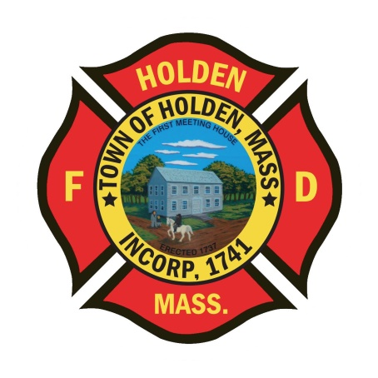* 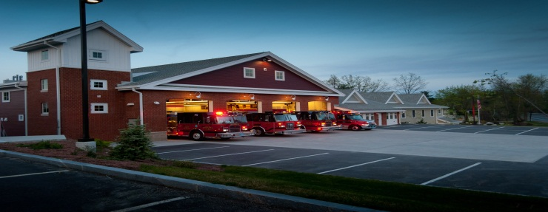

DEPARTMENT UPDATES

5/27/22 –6/3/22

**The Extinguisher**

I hope everyone enjoyed the long weekend. The department took part in the annual Memorial Day parade providing the Honor Guard, Engine 2 and the Fox. It was a great day and a very good turnout by the town residents.

The department Honor Guard was very busy last week. They represented the department in the Memorial Day parade and then the next evening, again represented the department and town at the WooSox game on Holden night. This was a great event that raised money for Holden Baseball and Softball. There was a great turnout of Holden residents for the night of the game and the WooSox even won in dramatic fashion.

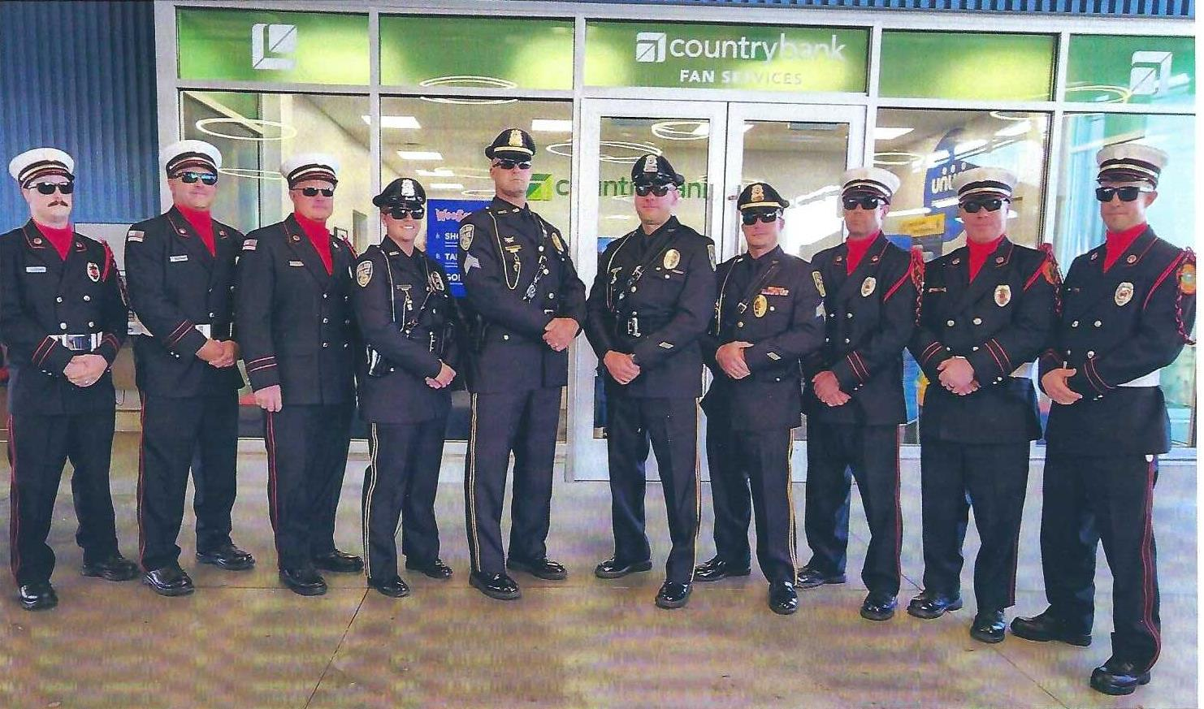

Our two new FF/Paramedics began their careers with the department this week. We have assigned FF/P Corey Lemon to Group 1 and FF/P Camron Charchafliah to the Impact 2 shift. Please take the opportunity to welcome them to the department and wish them well.

On Sunday 6/5, the 1st Annual Ross ‘ALF’ Reynolds Memorial Cornhole Tournament will be held at the Wachusett Brew Yard in Westminster. This is to benefit the wife of Captain Ross Reynolds, who sacrificed his life protecting our freedom. This event has been put together by FF/P Ryan Pescaro, FF/P Chris Leonard and many others. This is a great chance to get out, have some fun and support a great cause. Any questions, please contact FF/P Pescaro.

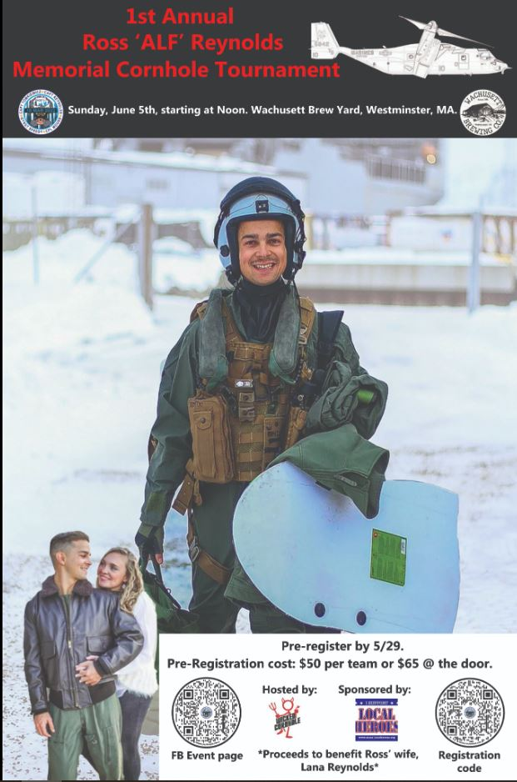

**Personnel**

1. For career members – June is the annual physical fitness exam. We will be scheduling the dates for the last week of the month. To be eligible, a physician signed physical wellness form must be on file with the Chief. Currently there are only 3 members who have filed the proper form to be eligible for the stipend.
2. We have some open overtime shifts for June. If interested go to ePro to put in your requests. With June being a very busy month for time off, we need to have the shifts filled. It becomes an even bigger issue when you add in coverage for classes and sick days.
3. Schedule Alert!!! – Holden Days will resume this year on 8/27. After 2 years away, we will be taking part as in the past with apparatus and SAFE displays. Mark your calendars early and come in for a fun day!
4. For those who get health insurance from the town, you may have noticed that the amount for BCBS started to be deducted from your check this week. Just a reminder, you are still on Fallon insurance until 7/1. The reason you now see BCBS being deducted is because the town deducts a month ahead for insurance.

Vehicles

1. No Updates

**Equipment**

1. All of the new 4” LDH as been loaded on the apparatus. Currently we are in the process of offering the old LDH and old Holmatro extrication tools to other departments in the fire district.
2. As we near the end of the fiscal year, we are putting together a list of items that we need to think about replacing. If there is soemthing that you feel could be replaced, forward it to either myself or the Deputy.

Stations

1. PSB UPDATE: Currently we are working with the tile installer to order the new tile for the area that was previously cork flooring. We have also looked at carpeting to replace the area rug. Buildings and Grounds is working on procuring the new ceiling tiles so hopefully that will start soon. On another note, we are working with ServPro to get the insurance company to pay for cleaning the HVAC ducts throughout the building. We have been pressing the insurance company to issue the go ahead, but have been meeting challenges to this point. We continue to work with the Town Manager’s office to get a resolution.