*C:\Users\jhanna\AppData\Local\Microsoft\Windows\Temporary Internet Files\Content.IE5\LE4P6T6Z\MC900340286[1].wmf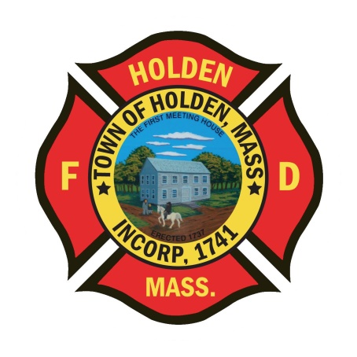* 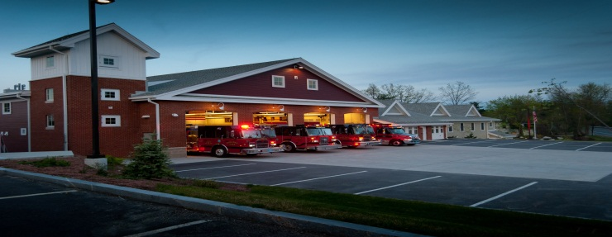

DEPARTMENT UPDATES

5/20/22 –5/27/22

**The Extinguisher**

On Monday, we will celebrate Memorial Day. As the unofficial kickoff to summer, this is a great time of year for all of us in the Northeast who suffered through another winter! The true meaning of Memorial Day though is a day to honor all those who gave their lives while serving our country. Please take a moment to thank all veterans for their service in protecting our way of life.



We will be taking part in the annual Memorial Day parade on 5/30. Members participating are asked to be at Fire HQ by 10:30 am. Currently, we have the Honor Guard, Engine 2 and the Fox in the parade.

On Tuesday 5/31, the WooSox will be hosting Holden night. We are pleased to announce that our HFD Honor Guard will be taking part in pre-game festivities on the field. It would be great to be there to support them. To purchase tickets that a portion will benefit Holden baseball and softball, go to fevo.me/towntakeover.

**Personnel**

1. On 5/30, our two new career FF/Paramedics will start with HFD. Corey Lemon, an Oakham resident, comes to the department from the Bellingham Fire Department and has both fire and EMS experience. Camron Charchafliah, a Millbury resident, is a recent Paramedic graduate with call firefighter experience with the Harmony and Albion Fire Departments in Rhode Island. Welcome and good luck to both of our new members.
2. For career members – June is the annual physical fitness exam. We will be scheduling the dates for the last week of the month. To be eligible, a physician signed physical wellness form must be on file with the Chief
3. Schedule Alert!!! – Holden Days will resume this year on 8/27. After 2 years away, we will be taking part as in the past with apparatus and SAFE displays. Mark your calendars early and come in for a fun day!

Vehicles

1. With the approval of the FY23 budget, the department will be ordering a replacement for Car 3. We will be purchasing and outfitting a 2023 Chevrolet Tahoe. This week, McGovern auto group came to view the current Car 3 to work on a quote for cabinetry and lighting.

**Equipment**

1. We continue to load all the new 4” supply lines on the apparatus and test the existing hose. Engine 4 LDH was done today.

Stations

1. PSB UPDATE: Painting has been completed as of this week. We have quotes and PO’s submitted for the flooring so hopefully that will be scheduled shortly.