*C:\Users\jhanna\AppData\Local\Microsoft\Windows\Temporary Internet Files\Content.IE5\LE4P6T6Z\MC900340286[1].wmf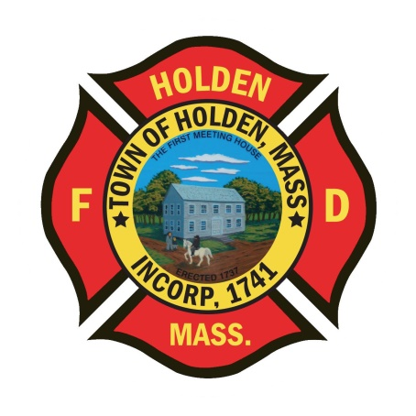* 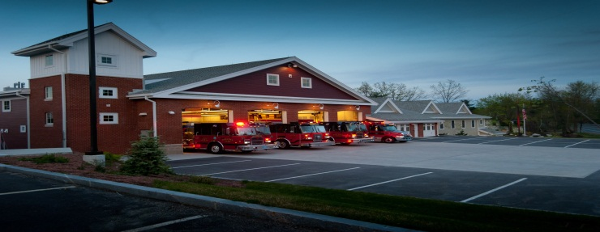

DEPARTMENT UPDATES

5/14/22 –5/20/22

**The Extinguisher**

Nicer weather is finally here!!!! With the warmer temps, please make sure you are prepared with proper hydration and appropriate PPE.

Throughout this week, we have been recognizing our EMS caregivers with National EMS Week. The Town would like to thank/ recognize everyone’s hard work, especially during the pandemic and with the increase in call volume the last 2 years.

FF Rogers will be starting the academy in Stow on Monday. Mark has been working hard to prepare himself and we wish him the best of luck!! We will surely miss his breakfast cooking skills on Fridays!!

**Personnel**

1. FF Kyle Blouin graduated from the MFA Career Recruit Class #S-27 today. We had a great showing of support from Department members, which is great to see. Kyle is anxious to get back to work when he returns shift with Gr 3 this week.
2. No changes with the new hires, we are targeting the week of 5/30 as a tentative start date.
3. Still looking for more members interested in the annual Memorial Day parade. Those interested in taking part, please notify either myself or Leah. We would like to get at least the Honor Guard and an Engine in the parade. So far, I have heard from a total of 2 members.
4. Schedule Alert!!! – Holden Days will resume this year on 8/27. After 2 years away, we will be taking part as in the past with apparatus and SAFE displays. Mark your calendars early and come in for a fun day!

Vehicles

1. **To clear up some confusion, Eng 1 needs the tank to pump valve rebuilt as it leaks by when closed. This does not mean the truck is OOS, and it did pass pump testing last week. This is a normal PM action with our trucks. The kit for the valve repair was delivered yesterday, hoping to have the work done next week.**
2. **Squad 2- The bolts that hold the bed to the the frame were found to be rusting through. The DPW looked at the situation and advised it can still be used normally untill a new bed can be obtained. The truck can be used to tow trailers.**

**Equipment**

1. **The new adapters for the forestry wyes have been installed, back to normal use!!**
2. We will making a push over the next month to finish putting the new LDH hose on the trucks and complete hose tested.

Stations

1. PSB UPDATE: The plaster work has been completed. Painting of the lobby and day room will be starting on Monday.
2. PSB climate control system – Still seeing temp fluctuations in the building. Any issues with extreme temps, please let us know.