*C:\Users\jhanna\AppData\Local\Microsoft\Windows\Temporary Internet Files\Content.IE5\LE4P6T6Z\MC900340286[1].wmf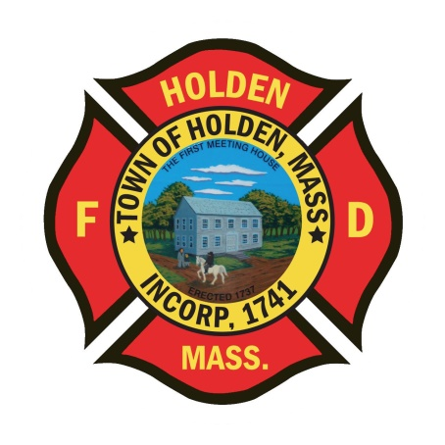* 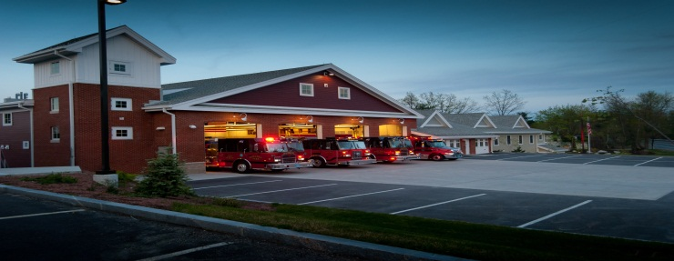

DEPARTMENT UPDATES

4/29/22 –5/6/22

**The Extinguisher**

Last weekend proved to be very busy, great work by all to ensure the demand was met. Friday afternoon through Sunday saw a total of 28 responses and a mutual aid response for a brush fire in Princeton. Issues with the forestry wyes were found when trying to put them into service at that M/A call. Investigation into what the cause was showed that the manufacturer sent us a thread pattern that was similar to NST but was slightly different. The mistake was on them, Deputy Smith is working with the manufacturer to take care of the issue.

Not that we have turned the calendar page to May, we anticipate participating in the annual Memorial Day parade. Those interested in taking part, please notify either myself or Leah. We would like to get at least the Honor Guard and an Engine in the parade.

Schedule Alert!!! – Holden Days will resume this year on 8/27. After 2 years away, we will be taking part as in the past with apparatus and SAFE displays. Mark your calendars early and come in for a fun day!

As we start to see an uptick in COVID cases around town and within town departments, just a reminder if you don’t feel well, test yourself. If you need rapid or PCR testing, we still have both here at the station.

For those who are interested, the WooSox offer discounts for first responders on Wednesday games. First responders receive 4 free tickets on Wednesdays when showing their credentials at the WooSox Ticket Office.

**Personnel**

1. No changes with the new hires, we are targeting the week of 5/30 as a tentative start date.
2. The posting for the LT position has closed as of last Friday. Thank you to those who have applied. We will be working towards setting up the process and dates shortly. Once we are set, applicants will be given the information.

Vehicles

1. On Thursday 5/12, WD Perkins will be here to do pump testing of the apparatus.
2. E2 – Battery issue found this week due to a sulfur odor in the apparatus bay. DPW mechanics repaired the issue in a matter of hours.
3. F2 – Battery problems are persisting. Working with DPW to identify where the issue is and repair it.
4. Squad 2 – Issues have been found with the bed and some rotting. This has caused an issue with the mounting bolts. We will be looking to replace the truck bed as we enter into the new fiscal year.

**Fire Prevention**

1. SAFE – The department participated in the opening day parade of the Holden Little League. The engine is always a hit with the kids!
2. For those that may have not seen this last week, we already have been there once. *The former “Local” Tavern at 680 Main Street is reopening this week as the Thai House of Holden. Inspections were performed earlier this week and the interior is wholly unchanged from the previous owners. The only changes are the second bar is no longer used as seating and some tables have been added. The fire alarm system has been updated and the hood supression system has also been updated. The keys in the Knox Box have been checked and are up to date.*

Stations

1. PSB UPDATE: We are in the process of issuing PO’s for the repairs. The drywall and insulation is tentatively scheduled to be repaired on Thursday 5/12.
2. PSB climate control system – We have seen some temperature fluctuations in the building over the last month or so. After speaking with Gary, there are ongoing issues with the heat pumps that repairs are upcoming. As of this morning, they adjusted the computer system and overrode some systems to lower the temps to a more comfortable level.