*C:\Users\jhanna\AppData\Local\Microsoft\Windows\Temporary Internet Files\Content.IE5\LE4P6T6Z\MC900340286[1].wmf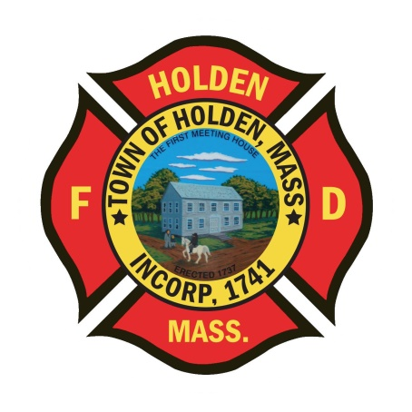* 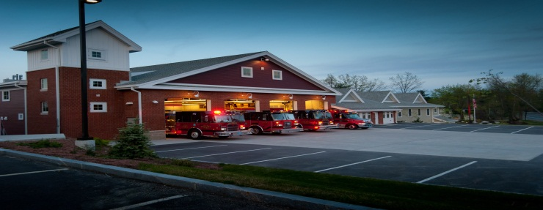

DEPARTMENT UPDATES

4/22/22 –4/29/22

**The Extinguisher**

Since the start of 2021 our call volume has been on the rise. Currently, we are 156 responses ahead of last year’s pace which is a 22% increase in volume through 1/3 of the calendar year.

**2021**

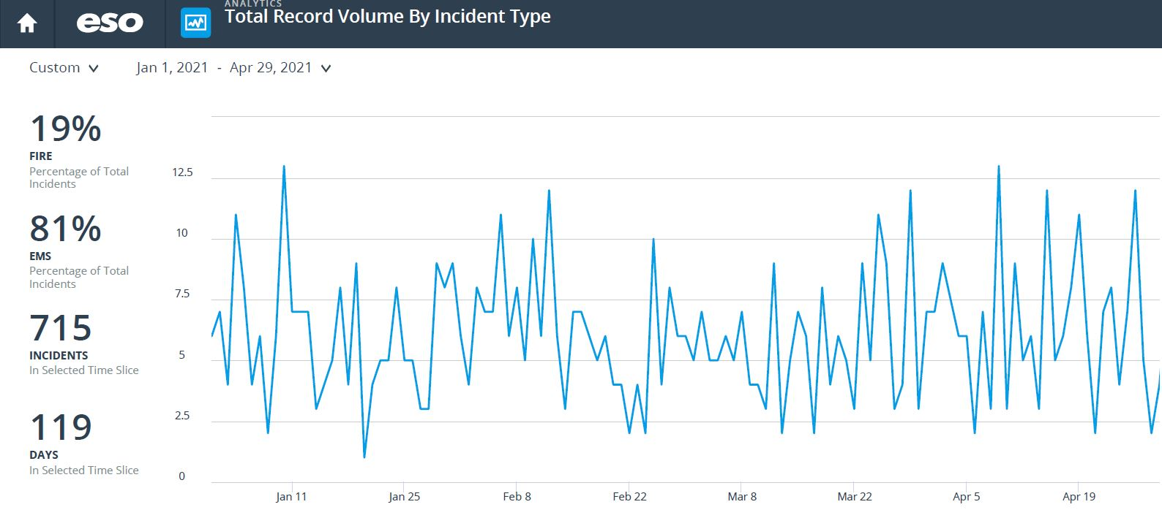

2022

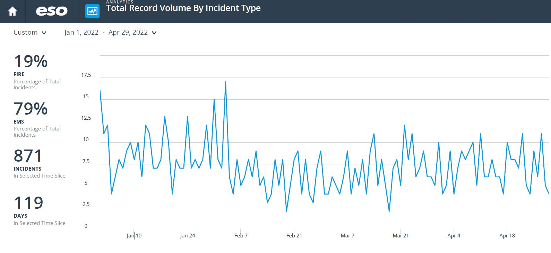

For those who are interested, the WooSox offer discounts for first responders on Wednesday games. First responders receive 4 free tickets on Wednesdays when showing their credentials at the WooSox Ticket Office.

**Personnel**

1. We are still on track for the new hires to start most likely the last week in May. PAT’s have been scheduled over the next couple of weeks.
2. Currently, we have an opening for a career Lieutenant/Shift Officer due to the departure of Chief Connor. The promotional position has been posted and will close TODAY, 4/29. Please remember that the Managers office closes at Noon on Fridays. To be eligible to apply, you must have 3 years of career service with HFD and have obtained your Pro-Board certifications in Fire Officer 1 and Fire Instructor I. We will be scheduling the interviews and assessment center process after the close of the applications.

Vehicles

1. Engine 1 – We have identified a problem with the front intake. Currently we are unable to pull a draft with it. Until further notice, do not use the front intake for drafting operations. It can still be used as an intake for hydrant operations. DPW has been working on this issue the last few days and believe there is an air leak in the system.

**Fire Prevention**

1. SAFE – We have entered into the season of station tours, pre-school visits and parades. You will see FF Sposato posting different events that he will need assistance with so please don’t hesitate to help out. This is a great opportunity for us as a department to get our safety message out there and make some kids very happy!
2. I have started working with the district and FF Nickerson to put the initial policies and procedures together for a district FIU program. The intent is to start out with a small number of investigators and see how the team will work. The basic fire investigation program fills up fast, if interested in taking the class, keep an eye on DFS-LMS for future offerings. Any info that we receive will be passed on.
3. The former “Local” Tavern at 680 Main Street is reopening this week as the Thai House of Holden. Inspections were performed earlier this week and the interior is wholly unchanged from the previous owners. The only changes are the second bar is no longer used as seating and some tables have been added. The fire alarm system has been updated and the hood supression system has also been updated. The keys in the Knox Box have been checked and are up to date.

Stations

1. PSB UPDATE: The Town is contining to work through the cleanup and repair process from the water leak on 03/19. We have received the majority of quotes for the work to be done. As always, insurance organizations are difficult to deal with and it is an ongoing process. We hope to start the drywall and insulation portion of the repair soon.