*C:\Users\jhanna\AppData\Local\Microsoft\Windows\Temporary Internet Files\Content.IE5\LE4P6T6Z\MC900340286[1].wmf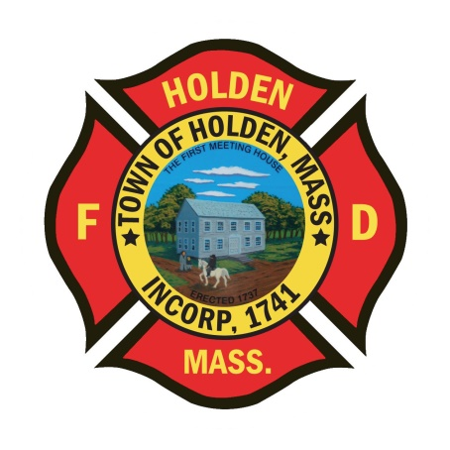* 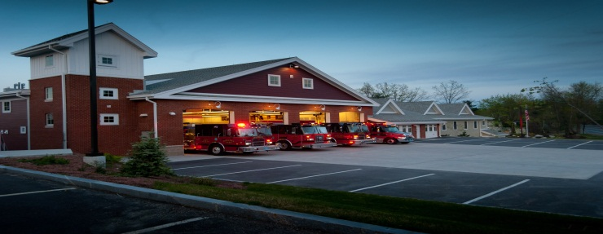

DEPARTMENT UPDATES

4/15/22 –4/22/22

**The Extinguisher**

We end another spring week with a Class 4 brush fire warning. In these instances, we will generally shut down all outside permit burning to alleviate the chance of these fires getting out of the control of homeowners. We have seen an uptick of brush fires over the last week throughout the Commonwealth, even though we have had quite a bit of rain lately. This is a good time of year to remember to make sure that you brush gear is ready to go and is in good condition. Any issues with your gear please let an officer know so that we can get it looked at.

Today marks the final shift of Captain Bob Connor. He will embark on his new challenge as the Fire Chief of the Littleton Fire Department. I would like to congratulate Chief Connor and thank him for his service and contributions to HFD. We wish him good luck and great success in his new position.

Earlier this week, the members of Group 4; FF/P Russo, FF Fasshauer and FF/P Lothrop along with LT Montiverdi, FF/P Blouin and FF/P Walters responded to a reported unresponsive patient. Upon their arrival the patient was in cardiac arrest. With a quick assessment, CPR was started and the patient received early defibrillation along with advanced life support care. Due to these decisive measures, the patient was revived and has had a positive outcome after cardiac treatment. Congratulations to these department members on a job well done!

Finally, the final finance committee hearing was this past Wednesday night on the upcoming FY23 budget. Normally, we don’t attend these meetings after our initial budget presentation, but there were items on the table that could be reduced or cut, which made it important for me to attend. Although some other general government lines took a hit, no HFD operational items were cut or reduced from the budget. The budget process is very robust, time consuming and difficult in trying to balance the needs of the town with keeping tax rates as low as possible.

**Personnel**

1. We are still on track for the new hires to start at some point in May. Physical exams have been completed and we are waiting for PAT’s to be scheduled.
2. Currently, we have an opening for a career Lieutenant/Shift Officer due to the departure of Chief Connor. The promotional position has been posted and will close next Friday, 4/29. To be eligible to apply, you must have 3 years of career service with HFD and have obtained your Pro-Board certifications in Fire Officer 1 and Fire Instructor I. We will be scheduling the interviews and assessment center process after the close of the applications.

Vehicles

1. The new Ambulance 4 has received it’s production number from Horton, which is a good sign. It means that it is anticipated that we are not far from the actual build to begin. According to Greenwood EV, the Dodge chassis is due to arrive in the next month or so. The next step is schematic drawings that we will review to ensure that the specification meets our current standard. We should be on a build time that was similar to A3.
2. Engine 1 – We have identified a problem with the front intake. Currently we are unable to pull a draft with it. Until further notice, do not use the front intake for drafting operations. It can still be used as an intake for hydrant operations.

**Fire Prevention**

1. SAFE – We have entered into the season of station tours, pre-school visits and parades. You will see FF Sposato posting different events that he will need assistance with so please don’t hesitate to help out. This is a great opportunity for us as a department to get our safety message out there and make some kids very happy!
2. In the next few weeks, Deputy Smith will be attending the Fire Investigator I course at the MFA. The department has always supported our members who are interested in becoming part of specialized teams or obtaining certifications. That being said, we are looking for members who are interested in the Fire Investigator program so that we can increase our coverage. I am working with FF Nickerson and Sterling Chief Hurlbut to try and put together a D8 Regional FIU team. This could be a great benefit to the district towns and individual investigators because it increases the number of fire investigations that can be done and is invaluable experience and training. If you have an interest, please contact either myself or Deputy Smith.

Stations

1. PSB UPDATE: The Town is contining to work through the cleanup and repair process from the water leak on 03/19. Awaiting pricing on repairs and the arrival of some insurance funds from our policy.
2. STATION 2 – We had an issue with the overhead speaker in the station not working. It was repaired but we found that there is a mice problem in the building. According to the DPW, they have been seeing damage to their equipment as well. We will be working with DPW in contacting the exterminator to get some treatment for the entire facility. In the meantime, please keep an eye on the apparatus and look for signs of any rodent issues during your truck checks.