*C:\Users\jhanna\AppData\Local\Microsoft\Windows\Temporary Internet Files\Content.IE5\LE4P6T6Z\MC900340286[1].wmf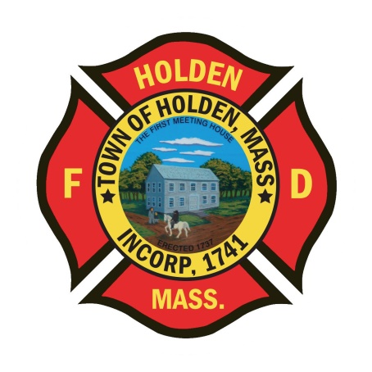* 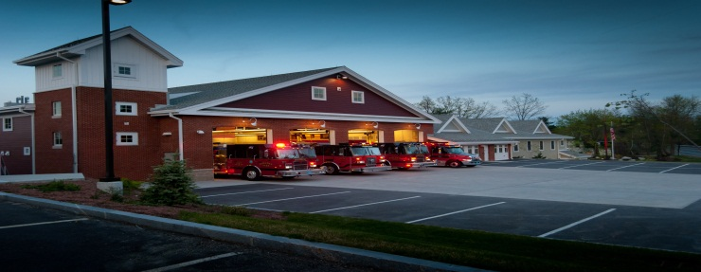

DEPARTMENT UPDATES

4/08/22 –4/15/22

**The Extinguisher**

Over the last few days, the on-duty groups have been putting a lot of time and effort into retrofitting E1. All of the hydraulic reels and the other items that were installed for the Holmatro extrication equipment have been removed and the turntable with the Hurst tools has been mounted in the R3 compartment. The 4” line has been stripped and will be replaced with 1200’ on the left side of the hose bed while on the right side; the divider has been moved to accommodate 300’ of 2 ½” hose. The rigid bed covers have been removed and replaced with a soft cover and the hydrant equipment will be in the rear compartment. All of these changes will bring E1 very close to mirroring the setup of E2 so that there is familiarity amongst apparatus. There will be more changes and retrofits to come, so stay tuned.

**Personnel**

1. We have made offers to 2 candidates in the hiring process which have been accepted. Currently, the candidates are in the process of medical physicals and the PAT. Once all steps are complete, we will announce the names and information on the new career firefighters. We have also extended a tentative offer to the a third candidate for an upcoming position in July. This candidate will begin the medical physical and PAT process at the end of May.
2. Payroll needed to be submitted by noon today due to the Monday Holiday. Any callbacks, call shifts or OT from today through Saturday will be added on Tuesday. Please make sure to complete payroll slips and sign the call shift log if doing a shift. If there are any unexpected OT shifts, please email Laura to inform her of the hours and date so that it can be added to payroll.

Vehicles

1. E1 – Should be back in service by this afternoon, Friday 4/15. Please look for a message in IAR when back in service

**Fire Prevention**

1. SAFE – We have entered into the season of station tours, pre-school visits and parades. You will see FF Sposato posting different events that he will need assistance with so please don’t hesitate to help out. This is a great opportunity for us as a department to get our safety message out there and make some kids very happy!

Stations

1. PSB UPDATE: The Town is contining to work through the cleanup and repair process from the water leak on 03/19. Awaiting pricing on repairs and the arrival of some insurance funds from our policy.
2. STATION 2 – There was a water leak found in the office at Station 2 during a rainstorm earlier this week. It has been reported to B&G and they will be looking at it. In the meantime, please keep an eye out for water.