*C:\Users\jhanna\AppData\Local\Microsoft\Windows\Temporary Internet Files\Content.IE5\LE4P6T6Z\MC900340286[1].wmf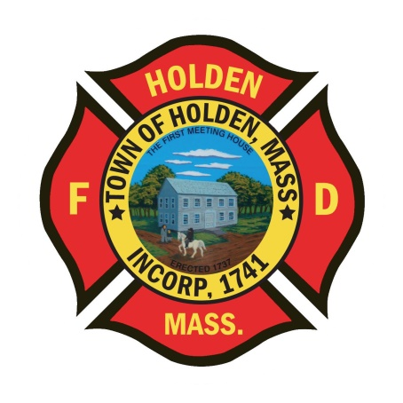* 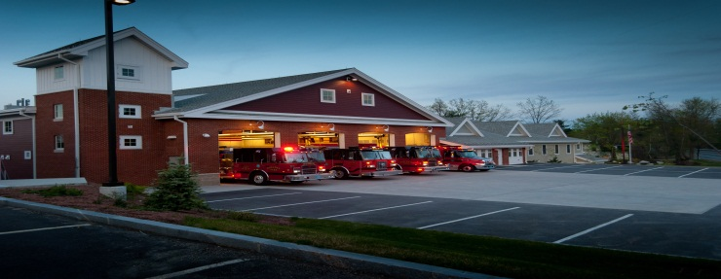

DEPARTMENT UPDATES

4/01/22 –4/08/22

**The Extinguisher**

We are another week closer to summer! Over the last few weeks we have had a pretty good increase in structure fires whether in town or mutual aid. Please remember to wash your gear after every fire for your own safety, protection and health. Last night we responded to a basement fire at 185 Quinapoxet Street. Great job by Group 1 to make a quick knockdown of the fire and contain the majority of the damage to the basement. It turned out to be a stubborn fire and we ended up chasing hot spots for some time. Although we are still investigating the cause of the fire, it appears as though it may have been electrical in nature. If anyone needs replacement of hoods, gloves or has any issues with PPE after a fire, please see a shift officer or FF Rich Johnson so we can keep track of what is getting distributed.

**Personnel**

1. We have concluded the interviews and background checks for the open positions and are in the process of making offers to some very good candidates. We will keep you updated when everything is official.
2. Please remember to always complete the necessary payroll slips. All personnel that come in for callbacks need to initial a completed payroll slip. Call members need to complete the payroll log sheet in the front hallway when you work shifts. Fulltime members need to submit a completed and signed payroll sheet by Monday morning on payroll weeks. Doing payroll for a Department of 40 members is a big task for Leah and Laura, we need to make sure everything is documented correctly for them.

Vehicles

1. E1 – The new Hurst tools for E1 arrived today! We will be scheduling the out of service time for installation. Stay tuned!

Operations

1. As stated earlier, crews responded to 185 Quinapoxet on 4/7 for a reported structure fire. Engine 2 arrived on scene to report smoke showing from multiple sides of a single story ranch. Upon entering the structure, C4 requested a working fire assignment. The main body of fire was located on the “C” side of the structure in the basement. The crew of E2 was able to quickly knock it down and begin overhaul and ventilation of the structure. Companies chased hotspots in the area of origin due to the construction of the home. The structure dates back to 1944, and is platform construction. A whole house renovation was performed some time in the early 2000’s which added an additional layer of subflooring over the original tongue and groove floor. It also added vinyl siding to cover the original wood siding. It was found that the fire had worked its way out of the basement and into the spaces between the header, sheathing and wood siding. Great work E2, E1, Tower 1 and an assist by Rutland E1.

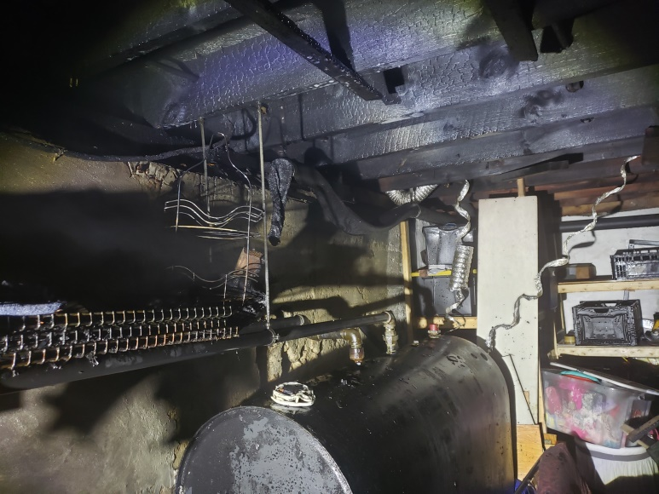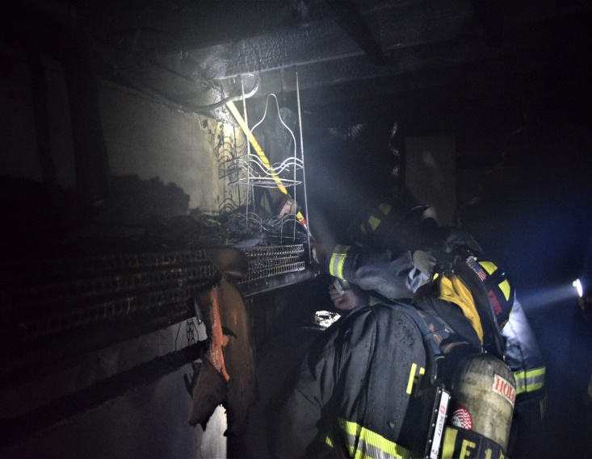

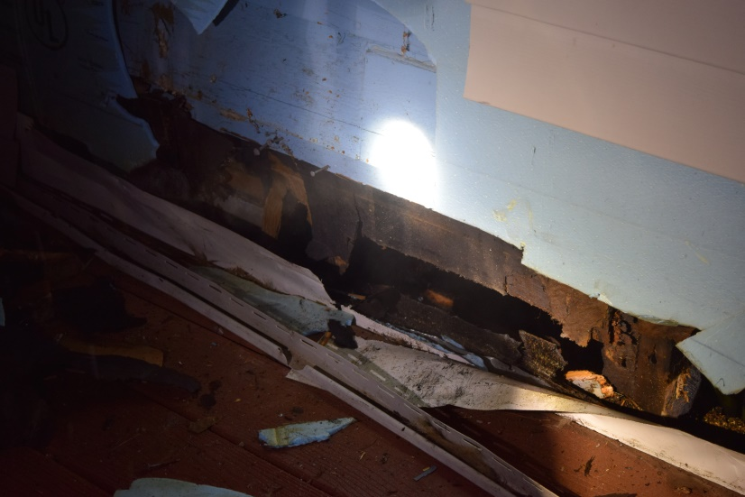 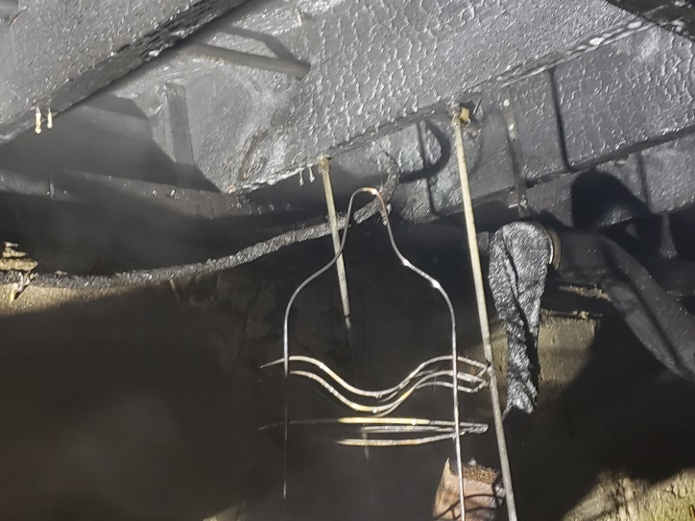

**Fire Prevention**

1. SAFE – We have entered into the season of station tours, pre-school visits and parades. You will see FF Sposato posting different events that he will need assistance with so please don’t hesitate to help out. This is a great opportunity for us as a department to get our safety message out there and make some kids very happy!

Stations

1. PSB UPDATE: The Town is contining to work through the cleanup and repair process from the water leak on 03/19. Insurance adjusters and contractors have been out and we are awaiting the report. As of now, the drywall and floor have been removed and the carpets have been steam cleaned in the career office and admin hallway. We understand that this will be an inconvience over the next several weeks, but we thank you for your anticipated corperation and understanding throughout the process.