*C:\Users\jhanna\AppData\Local\Microsoft\Windows\Temporary Internet Files\Content.IE5\LE4P6T6Z\MC900340286[1].wmf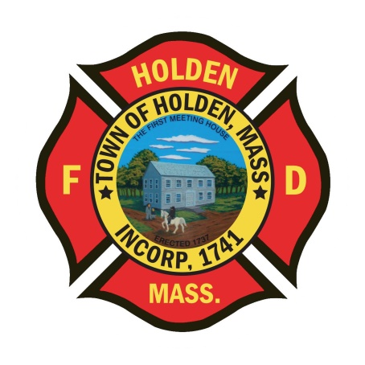* 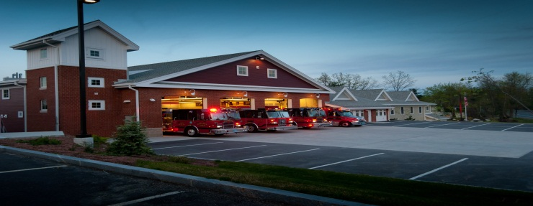

DEPARTMENT UPDATES

3/26/22 –4/01/22

**The Extinguisher**

Happy Friday!!! Hope everyone has had a great week. Although the weather hasn’t been great, it is nice to open up the doors/ windows and get outside for trainings after a long winter!

Just wanted to give you a quick 1st quarter incident analysis for 2022. This year is still on track to be the busiest call volume ever. Compared to this point last year, we are over by 121 incidents. One category that is specifically higher is the 100 incident type calls. These are the structure/ cooking fire incidents. So far in 2022, we have had eight (8) 111 type incidents where at this point last year, we had three (3). This shows an increase of fire related incidents. EMS numbers are relatively stable, accounting for about 80.1 percent of total incidents. Mutual aid to other communities is also similar to last year.

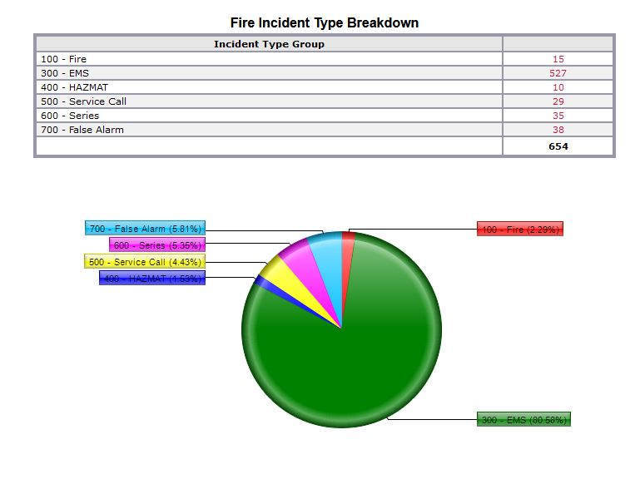

**Personnel**

1. Interviews for the open FF/ Medic positions have been completed. We interviewed some great candidates and are confident those who are hired will be a great fit for our Department. We will be completing the background checks and extending job offers next week.
2. New Health Insurance – For those members who have health coverage through the town, the new plan will be HMO Blue. Enrollment starts April 4th. If you have any questions, please see Leah.
3. Please remember to always complete the necessary payroll slips. All personnel that come in for callbacks need to initial a completed payroll slip. Call/ per diem members need to complete the payroll log sheet in the front hallway when you work shifts. Fulltime members need to submit a completed and signed payroll sheet by Monday morning on payroll weeks. Doing payroll for a Department of 40 members is a big task for Leah and Laura, we need to make sure everything is documented correctly for them.

Vehicles

1. A1 – is back in service!!!! Crews spent the weekend cleaning and restocking the truck. The vehicle was also serviced prior to being put back into service.
2. A2- Was serviced this week. The ABS light and steering issue was repaired. Please report any further issues if they arise.
3. E1 – We are still waiting on delivery of the Hurst tools to schedule the out of service time to outfit the new equipment. (Still Waiting!)
4. Car 3 – The transmission was rebuilt by a local transmission shop and returned to service on Tuesday.

Operations

1. On Sunday 03/27, the department responded to 81 Mount View Drive for a reported stove fire. Prior to arrival, dispatched updated crews that the fire was out (as extinguished by HPD) When Engine 2 arrived, crews investigated to find there was still a small fire in the kitchen. The kitchen needed extensive overhaul and extinguishment. In addition to Eng 2, the Tower responded to the scene. Great Job to Group 1 and call back personnel handling this incident.

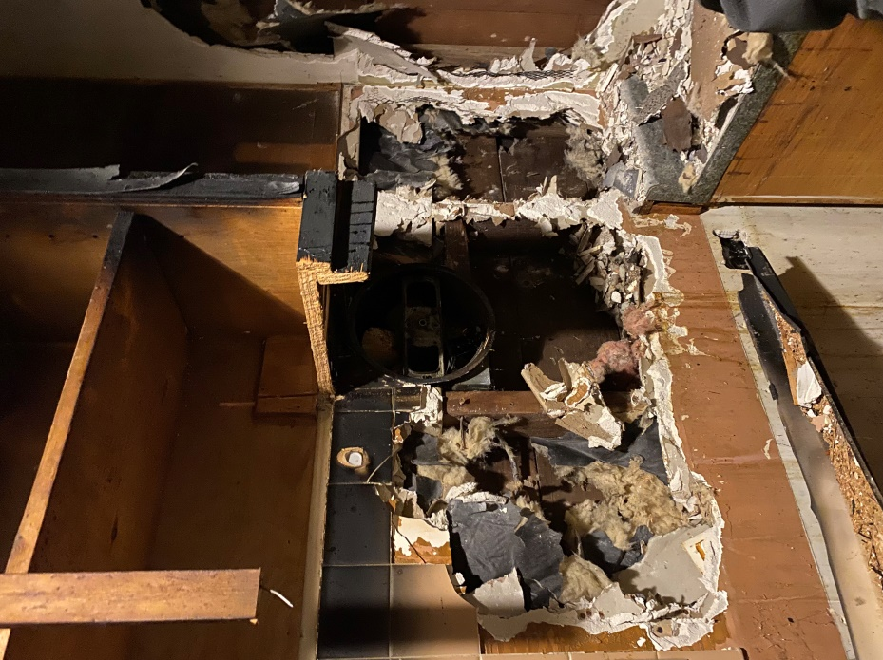 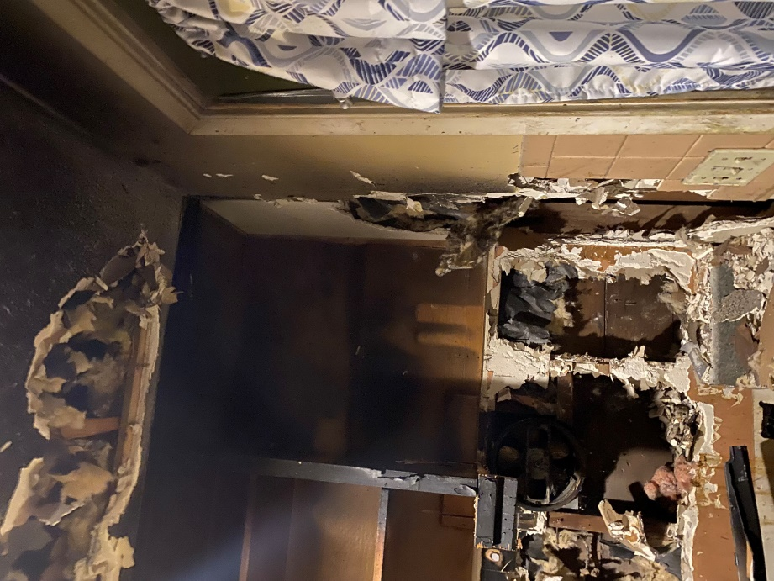

**Fire Prevention**

1. SAFE – We have entered into the season of station tours, pre-school visits and parades. You will see FF Sposato posting different events that he will need assistance with so please don’t hesitate to help out. This is a great opportunity for us as a department to get our safety message out there and make some kids very happy!

Stations

1. PSB UPDATE: The Town is contining to work through the cleanup and repair process from the water leak on 03/19. Insurance adjusters and contractors have been out throughout this week to start the demolition and repairs. We understand that this will be an inconvience over the next several weeks, but we thank you for your anticipated corperation and understanding throughout the process.
2. PSB Cameras- The Town received a grant in 2021 to make repairs and improvements to the PSB security cameras. Most of the cameras are original to the building (12 years old) and needed some updating. Contractors spent this week repairing/ adding some cameras to the apparatus bay. Over the next week or two, the contractor will be upgrading some of the exterior camers as well as updating the software program that runs the cameras.
3. Station 2 Annex- Earlier this week, when duties crews arrived at station 2 in the morning, they found the heating unit in the annex garage was malfunctioning. The Buildings and Ground crew was able to make repairs to this unit. Reminder as we get into nicer weather, shut off the heat on the warmer days. (no need to have the heat running when the garage is left open.)