*C:\Users\jhanna\AppData\Local\Microsoft\Windows\Temporary Internet Files\Content.IE5\LE4P6T6Z\MC900340286[1].wmf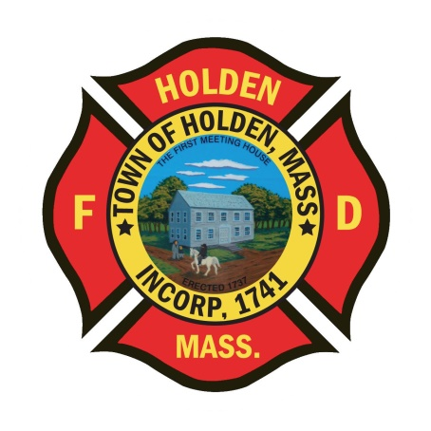* 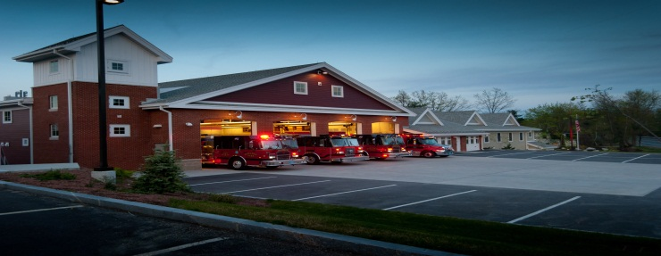

DEPARTMENT UPDATES

3/18/22 –3/25/22

**The Extinguisher**

Last night, we attended the Annual Mid-State Education Seminar held at the Manor in West Boylston. It was a great night of education with a presentation by Chief John Norman of FDNY. Chief Norman was in charge of Special Operations for FDNY and brings a great perspective to the fire service and leadership. The training was attended by over 160 firefighters from around Central Mass and it was great to get out and see everyone from the different departments after 2 years of cancelations.

We have placed the order with Greenwood EV for the new A4 which we will be purchasing with federal funding. This ambulance will be the identical spec as A3 with the exception of the chassis. We have purchased it with a Dodge Ram 5500 4X4, which will be new for our fleet. We were able to secure this chassis through Greenwood who had purchased 8 of them for demo units. By securing this chassis, we should see this new vehicle quicker than if we had to wait in line for a Ford, Chevy, International or Dodge. There are no chassis out there right now and no plans from the manufacturers on build dates for the 2023 models. As long as everything works out, we will be very lucky to have found this chassis.

I will be away on vacation from Tuesday 3/29 – Tuesday 4/5 with limited email/phone availability. Any issues please refer them to Deputy Smith.

**Personnel**

1. We have scheduled 2nd round interviews for the open positions on 3/28.
2. New Health Insurance – For those members who have health coverage through the town, the new plan will be HMO Blue. The final Zoom session is scheduled for 3/29 at 6pm. Zoom links can be found at holdenma.gov/town-manager/pages/2022-open-enrollment. If you can’t make the live session, here is the link for the recording of the session that was held earlier this week: <https://cabotrisk.zoom.us/rec/share/nJ3TRF_cxWC7fgxXTjUSPAR3DcoNgzqtV7kSRY3vsOfcbevYxrDoZpL-rEbdFZNf.ALwImL5g4Hg2d4aw> . Passcode: sAk%3+5i

Vehicles

1. A1 – Is being picked up at Greenwood as we speak. Group 4 has started cleaning the equipment that has been in the back of the station. Once back, it will be throroughly cleaned and stocked before being placed back in service.
2. E1 – We are still waiting on delivery of the Hurst tools to schedule the out of service time to outfit the new equipment.
3. Car 3 – Currently OOS with a transmission problem. Vehicle has been towed to a vendor for repair, hopefully back in a week or 2.

Operations

1. On Thursday 3/24, the department responded to 3 Seasons Drive for a structure fire. The building is a 2 story woodframe triplex condo building with no fire protection systems. Built in 2002, this structure does not have the fire barrier protection of similar buildings built under today’s uniformed building code. The fire was ignited by a torch used on plumbing and ran within the walls with heavy damage to the bathrooms in units 3 and 5. Walls needed to be opened on the second floor due to extension and there was a smoke condition throughout. While the unit of origin was being remodeled and was not occupied, the resident of unit 5 was displaced due to the damage. Just a reminder, the power for these buildings can be secured outside at the meters. There is a disconnect at each meter socket. This particular building the meters were located on the “D” side. We had a good response with E2, Tower 1 and A3 (responding from the City). We were also assisted by Rutland E1 on scene. Big thank you to Captain Connor who took much time to work with the displaced resident and get her situated with alternative arrangements.

**Fire Prevention**

1. SAFE – We have entered into the season of station tours, pre-school visits and parades. You will see FF Sposato posting different events that he will need assistance with so please don’t hesitate to help out. This is a great opportunity for us as a department to get our safety message out there and make some kids very happy!

Stations

1. As most of you are aware, we had a major water leak at the PSB on Saturday afternoon. The coil in the air handler for dispatch let go and created a flood in the dayroom and part of the administration area. We were lucky that someone was in the building as there were 2 ambulance calls going on at that time. The bulk of the damage is in the dayroom and includes the wall between the career office and the dayroom along with the floor, ceiling tiles and insulation around the duct work.

Servpro was brought in Saturday evening and they were able to dry out the majority of the wet areas to prevent any mold growth but the aforementioned wall and flooring will be removed and remediated. We are working with the insurance adjuster to assess the damage and get a cost for the repairs. We will keep you updated as we schedule work to be completed.