*C:\Users\jhanna\AppData\Local\Microsoft\Windows\Temporary Internet Files\Content.IE5\LE4P6T6Z\MC900340286[1].wmf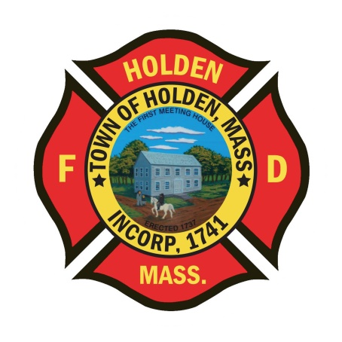* 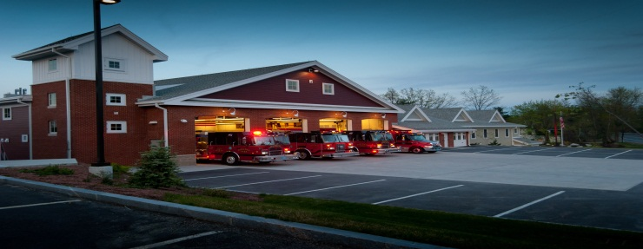

DEPARTMENT UPDATES

3/11/22 –3/18/22

**The Extinguisher**

As we head into spring, we have been working to get the forestry equipment ready to go. As of today, F1 and F2 are in-service for the upcoming brush season. Just a reminder that all forestry equipment has been updated to NST from the old Mass Forestry thread. This means that all of our hose and nozzles now have the same thread department wide.

The DCR Bureau of Forest Fire Control is up and running for 2022. Staffing began on 3/13 and runs through 11/5 with 48 seasonal firefighting staff statewide. As the snow on Wachusett recedes, the fire tower will be operational sooner rather than later.

The department hosted the D8 Regional Tech Rescue team for their quarterly training on 3/17. A confined space training prop was constructed in the station and the day long drill was a great success bringing together members from around the district. Thank you to all who worked to construct, dismantle the prop and help with the training.

**Personnel**

1. We have scheduled 1st round interviews for the open positions on 3/21, 3/22 with an anticipated 2nd round on 3/28.
2. New Health Insurance – For those members who have health coverage through the town, the new plan will be HMO Blue. Zoom sessions are scheduled for 3/22 at 10am and 3/29 at 6pm. Zoom links can be found at holdenma.gov/town-manager/pages/2022-open-enrollment.

Vehicles

1. A1 – No new updates
2. E1 – We are still waiting on delivery of the Hurst tools to schedule the out of service time to outfit the new equipment.
3. F2 – DPW installing the new air valve as of 3/18.
4. Car 3 – Currently OOS with a transmission problem. This issue will necessitate new transmission installation.

Equipment

1. We have tested some lengths of the new LDH and found that there is an issue between the outer and inner jackets. Deputy Smith is working with the vendor on the issue
2. We are still looking at options for new PPE. Globe is currently a 12 month wait for new gear as are many other vendors. We will be looking at some alternatives over the next few weeks to try and cut down the wait time for those who need a new primary set.

Operations

1. We did a walk through of the Jefferson Mill property on 3/11 with the contractors and property owners. Currently the main mill building is being converted into apartments on floors 2 and 3 with a parking garage on floor 1. The units have been framed out and rough electrical is beginning. The sprinkler system has been designed but not yet approved by the department. If responding there, a Knox box has been located on the pump house at Main Street and Village Way. The building is equipped with a fire alarm panel and heat detection. If there is a need for EMS during construction, there is no ramp access or elevator so plan accordingly for patient extrication.

**Fire Prevention**

1. Worcester Water Treatment Plant: They are having fire alarm notification issues with the panel. Portions of the system are not dialing out to the central station or the Worcester Fire Alarm box system. The plant will need to call by phone for alarms that don’t ring through.