*C:\Users\jhanna\AppData\Local\Microsoft\Windows\Temporary Internet Files\Content.IE5\LE4P6T6Z\MC900340286[1].wmf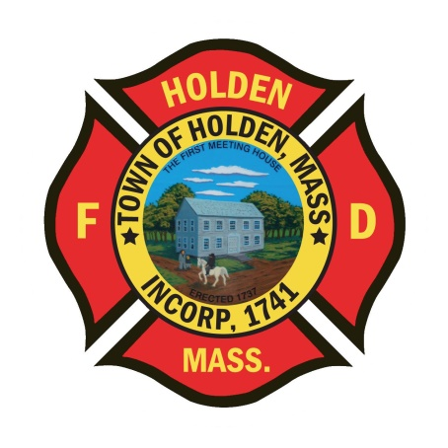* 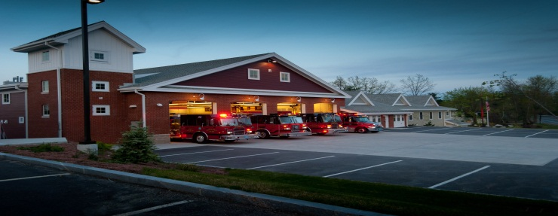

DEPARTMENT UPDATES

3/4/22 –3/11/22

**The Extinguisher**

It was great to see everyone who attended the department “Christmas in March” party on Tuesday. Fun time had by all, if you missed it, you missed a good time. The new Seven Saws facility is a great space for us to hold our event and the BBQ caterer did a fantastic job with the meal. Big thanks to Leah and Laura for setting everything up and pulling of a great night. Also thank you to Dave Chapin for the annual slide show, lots of laughs (some at my expense!).

We presented our annual budget to the Finance Committee on Wednesday evening this week. There were no surprises to speak of and it went very well. Overall the town is looking at a deficit of around $400,000. This is much better than the initial projections as the school budget was not as high as was thought. Biggest questions were vehicle acquisitions moving forward due to the long lead times with orders. We discussed the new ambulance we are working on with the federal funding along with our capital request to replace Car 3 and the looming replacement of Tower 1. It was a productive meeting overall.

**Personnel**

1. We have scheduled 1st round interviews for the open positions on 3/21, 3/22 with an anticipated 2nd round on 3/28.
2. Last week for this reminder: *The new light blue dress shirts for the Class A uniforms are in. Please see Deputy Smith to pick up your shirt. If you currently do not have a Department issued Class A uniform, please let Deputy Smith know.*
3. For the career staff – Prime Time vacation requests for the period 6/15-9/15 need to be submitted by Tuesday.
4. New Health Insurance – For those members who have health coverage through the town, the new plan will be HMO Blue. A fact sheet has been attached to everyones paystub this week. The town has put up a website to help you navigate the plans and compare what we currently have to the new plan. I would highly recommend attending one of the Zoom information sessions to get whatever questions you have answered by Blue Cross. In the Zoom sessions, you will also have the ability to setup a 1 on 1 session for personal questions.

Vehicles

1. A1 – We spoke with Greenwood and are projecting A1 to be back in 1-2 weeks. Once back, it will need extensive cleaning and is due for it’s OEMS inspection.
2. E1 – We are working to schedule some projects that need to be completed with E1. We will need to take it out of service to complete them, so watch your emails. The hosebed will undergo a configuration change and update in the hose load. We will be removing the hard cover and replacing it with a soft cover to mirror E2. The 4” hose will be reduced to 1200’ and we will add 2 ½ off the rear as well. This project will be in conjunction with the addition of the new hurst tools.
3. F2 – Deputy Smith and FF Johnson have been working to repair some minor issues and update some items to get it ready for the brush season.

Equipment

1. The department took delivery of the new 4” supply line. Currently we are in the process of numbering the lengths, visually inspecting them and testing some of the lengths to make sure there are no defects. Very soon, this hose will replace the Red 4” on all apparatus.
2. We are still awaiting delivery of our PPE from June/July. Globe is way behind in delivery. We have reached out to another Globe vendor to see if we can procure some gear quicker for those who need it.

Operations

1. We have been attending meetings with MSP regarding their EMS operations at their academy in New Braintree. For those who don’t know, MSP has a licensed ambulance service at the BLS level which is attached to their medical unit. We have entered into an intercept agreement with them to provide ALS service if necessary and also to respond mutual aid to their campus. HFD is a backup to the services that surround the academy but the intent is for them to transport any patients to UMass which puts us along their route for intercepts. If they do call, you will need to go to Worcester CMED and get a channel assigned so you can communicate with them directly. As this process evolves, further info will be provided by EMS Coordinator Naiman.