*C:\Users\jhanna\AppData\Local\Microsoft\Windows\Temporary Internet Files\Content.IE5\LE4P6T6Z\MC900340286[1].wmf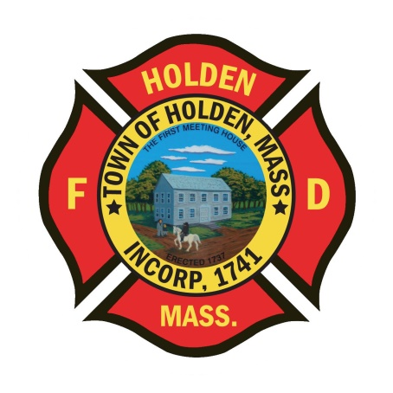* 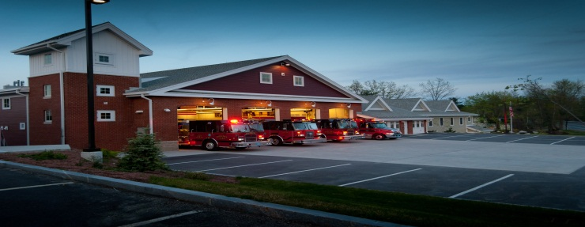

DEPARTMENT UPDATES

2/25/22 –3/4/22

**The Extinguisher**

This week, the Deputy and I attended the FCAM Professional Development Conference at the DCU center in Worcester. This was the first training conference held since early 2020 and it was good to get back out and do some professional development. This conference allows us to gain some training on national topics, network with Chief’s from around the state and also spend time with vendors and see products that could be of use by our department. We did spend time reviewing ambulance build specs and time frames along with reviewing the specs for multiple different gear vendors. The common theme that we found was the supply shortfalls that are plaguing our industry. Overall, it was a great experience to speak with people that are outside of our normal area and see where they are at since the pandemic began.

Reminder, the department St. Patrick’s Day Party is this Tuesday, 3/8 at Seven Saws. We have had a good response and look forward to seeing everyone for a good time and some fun.

There is still time to sign up for the Mid State Seminar at the Manor on March 24, please rsvp to Leah as soon as possible so we can pay for department members attending. Registration is due by 3/14 and is open to any HFD member. This program titled “Leadership on the Fireground will be presented by Chief John Norman from FDNY.

**Personnel**

1. Congratulations to Captain Bob Connor who has been appointed the new Fire Chief for the Town of Littleton. After an exhaustive process, Littleton made a great choice. We are sure that you will do great things for the department and the citizens of the Town of Littleton!
2. The department would like to congratulate FF Robert Mulvaney in his graduation from the Massachusetts Firefighting Academy Call/Volunteer Recruit Training Program. FF Mulvaney was also the recipient of the Martin McNamara Award for Outstanding Student for his exemplary practical skills during drills, his academics, and achievements during his time at the academy.

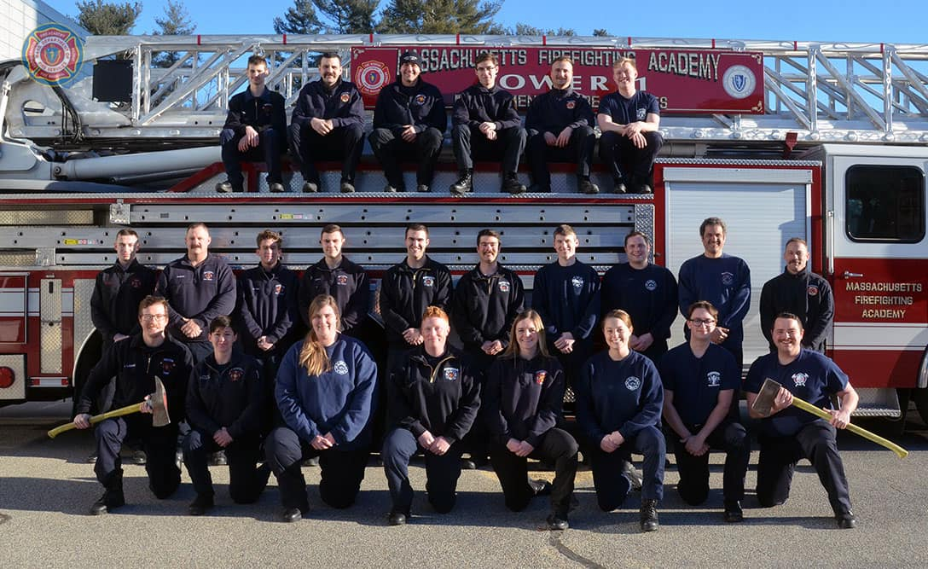

1. Currently, we have reviewed resumes for the soon to be opened position. We are working to schedule interviews soon.
2. If this is you, please make an effort to pick them up: *The new light blue dress shirts for the Class A uniforms are in. Please see Deputy Smith to pick up your shirt. If you currently do not have a Department issued Class A uniform, please let Deputy Smith know.*

Vehicles

1. A1 – Nothing new to report
2. New Ambulance project – Still in the process of working with Greenwood on the order. We have a line on a chassis that may be available, which would speed up the build process.

Equipment

1. *Status Update - No shippment of these items to date*. According to the vendors, both the LDH and the Hurst tools were scheduled to ship this week. Hopefully we will see some items arrive over the next week.
2. We looked at multiple gear vendors to see if we could speed up delivery time by moving to another brand. As of now, the decision has been made to stick with Globe as all of the manufacturers have similar delivery time frames of 9 months plus.

Operations

1. The department responded to 2 structure fires over the last week. The first was in town on Parker Ave in a 2 family home. Great work by operating companies to make a quick knockdown of a fire that originated in the dryer. The second was a mutual aid response to Sterling. This fire was in a brick colonial with fire on the first floor spreading to floor 2 and the attic. Just a reminder, when we respond to a fire, the need for firefighters to come in on the call back is important not only for the response but for coverage.
2. Training – We continue to schedule training for both call and career members. This is a very important part of the job of a firefighter, so please make every attempt to participate. If you are interested in taking any courses made available by the MFA, and have questions on how to sign up or need assistance with your LMA account, please contact me.