*C:\Users\jhanna\AppData\Local\Microsoft\Windows\Temporary Internet Files\Content.IE5\LE4P6T6Z\MC900340286[1].wmf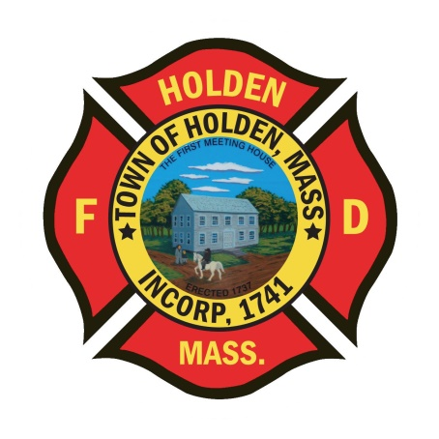* 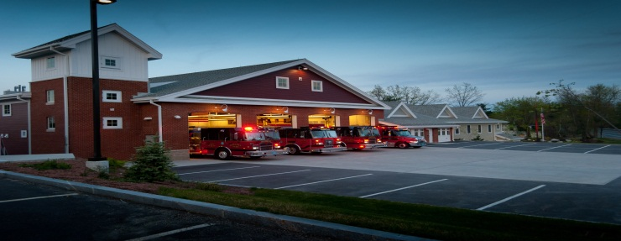

DEPARTMENT UPDATES

2/18/22 –2/25/22

**The Extinguisher**

We continue on a busy pace this year. As of this morning, we have responded to 440 calls, 93 higher than this point in 2021. The ambulance has been busy and we responded to a possible structure fire over the long weekend. On duty crews had the opportunity to do a walk- through of 100 Industrial Drive, Alexion Pharmaceuticals. This building is currently not occupied but is setup for drug experimental research and could be occupied at any time. It was good to get into this facility as when it was in operation, we were restricted in the areas we could access. This building is maze like, especially in the “clean” areas where the experiments were conducted. The fire alarm and sprinkler systems remain active and Johnson Controls is in the building every day ensuring all the systems are working properly.

The department St. Patrick’s Day Party is scheduled for 3/8 at Seven Saws. We have had a good response and look forward to seeing everyone now that the COVID surge has subsided. If you are interested in attending, please contact Leah as soon as possible, the headcount is due to the caterer by March 4. Should be a fun night with some great BBQ.

There is still time to sign up for the Mid State Seminar at the Manor on March 24, please rsvp to Leah as soon as possible so we can pay for department members attending. Registration is due by 3/14 and is open to any HFD member. This program titled “Leadership on the Fireground will be presented by Chief John Norman from FDNY.

**Personnel**

1. March 12 will mark the last day at HFD for Connor Lyons. He began his career here as part of the SAFER grant hiring and has been a great addition to the department. Connor is heading to Portland Maine to become a firefighter with the Portland Fire Department. We wish him a safe, successful and happy career in the Great White North.
2. Currently, we are reviewing resumes for the soon to be opened position. We hope to interview in early March and fill the position by April.
3. The SAFER grant that the department was awarded in 2019 has expired as of last week. The 3 year period went by very fast but it was a great success. With the funding, we hired 6 additional fulltime firefighters, staffed station 2 every day since July 1, 2019 and enhanced our response capabilities.
4. If this is you, please make an effort to pick them up: *The new light blue dress shirts for the Class A uniforms are in. Please see Deputy Smith to pick up your shirt. If you currently do not have a Department issued Class A uniform, please let Deputy Smith know.*

Vehicles

1. The Deputy and I went to Greenwood EV this week to get a look at the progress on A1. The body work is almost complete and it was in the paint booth when we saw it. We hope to have it back in service shortly.
2. New Ambulance project – Currently, we are working with Horton on a cost and order for the new ambulance. We are exploring options with vehicles that they already have in the production line which have a chassis assigned. Hopefully if we can go this route, the ambulance would be here quicker than anticipated.
3. We have started getting the Forestry units ready for the upcoming

season. Pumps have been checked and serviced along with any vehicle or equipment issues. The pumps are still winterized for now and we will revisit that when the outside temps warm up.

Equipment

1. According to the vendors, both the LDH and the Hurst tools were scheduled to ship this week. Hopefully we will see some items arrive over the next week.
2. The new headset communication systems for the apparatus have been ordered, no delivery or installation date has been given.
3. We anticipate delivery of some of the PPE ordered through Globe back in the spring/summer. Currently, the lead time on new gear is 12 months due to….you guessed it….supply chain issues. We will be looking at other brands and vendors to see if we can get some upcoming sets of gear quicker than 1 year.

Operations

1. On-duty crews have been working on the forestry equipment over the last week. We have decided to change our forestry hose, appliances and nozzles over to NST from Mass Forestry. This will make all of our hose and appliances throughout the department NST and allow for further compatibility. We tried to start this process 6 years ago and were meet with resistance. Since that time, even Mass DCR no longer uses the Mass Forestry thread, so now was the time to do the conversion once and for all. Thanks to Captain Connor for getting the adapters for the appliances and FF Rogers for working all week getting the equipment ready to go.