*C:\Users\jhanna\AppData\Local\Microsoft\Windows\Temporary Internet Files\Content.IE5\LE4P6T6Z\MC900340286[1].wmf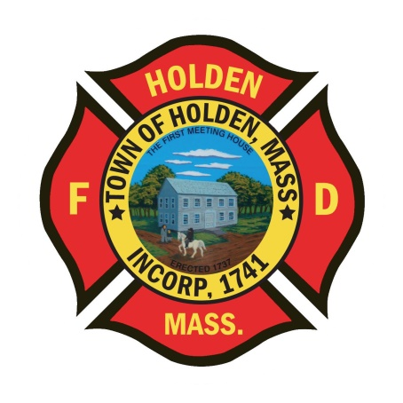* 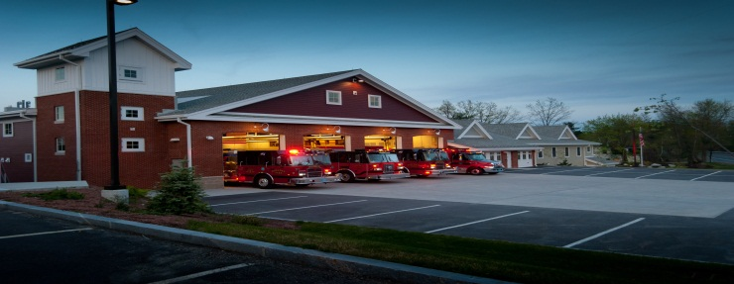

DEPARTMENT UPDATES

2/11/22 –2/18/22

**The Extinguisher**

Another week is in the books and it has been a little more normal call volume wise. The Town Manager presented his resource profile overview of the FY23 budget this week and the budget season has begun. The most important part of the FinCom meeting this week was their support of using federal funds to buy a new ambulance for the department. This will allow us to place an order for the vehicle early rather than wait until it appears on the capital plan in FY24. The build time for these vehicles is now out to around 450 days.

We have re-scheduled the department Christmas Party to 3/8 at Seven Saws. Please let Leah know if you are interested in attending so we can get a headcount before moving forward. Right now we have 10 signed up. If we don’t get more interest we will be forced to cancel it.

For those interested in the Mid State Seminar at the Manor on March 24, please rsvp to Leah as soon as possible so we can pay for department members attending. Registration is due by 3/14 and is open to any HFD member. This program titled “Leadership on the Fireground will be presented by Chief John Norman from FDNY.

Chief Norman is a veteran of over 40 years in the fire service; until his retirement in 2007, he served as Deputy Assistant Chief, Special Operations Command for FDNY. Chief Norman served as the Search and Rescue Manager for the World Trade Center terrorist attack on Sept. 11, 2001, and held a key role in rebuilding the Fire Department of New York in the following years. Chief Norman is the author of many well-known books, including *Fire Officer’s Handbook of Tactics*, *Fire Department Special Operations*, and his new book, *Working with Giants*.

**Personnel**

1. New Health Insurance – For those department members who are on the town insurance, we will be changing vendors to Blue Cross starting July 1. The Town Managers office is in the process of developing a website that will contain all of the information on the plans. You will be getting the information attached to your March 10 paycheck stub and that is the time the site will go live. Informational sessions will be scheduled via Zoom with BC/BS towards the end of March.
2. We have started to place orders for the new approved Jacket. This is the Game “Bravest” quilted jacket in Navy Blue. Anyone with interest needs to contact Leah for information.
3. The new light blue dress shirts for the Class A uniforms are in. Please see Deputy Smith to pick up your shirt. If you currently do not have a Department issued Class A uniform, please let Deputy Smith know.

Vehicles

1. As a reminder, any type of accident or incident with a department vehicle needs an incident report no matter how minor, kind of like this one:

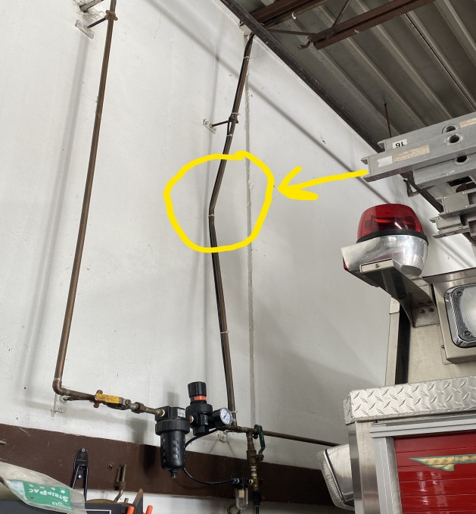

1. Ambulance 1 - remains at Greenwood for the remaining body work. Currently, it is in the body shop for paint and will still need some fabrication work prior to getting it back.
2. New Ambulance project – We are still moving forward with specifications and working to determine the best fit for the department.

Equipment

1. The new Hurst tools are scheduled to arrive on 2/24. These are earmarked to replace the current set of hydraulic tools on E1.
2. No update yet on the delivery time frame of the new LDH hose

Operations

1. 61 Woodland Road- The Department responded to a vehicle fire with extension to a deteached garage on 02/17. Luckily, quick water on the fire held the incident to a working fire assignment and limited the amount of damage to the garage. Mutual aid cover companies assisted both on scene and responded to other incidents in Town. During the last 3 fires we have responded to, either some or all of the on-duty crews were committed to other incidents when the calls were dispatched. It is important to come in for these incidents when you can, the duty crews are not always available.

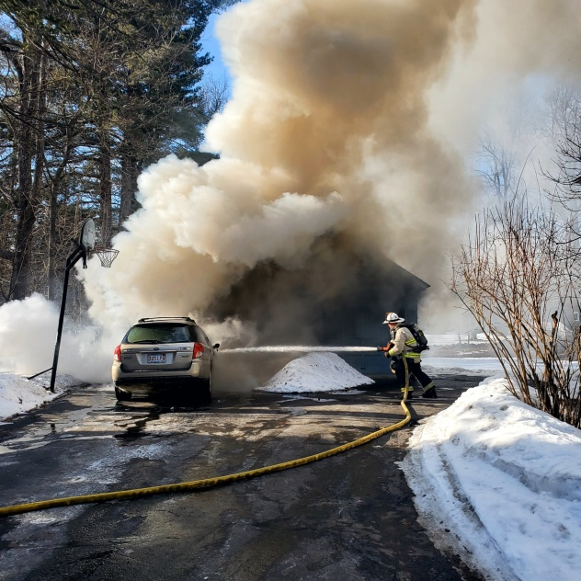 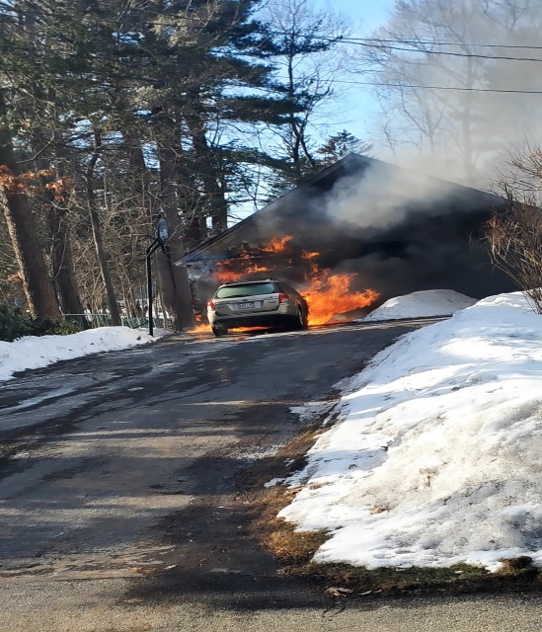

Stations

1. New rubber shower mats have been installed in the men’s locker room at HQ. These do not have cloth on them and can be easily cleaned if they start to get mold on them. Please do not throw them away as in the past, clean them as needed.
2. The oven and dishwasher were repaired Tuesday by Stasukelis Appliance and are fully functional.