*C:\Users\jhanna\AppData\Local\Microsoft\Windows\Temporary Internet Files\Content.IE5\LE4P6T6Z\MC900340286[1].wmf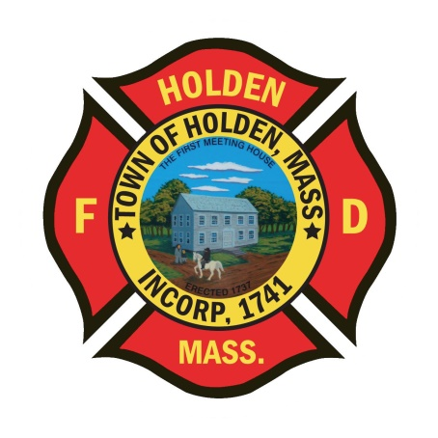* 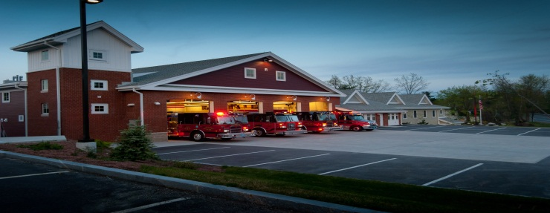

DEPARTMENT UPDATES

2/4/22 –2/11/22

**The Extinguisher**

Now that we are into February, I wanted to take a look back at the January numbers in total. For the month of January we responded to a total of 278 calls. For a comparison, the average of the same month in 2019, 2020 and 2021 was 197. During the month, we had a total of 24 All Calls and 5 recalls for EMS coverage. Great work by all during a very busy month.

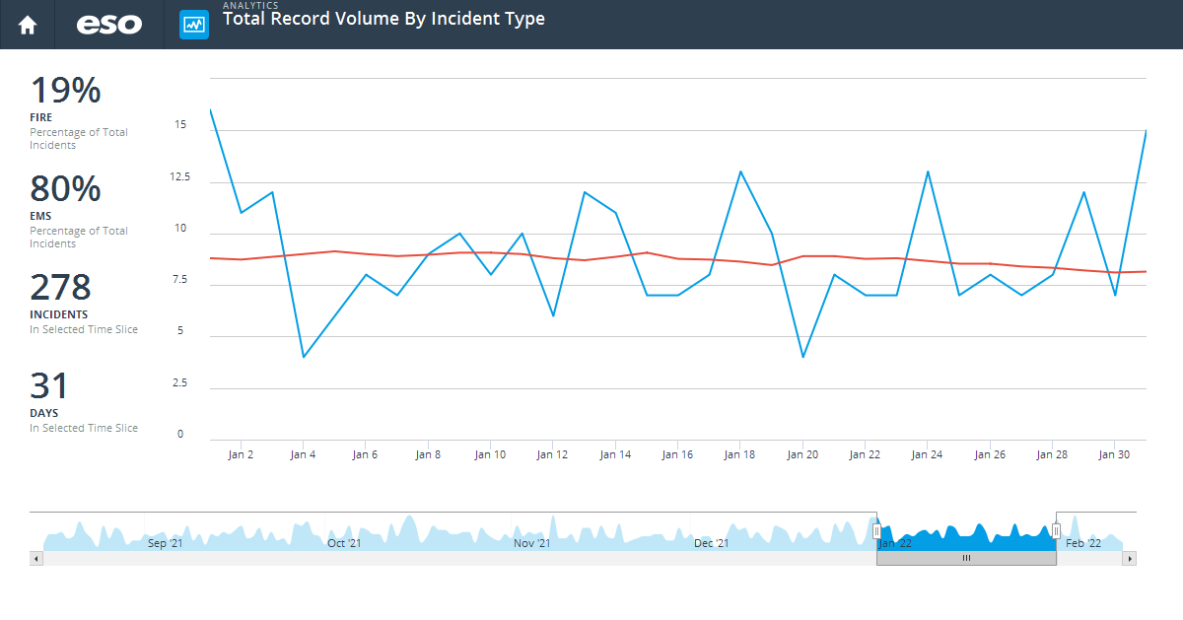

|  |  |  |  |  |  |  |  |
| --- | --- | --- | --- | --- | --- | --- | --- |
| Week Ending | 1/2/22 | 1/9/22 | 1/16/22 | 1/23/22 | 1/30/22 | 2/6/22 | Total |
| (11) Structure Fire |  |  | 1 | 2 | 2 |  | 5 |
| (16) Special outside fire |  |  |  |  |  | 1 | 1 |
| (32) Emergency medical service (EMS) incident | 23 | 48 | 54 | 43 | 46 | 9 | 223 |
| (42) Chemical release, reaction, or toxic condition | 1 | 1 | 1 | 1 |  |  | 4 |
| (50) Service call, other |  |  |  | 2 |  |  | 2 |
| (52) Water problem |  |  | 1 | 1 | 1 |  | 3 |
| (53) Smoke, odor problem |  |  | 1 |  |  |  | 1 |
| (55) Public service assistance | 1 |  | 1 |  | 3 | 1 | 6 |
| (57) Cover assignment, standby at fire station, move-up |  |  | 1 | 2 |  |  | 3 |
| (60) Good intent call, other |  |  |  |  | 2 | 2 | 4 |
| (61) Dispatched and canceled en route | 1 | 2 | 1 | 1 | 1 |  | 6 |
| (70) False alarm and false call, other |  |  |  |  | 1 |  | 1 |
| (73) System or detector malfunction | 1 | 1 |  | 2 | 3 | 1 | 8 |
| (74) Unintentional system/detector operation (no fire) |  | 4 |  | 2 | 3 | 1 | 10 |
| NULL |  |  |  | 1 |  |  | 1 |
| Total | 27 | 56 | 61 | 57 | 62 | 15 | 278 |

We are in the process of trying to plan the postponed department Christmas party for late March, early April. We are looking at a Tuesday training night so let Leah know if you are interested in attending so we can get a headcount before moving forward.

For those interested in the Mid State Seminar at the Manor on March 24, please rsvp to Leah as soon as possible so we can pay for department members attending. Registration is due by 3/14 and is open to any HFD member. This program titled “Leadership on the Fireground will be presented by Chief John Norman from FDNY.

Chief Norman is a veteran of over 40 years in the fire service; until his retirement in 2007, he served as Deputy Assistant Chief, Special Operations Command for FDNY. Chief Norman served as the Search and Rescue Manager for the World Trade Center terrorist attack on Sept. 11, 2001, and held a key role in rebuilding the Fire Department of New York in the following years. Chief Norman is the author of many well-known books, including *Fire Officer’s Handbook of Tactics*, *Fire Department Special Operations*, and his new book, *Working with Giants*.

**Personnel**

1. We have added a new jacket to the approved duty uniform list. This is the Game “Bravest” quilted jacket in Navy Blue. This item will have the department patch embroidered by Advanced Embroidery.
2. The new light blue dress shirts for the Class A uniforms are in. Please see Deputy Smith to pick up your shirt. If you currently do not have a Department issued Class A uniform, please let Deputy Smith know.

Vehicles

1. Engine 1 - was taken out of service on Thursday to begin outfitting it for the new edraulic Hurst tools that the department purchased with capital funds. The goal is to set this engine up to mirror E2 as much as possible. Group 1 started the process of running power to the R1-R3 cabinets for charging of the fan, Hurst tools and other battery operated items. A tool carousel, same as E2 will be installed in the R3 compartment after removal of the air reel and tank. Group 2 will be fabricating a new shelf for the rear compartment for the hydrant equipment and to setup that cabinet the same as E2.
2. Ambulance 1 - remains at Greenwood for the remaining body work, no timetable for it’s return as of now.
3. New Ambulance project – We have been reviewing pricing from ambulance vendors to gauge timeframes and costs for a new vehicle. Due to the shortage of chassis availability, the build time looks to be a minimum of at least 18 months. Pricing has also risen substantially since we purchased A1 in 2019/2020. Once we are able to secure a quote from whichever vendor we choose to go with, the ARPA federal funds process will be the next step prior to a purchase order going to the vendor.

Equipment

1. The new Hurst tools are scheduled to arrive on 2/24. These are earmarked to replace the current set of hydraulic tools on E1.
2. No update yet on the delivery time frame of the new LDH hose
3. Both new TIC’s have been installed in Engine 4 and Engine 3. Thank you to FF Chapin for his hard work on this project.

Operations

1. ECC Building – 156 Princeton Street: As most of you are aware, the former ECC building has been abandoned for the better part of 15 years. The town received funding from the legislature to do some environmental cleanup of the property. Part of the funding was to remove the overgrown vegetation and secure the doors and windows. This building is a prime target of trespassers and we have seen evidence of small fires set within the building. This building is a hazard and has had red “X” placards placed on it. The town is moving forward with more funding to demolish the barn that is on the property which is in disrepair.
2. 168 Princeton Street – This property is located just in front of the ECC building. It served as a 2-3 family rental occupancy into recently when the town took possession due to non payment of taxes. This building is vacant, has no water or electricity to it. If you happen to notice that it appears individuals are getting in, please notify us so we can alert HPD. The plan for this building going forward is demolition and clearance of the lot.
3. On Friday 2/4, Captain Pierce, FF/P Patch and FF Brady responded to a medical call for an unresponsive patient. The patient ultimately had a tension pneumothorax which caused severe respiratory distress and airway comprmise. Due to their care and quick actions during transport, the patient had a positive outcome and is doing well. This was great work by this group and further exemplifies the outstanding care we provide to the Town of Holden.

Stations

1. New rubber shower mats have been ordered for the men’s locker room at HQ. These do not have cloth on them and can be easily cleaned if they start to get mold on them. Once in place, please do not throw them away as in the past, clean them.
2. We are aware of the ongoing issues with the oven in the kitchen at HQ, Stasukelis Appliance is scheduled on Tuesday 2/15 to repair it.
3. During the week, the heating system in the Annex was found to be not operational. Renaud heating has been contacted and was working on the problem. Please try and check the building and make sure that the heat is on.
4. We met with a design firm this week to begin work on a feasbility study for the replacement of Station 2. The group toured the fire station and DPW along with the grounds to begin getting ideas toward a location to site a new building. This study is part of a MassWorks Grant that the town received for the Adams Road property redevelopment. This is the first step in the process.