*C:\Users\jhanna\AppData\Local\Microsoft\Windows\Temporary Internet Files\Content.IE5\LE4P6T6Z\MC900340286[1].wmf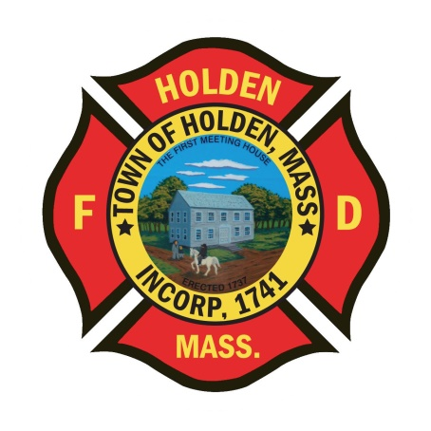* 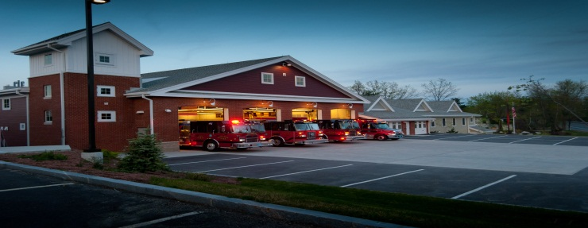

DEPARTMENT UPDATES

1/28/22 – 2/4/22

**The Extinguisher**

We seem to keep saying this every week, but call volume has been pretty high over the last week. As of this morning, we have responded to over 80 calls for service since last Friday. Some of the call highlights were the 3rd alarm response to Boylston for a structure fire, a large natural gas leak on Winfield and electrical issues at 8 Boyden. Ice rescue training was held Tuesday night at Unionville pond. Although the ice was 14” thick, we were able to make it work and had a very successful update on all the ice rescue procedures. Anyone who didn’t attend, please refresh yourself on where the ice rescue equipment is located and the proper procedures and techniques. Big thanks to Captain Connor and Group 2 for setting up the location and getting a large amount of ice out of the way so we could get in the water. Also thanks to LT Tupper for the laughs watching him put the ice chunks back in! For those interested in the Mid State Seminar at the Manor on March 24, please rsvp to Leah as soon as possible so we can pay for department members attending. This will be an excellent program and a free buffet meal!

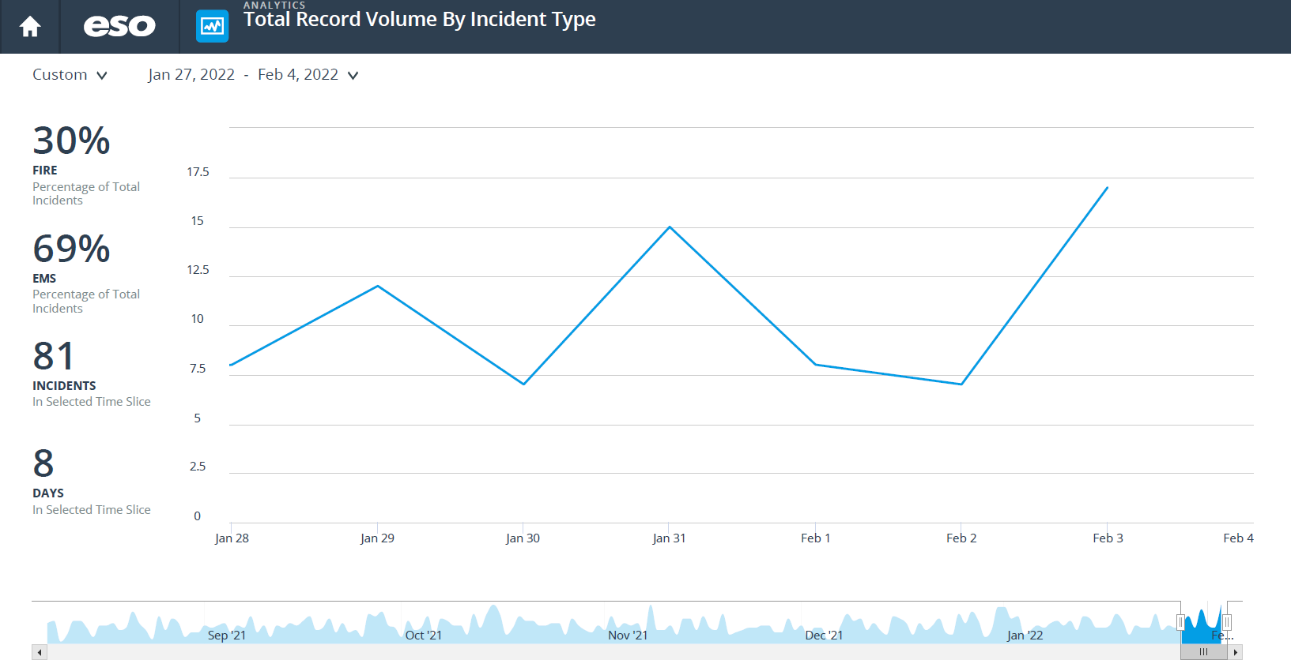

**Personnel**

1. The department has posted a full-time FF/Paramedic position. The intent is to establish a hiring list for anticipated open positions over the next 6 months.
2. For those members who have health insurance through the town and are aware that FCHP will cease to exist for us as of June 30, new plan info is coming. The town will be offering Blue Cross as a replacement and is working on putting the information for employees on a webpage that will be accessed through the town website. I will keep you posted when that is in place.
3. CORI Checks – All members who are checked off on the departments ambulances will need to fill out a CORI form. Leah will be placing them in your mailboxes, please return them as soon as possible. This is a requirement put in place by the state in 2017, that we process these annually.

Vehicles

1. Ambulance 1 – As of now, it is status quo. Work should have been completed by Rodman and now we wait for the Horton/Greenwood repairs.
2. Tower – We have identified needed service and repairs to the vehicle, some are routine maintenance and others are due to age and wear. We are working with the town to obtain the funding and we will be scheduling a time for it to be taken out of service and have the list of repairs completed. This will be similar to the minor refurb we did in 2016 but should not be as in depth.

Equipment

1. The new FLIR Thermal Imaging Cameras have been delivered. We are working on getting them installed.
2. For those that haven’t had a chance to look at these: New CO meters for the first in bags on the ambulances were put into service on 1/27. These alarm between 35ppm – 200ppm. For more info on the units go to this link: <https://sps.honeywell.com/us/en/products/safety/gas-and-flame-detection/portables/bw-clip-series>
3. Update – Deputy Chief Smith/LT Montiverdi have identified the vendor for this project and are working to secure quotes and place the order. *Part of the DFS grant equipment is purchase of headsets for communications inside the apparatus. These systems will allow occupants to communicate and hear much easier than the way it is now. We will be able to communicate inside the vehicle and the officer will be able to talk on the mobile radio too. Premliminary review of 2 systems has been started and hopefully we will order the necessary system soon.*

Operations

1. 8 Boyden Road:

We responded to 8 Boyden Road on Thursday evening for the smell of plastic burning. We had been there on Christmas for the same issue and found that one of the many electrical panels had arced and was damaged. The recent call found the same issue in the panel next to the one that was previously damaged. We utilized the wiring inspector and building inspector to work with HMLD and it was determined that power to the building needed to be removed until an electrician can repair the problem. Some interesting points:

1. The issue with the electrical panels was caused by water that was getting into the meter sockets on the “D” side of the building. Once the water was in, it was running along the bottom of the chase and into the wiring and electrical panels causing shorts in the service.
2. This building has a very strange layout and it would be confusing at best in a smoke filled environment. There are access issues as all apartments are not accessible through the main entrance on Boyden Road. The door on the “B” side is access for some apartments and for the basement. If ever entering the basement under hazardous conditions, there is only 1 egress and that is the stairway. There is no bulkhead or door in the basement itself.

Fire Prevention

1. We are continuing the changeover to Knox boxes from the old EAS boxes. We will be ordering about 20 more lock cores and that should get us close to having everything keyed to the new Knox keys. If the box has a blue dot sticker on the door, it has been changed to the new key.

Stations

1. B/G and Gary Kazmarek are working on some HVAC issues within the public safety building. There has been no interuption in our systems on the FD level.
2. The Oxygen Generator is having some mechanical issues. It keeps cutting out after only filling a small amount of bottles. Deputy Smith will be evaluating the issue.