*C:\Users\jhanna\AppData\Local\Microsoft\Windows\Temporary Internet Files\Content.IE5\LE4P6T6Z\MC900340286[1].wmf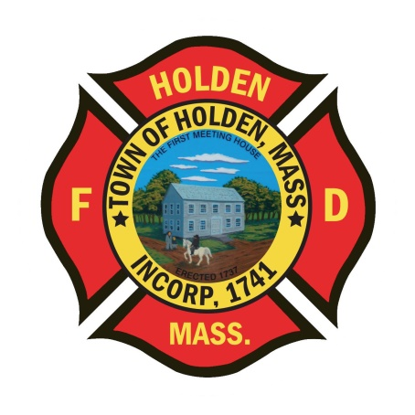* 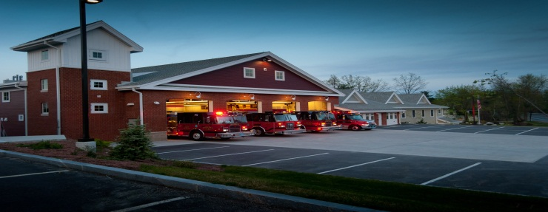

DEPARTMENT UPDATES

1/21/22 – 1/28/22

**The Extinguisher**

.

Another busy week is in the books for the HFD. Over the last week we have responded to a total of 58 calls for service as of this writing. It has also been a steady month so far for fire prevention with over 40 daily inspections completed. As the COVID uptick starts to decline, we are hoping to return to normal. Call training will resume in February and we will be looking at re-scheduling the Christmas Party. For those interested in the Mid State Seminar at the Manor in March, please rsvp to Leah as soon as possible so we can pay for department members attending. As we prepare for another snowstorm that is running up the coast at us for tomorrow, stay safe and be cautious when responding to incidents.

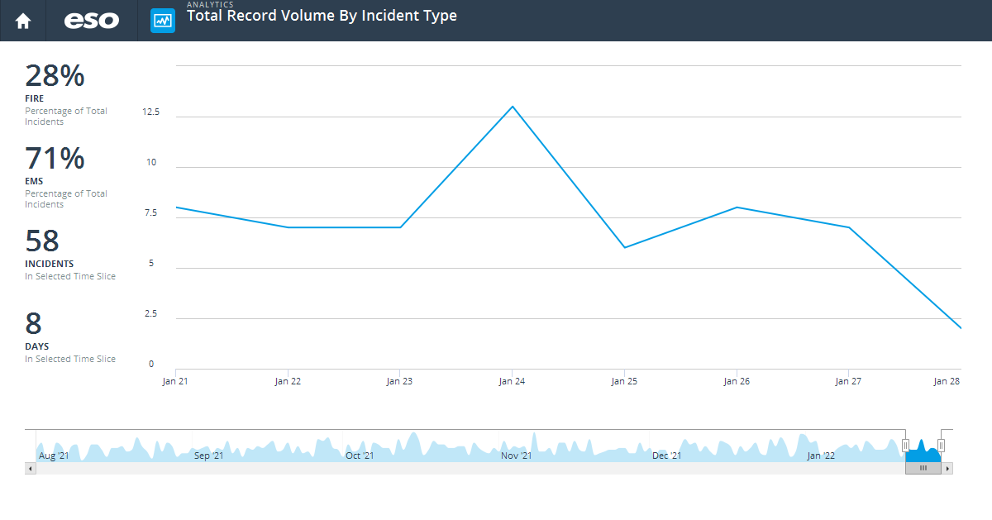

**Personnel**

1. The department would like to recognize FF Robert Walters for passing his NREMT Paramedic exam this week. Good luck and congratualtion on your new certification.
2. FF Chuck Borowy resigned as a call member of HFD just before the holidays. We wish Chuck well and also congratulate him and his wife Layla on the recent birth of their daughter Isabella.
3. FF John Bain resigned this week as a call member of HFD. He is a career member of the Northborough Fire Department and part time Paramedic with WEMS, so schedules just didn’t work out. We wish John well in his careers.

Vehicles

1. Ambulance 3 – Inverter repaired and back in service today. As of now, Greenwood has not reproduced the heat or door lock issue.
2. Ambulance 1 – Work is close to being completed by Rodman Ford and the vehicle will be returned to Greenwood for the Horton body repairs.
3. Engine 4 – When doing the weekly check, it was found to not build air pressure. DPW mechanics came to the station and were able to repair it with no issues. The findings was a faulty air valve.
4. Engine 1 – One of the outside rear tires needed replacement due to damage from curbs. Please use caution when parking near curbing or snow banks to avoid damage to the apparatus.
5. Ambulance 4??? – We have started working with the town to see if there is a possibility of using the American Rescue Act funding to purchase a new ambulance to add to the fleet. We have received intial approval from the Manager but still have some leg work to go. We will keep you updated on future progress.

Equipment

1. Order has been placed for the 2 new FLIR Thermal Imaging Cameras. Hopefully they will be delivered soon.
2. New CO meters for the first in bags on the ambulances were put into service on 1/27. These alarm between 35ppm – 200ppm. For more info on the units go to this link: <https://sps.honeywell.com/us/en/products/safety/gas-and-flame-detection/portables/bw-clip-series>
3. Part of the DFS grant equipment is purchase of headsets for communications inside the apparatus. These systems will allow occupants to communicate and hear much easier than the way it is now. We will be able to communicate inside the vehicle and the officer will be able to talk on the mobile radio too. Premliminary review of 2 systems has been started and hopefully we will order the necessary system soon.
4. We are awaiting many different equipment items that have been ordered but have long lead times. The department has ordered new 4” supply line, Hurst tools for E-1 and multiple sets of gear. We will update once we have an idea on delivery times.

Operations

1. Over the weekend we had a couple of calls at the same time which really stretched our coverage. Thanks to everyone who came in so we could get them covered.
2. 181 Princeton Street – Chimney Fire: Good work and great stop by all on this call. The condition of the home and chimney could have led to a catastrophic failure but crews were able to contain the fire to the area of origin so the homeowner could stay home. After the call, Captain Pierce provided smoke/CO detectors to the elderly resident. Just be aware on any subsequent calls to this address that the home is in disrepair and the chimney is unstable at best so use caution.
3. “1” Stonehouse Hill Road – Fire Alarm: We were called to this address for a fire alarm with dispatch verifing the address with the alarm company. Worcester responded mutual aid to the water treatment plant with no alarm found. Having dispatch call the alarm company back for an account name it was found to be Camp Kinneywood, which is the driveway just after the water treatment plant. If accessing this address with any apparatus, use caution anytime, but especially in the winter due to a narrow dirt road and ice. There is an occupied single family home there that is for the camp caretaker and it is 50 Stonehouse Hill. The monitoring company is American Alarm.

Training

1. We will be resuming Call Training on 2/1 and the topic is ice rescue. Good time of year to get out on the ice!
2. Career training will also be ice rescue and all groups should try and complete it over the next couple of weeks.

Fire Prevention

1. Shaw Dental has moved into the vacant space on the “AD” corner of floor 1 at 64 Boyden Road. If you are not familiar with the space, take a look at it. The keys for this space are in the Knox Box at the main entrance of Reliant.

Stations

1. There was a leak in the dispatch heating unit at HQ which caused a water problem in the dayroom over the weekend. DPW B/G made temporary repairs. This week Renaud Heating and Control Tech were scheduled to review the issues and come up with a fix for the problem. Thank you to Captain Poznanski for handling the issues and putting a dehumidifier in place to dry out the attic space.