Annual Firefighter Safety and Survival Seminar
Leadership on the Fireground
Thursday, January 13th, 2022
The Manor, 42 W. Boylston St., West Boylston, MA
Social Hour 6:00 pm, Dinner and Seminar to Follow
Presented by: Chief John Norman, Fire Department of New York
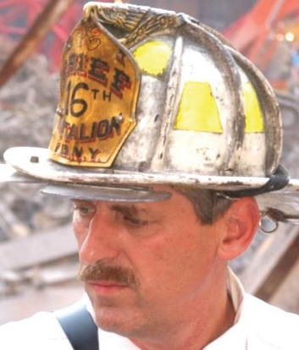
Chief Norman is a veteran of over 40 years in the fire service; until his retirement in 2007, he served as Deputy Assistant Chief, Special Operations Command for FDNY. Chief Norman served as the Search and Rescue Manager for the World Trade Center terrorist attack on Sept. 11, 2001, and held a key role in rebuilding the Fire Department of New York in the following years. Chief Norman is the author of many well-known books, including Fire Officer’s Handbook of Tactics, Fire Department Special Operations, and his new book, Working with Giants.
Cost: $25.00 per person
Payment can be made by Venmo at: @MAFireDistrict8
Or by check payable to: MA Fire District 8
Registration must be made by January 3rd. No payment will be accepted at the door.
For additional information contact: massfiredistrict8@gmail.com or jflanagan@boylston-ma.gov

