**COME CELEBRATE THE RETIREMENT OF CAPTAIN STEVE OBERG**

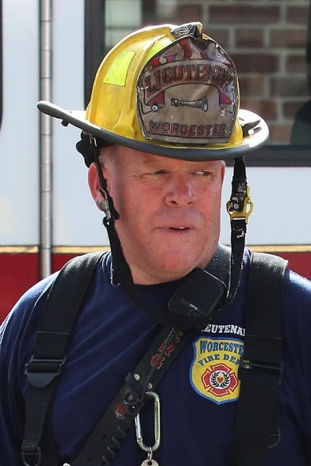

OCTOBER 21, 2021 AT THE KNIGHTS OF COLUMBUS 44 CIRCUIT AVE NORTH WORCESTER AT 6PM

**Tickets MARK CADY**

**508-335-0541**

ACTIVE $20 RETIREE $15