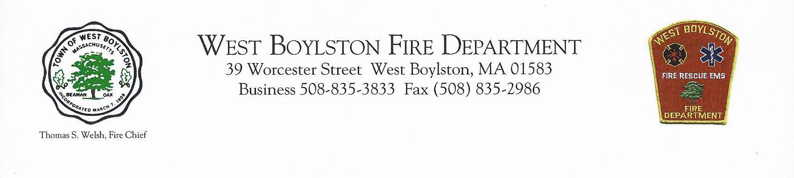

It is with deep regret the West Boylston Fire Department announces the death of Thomas J. Welsh, father of Fire Chief Thomas S. Welsh. Thomas J. Welsh was a member of the West Boylston Fire Department for 37 years.

The wake for Deputy Chief Thomas J. Welsh will be held Sunday April 7, 2019, from 3 pm to 6 pm, at Miles Funeral home, 100 Worcester Road, Sterling Mass. There will be a fire department walk thru at 2:45 pm.

The funeral will be held at Our Lady of Good Counsel Church, 111 Worcester Street, West Boylston, Mass, on Monday April 8th, at 10:00 am. Please keep the Welsh family in your thoughts and prayers!

Thank you.

Deputy Chief Mark Hopewell

West Boylston Fire Department