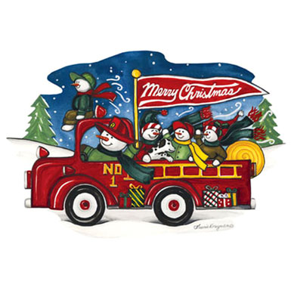

**YOU’RE INVITED!**

**Holden Fire Department**

**Christmas Party**

**Where:** Wong Dynasty Restaurant

**When:** Tuesday, December 18

**Time:** 6:30pm social hour - 7:00 dinner

Yankee Swap! Bring in a wrapped gift up to $25.

Wear your best or ugliest Christmas attire!

Department members- $20 & retired members- $5.00.

Pay Leah in advance, or pay at door.

RSVP at [lfwood@holdenma.gov](mailto:lfwood@holdenma.gov) or sign up at HQ.

|  |  |
| --- | --- |
| **Name** | **Yankee Swap (yes/no)** |
|  |  |
|  |  |
|  |  |
|  |  |
|  |  |
|  |  |
|  |  |
|  |  |
|  |  |
|  |  |
|  |  |
|  |  |
|  |  |