**Holden Fire Department**

**February 21 Training Advisory- SCBA (Scott AP-75) 4500psi**

Hello all,

Sorry for the delay. My hope is to have this put out 2 weeks prior to training to give everyone plenty of time to prepare. This month is pretty straight forward but here are a couple of pointers to get you prepared.

Know your air pack, it is your lifeline in IDLH conditions. We use mostly SCOTT AP-75 with AV-3000 masks with the exception of the ambulances and cars. All trucks have 45 min 4500 PSI bottles. Remember, bottles must be 90% to full (4050 PSI) to be considered “In Service”. Anything less than 90% (4050 PSI) could mean life or death for you or whoever puts the pack on next. Make sure to always leave the pack ready to go. Know the components, where they’re located and how they work.

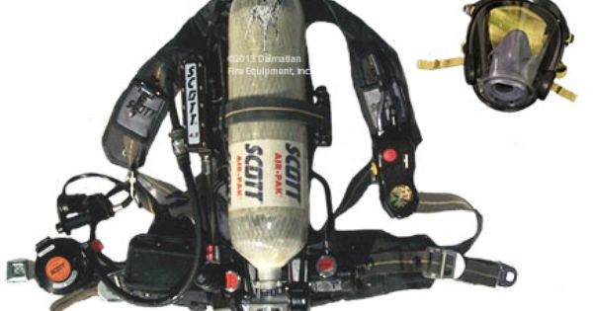

Here is a link to a quick video to help you get prepared.

<https://www.youtube.com/watch?v=M1IepUPnYkY>

I have attached a copy of the outline for your viewing pleasure.

Finally, all members please be at HQ by 1930 for a meeting that 14C set up. Chaffins please make all efforts to get on the road early so we can get out a reasonable time.

Any questions, complaints or comments please feel free to give me a call, 774-287-5318. If you’re not planning on attending, please email me.

Thank you,

Josh