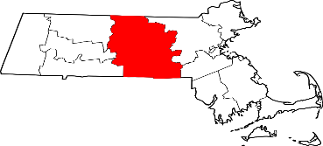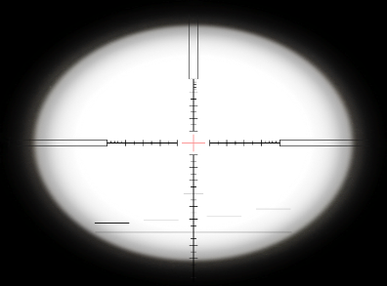

**Central Shield**

**2016**

**Volunteers**

Volunteer “victims” are needed for this exercise! Please contact John Broach at [john.broach@umassmemorial.org](mailto:john.broach@umassmemorial.org) and Judy Verdini at [Judith.Verdini@umassmed.edufor](mailto:Judith.Verdini@umassmed.edufor) more information or to volunteer.

**Benefits:**

**Up to 8 hours of OEMS credit**

**Free parking**

**Breakfast and lunch included**

**Executive Summary**

An MCI in a metropolitan area has the potential to place significant strain on local emergency preparedness and response infrastructure in both the pre-hospital and in-hospital environments. A large scale exercise focused on interoperability of the several relevant response agencies within the city of Worcester and the surrounding region is considered an important step to ensure a robust and effective response to a large scale, multi-casualty event. In addition, such an exercise will also provide an opportunity to conduct scientific research focused on MCI best practices.

On September 20th, 2016, an MCI with approximately 200 victims will be simulated in the city of Worcester. First response agencies will establish Incident Command and CMED will provide communications capability to augment the response. Live actors will portray victims and will be triaged on scene according to usual practice. A number of these “victims” will be transported to the three Worcester hospitals where in hospital MCI management will be exercised.

To support the dual objectives of an operational exercise and a research platform, the MCI exercise will be divided into two phases. The first phase, the *MCI Lab*, will focus on providing a platform for training. In the morning of the exercise day, “victims” will be on scene at the venue and between 7am and noon, they will assist in various MCI training protocols. At noon, a break will occur and the volunteer victims will be organized to prepare for the operation phase. At 1pm the *MCI Exercise* will begin and will continue until the operational goals of the exercise are met and Incident Command is stood down.

After the exercise is complete, each participating agency will be encouraged to perform its own After Action Report (AAR) and subsequent to this an interagency AAR will be conducted to identify areas for continued improvement of response capabilities.

**Overall Goals**

1. Exercise and Assess the capability of the Central Massachusetts Region to respond effectively to a mass casualty incident (MCI)
2. Exercise and assess communications interoperability within Central Massachusetts and among response agencies
3. Exercise and Assess key elements of the City of Worcester’s LEPC Emergency Response Plan
4. Exercise and assess the activation of the RMCC and notification of regional resources required to support the management of an MCI
5. Exercise and assess the hospital response to receiving large number of casualties from an MCI
6. Conduct MCI management related research to better understand effectiveness of various triage and scene management techniques and technologies

**Participating Agencies**

Massachusetts Central Region Homeland Security Council

Worcester Emergency Medical Services

Worcester Fire Department

Worcester Police Department

Worcester Division of Public Health

Worcester Emergency Management

MA Region 2 CMED

UMass Memorial Medical Center University Campus

UMass Memorial Medical Center Memorial Campus

St. Vincent Hospital

UMass Emergency Medicine Division of Emergency Medical Services

UMass Emergency Medicine Division of Disaster Management and Emergency Preparedness

MedStar Ambulance

Vital Emergency Medical Services

Boylston Fire Department

West Boylston Fire Department

Clinton Fire Department