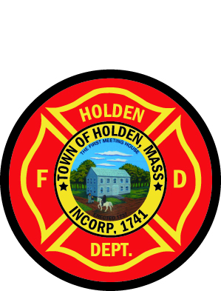
HOLDEN FIREFIGHTERS MUTUAL AID BALL
Friday, March 18, 2016






The Manor Banquet Facility
42 West Boylston Street, West Boylston
6:30pm- Hors D’oeuvres & Cocktails
7:15pm – 4 Course Seated Dinner

Fire Department Personnel – Class A or Suit & Tie
Guests – Semi Formal/Formal

$45/Person - $90/Couple
TICKET Purchase Deadline: March 4, 2016
----------------------------------------------------------------
Ticket

NAME:_________________# OF ATTENDEES_____
Mediterranean Chicken___ Prime Rib___ Baked Haddock___
IF PAYING BY CHECK, MAKE CHECK PAYABLE TO: HEIDI McALICE
Mail Payment and Food Selection to:
Attn: Heidi McAlice
Holden Fire Dept. 1370 Main Street, Holden, MA 01520

