*C:\Users\jhanna\AppData\Local\Microsoft\Windows\Temporary Internet Files\Content.IE5\LE4P6T6Z\MC900340286[1].wmf* 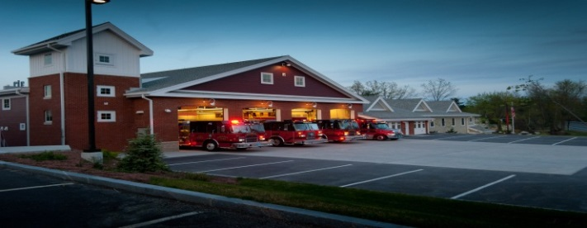

**The Extinguisher**

MAY/JUNE 2015

**A Publication of the Holden Fire Department**

1370 Main Street, Holden, Ma 01520.  (508)210-5650.

# Chief’s News

# by Chief Jack Chandler

Newsletter Editor  
Ethan Naiman

**DEPARTMENT SCHEDULE**

**5/5/15** – E4 Hose Testing – **1830**

**5/19/15** – Mandatory Ladder Drill – **1830**

**5/25/15** – Memorial Day – **Offices closed**

**5/26/15** – EMS Training – **1830**

**6/2/15** – MFA Impact Course – **1830**

**6/16/15** – MIIA Driver Training – **1830**

**6/22/15** – M&M Rounds – **1000**

**06/23/15** – EMS Training – **1830**

****The Department paid tribute to yet another long time member this spring when Rich DeWitt passed away in April. Rich was a 43 year member of the Holden Fore Department and served as a Lieutenant for about ten of those years. For the past eight years, (even after his retirement) Rich was always the water guy. Not only did he know the town water system better than anyone else, he also knew every brook, stream, pond and reservoir in Holden.

I would like to thank everyone who came out for Rich’s services both at Miles and at the Chaffins Congregational Church.

Brush season is officially here so please make sure your brush gear is already to go! Remember that structural gear is not to be used as it will damage the gear and unnecessarily fatigue the firefighter!

A big thank you to Paul Pierce, Bob Connor and everyone else who has helped with the Firefighter I/II class! It has been going very and I was impressed to see the recruits go through the maze prop with little difficulty!

Opticom is coming soon! The electrical components are all here and we are just waiting for a permit from the State DOT before we begin installation. I hope that it will be up and running by the end of May. We will begin a public awareness campaign in the Landmark in the near future.

Please respond to every call that you are available for! We are still struggling with low turnout numbers for calls so please respond to your respective station.

**EMS Update**

by EMS Coordinator David Russo

We have taken delivery of the new “A2”, and should be in service within a couple weeks. I have attached updated photos for your review.

We have also purchased two new Stryker Power cots and stair-chairs to replace the Ferno cots and stair-chairs. We will have an in-service training on the new equipment, which will be taught by Stryker representatives. I will notify every one of the date and time of that in-service in the following weeks.

May 13th, we have CPR refresher for all CERT staff start time 19:00 hrs, in the downstairs training room.

The August 25th inter-facility transfer class and ALS/BLS interface class is being moved to June 23rd, starting at 18:30hrs. This is a Mandatory class for all Paramedics & EMT’s who have not yet taken the class this year.

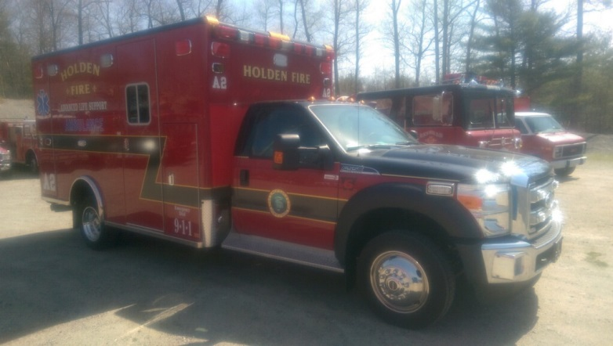

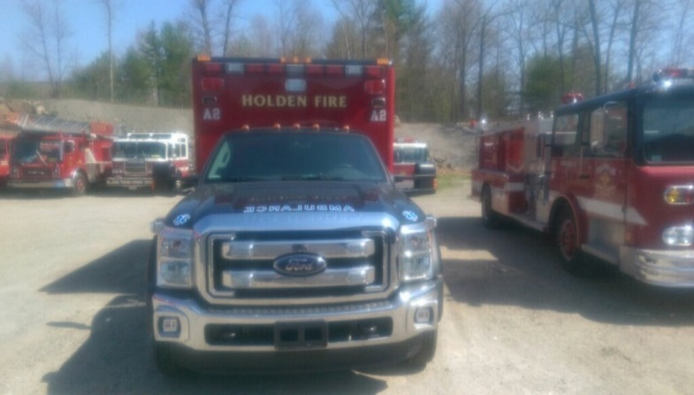

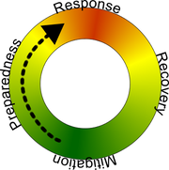Emergency Management News

by Emergency Management Coordinator Chris Montiverdi

Finally, spring had sprung and we can say goodbye to the cold weather and snow, for at least a few months!! Only 180 days until the official start of winter….

On April 13, 2015, the President declared a Federal disaster in Massachusetts for the January 26-28 blizzard allowing the affected communities the ability to seek reimbursement for some costs related to storm response and clean up. The town is currently collecting all the necessary expense paperwork to submit to FEMA for reimbursement. Typically, the federal government will reimburse the communities 75% of allowable reimbursements.

On April 27th, the Fire Department participated in a functional exercise at Wachusett Extended Care. The exercise simulated the evacuation of 10 ventilator dependent residents to other facilities in the region that could care for the patients. Wachusett Extended Care, like most of the Long Term Care facilities in Worcester County, belong to MassMAP. MassMAP is a mutual aid plan for healthcare facilities which includes a listing of skilled facilities, contact names and numbers, bed counts and equipment resources that can be requested during an incident. Any facility belonging to MassMAP will have a copy of this plan. In the event of an incident, if the facility does not have the plan, Central Ma EMS Corp (CMED) can be called to activate the plan and coordinate the resources.

With the arrival of the summer months, comes the threat of severe weather, including severe thunderstorms, flash flooding. lightening and tornadoes. Although tornadoes in Worcester County are rare, they do happen when conditions are right. Below is a map which shows some of the tornadoes that have occurred over the past 50 years.

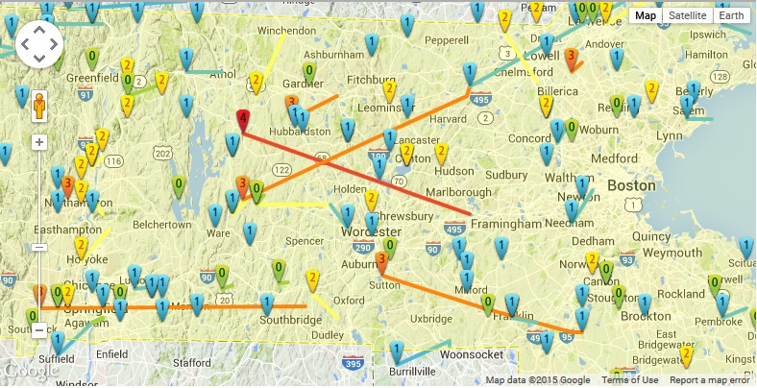

Here are some severe weather facts and preparedness tips from MEMA:

**Thunderstorms, Lightning & Severe Weather**

Every thunderstorm produces lightning and has the potential to produce associated dangers such as tornadoes, destructive winds, hail and flash flooding. Of the estimated 100,000 thunderstorms each year in the U.S., about 10% are classified as severe, meaning it produces hail, at least ¾" in diameter, has winds of 58 mph or higher, or produces a tornado.

***Thunderstorms***

**Severe Thunderstorm Watch** - Tells where and when severe thunderstorms are likely to occur. Watch the sky and stay tuned to the Media.

**Severe Thunderstorm Warning** - Issued when severe weather has been reported by spotters or indicated on radar. Warnings indicate imminent danger to life and property to those in the path of the storm.

* Before a thunderstorm strikes, keep an eye on the sky. Look for darkening skies, flashes of light, or increasing wind.
* Thunderstorms can occur singly, in clusters or in lines. The typical thunderstorm is 15 miles in diameter, producing heavy rain for a brief period from 30 to 60 minutes.
* When a thunderstorm approaches, secure outdoor objects that could be blown away or cause damage. Shutter windows, if possible, and secure outside doors.
* If you can hear thunder, you are close enough to the storm to be affected by lightning, and should go inside to safe shelter immediately.
* Remember that lightning can strike up to 10 miles ahead of or after the arrival of the storm. Listen to weather forecasts on NOAA Weather Radio, or to local radio and television stations for the latest information. Lightning kills an average of 73 people in this country annually, more than tornadoes or hurricanes. In general, lightning will travel the easiest route from the clouds to the ground, which means it often strikes the tallest object.
* During this season people are taking part in activities that place them in locations most vulnerable to being struck by lightning, such as on golf courses, ball fields, beaches and large bodies of water. In the U.S., an average of 300 people are injured and 80 killed each year by lightning.
* If you are caught outside during a thunderstorm, you should protect yourself from lightning by going to a low-lying, open place away from trees, poles or metal object, which can serve as a natural lightning rod.
* Make yourself the smallest target possible by squatting low to the ground and by placing your hands on your knees with your head between them. Be as low to the ground as possible, with as little of your body touching the ground as possible. (Don't lie flat; this will make you a larger target!).
* Do not stand on a hilltop, in an open field, on a beach or in a boat on the water.
* If boating, or swimming, get to land immediately.
* Avoid isolated sheds or small structures in open areas.
* Get away from anything metal such as tractors, farm equipment, motorcycles, golf carts, golf clubs, bicycles, wire fences, clotheslines, metal pipes, rails, and other metallic paths that could carry lightning to you from a distance.
* In a forest, seek shelter in a low area under a growth of smaller trees.
* If indoors, avoid metallic objects and fixtures.
* Avoid showering or bathing. Plumbing and bathroom fixtures can conduct electricity.
* Avoid using a corded telephone, except for emergencies. Cordless or cellular telephones are safe to use.
* Unplug appliances and other electrical items such as computers. Turn off air conditioners. Power surges from lightning can cause serious damage.

***Tornadoes***

**Tornado Watch** - Tornadoes are possible. Remain alert for approaching storms. Listen to the Media for updates.  
**Tornado Warning** - A tornado has been sited or indicated by weather radar. Take shelter immediately.

* Purchase a NOAA Weather Radio with a battery backup and tone-alert feature, as well as a battery-powered commercial radio and extra batteries.
* Download the free *Massachusetts Alerts* app to your Smartphone to receive important weather alerts and emergency messages from MEMA.  Easy instructions are available at [www.mass.gov/mema/mobileappp](http://www.mass.gov/mema/mobileappp)
* Determine locations to seek shelter, such as a basement or storm cellar. If an underground location is not available, identify an interior room or hallway on the lowest floor.
* Practice going to your shelter with your household.
* Know locations of designated shelters in places where your family spends time such as public buildings, nursing homes, shopping centers and schools.
* Assemble your family's Disaster Supply Kit

**During a Tornado Watch**

* Listen to NOAA Weather Radio or commercial Media for updates.
* Be alert for approaching storm, particularly revolving funnel-shaped cloud. Other tornado danger signs include a dark, almost greenish sky; large hail; a large, dark, low-lying cloud; or a loud roar, similar to a freight train.
* Be warned that sometimes tornadoes develop so rapidly; there is no visible advanced warning.
* Avoid places with wide-span roofs such as an auditorium, cafeteria, supermarket or shopping mall.
* Be prepared to take shelter immediately.

**During a Tornado Warning**

* In a residence or small building, move to a pre-designated shelter, such as a basement or storm cellar. If there is none, go to an interior room on the lower level (Closet, interior hallway). Put as many walls as possible between you and the outside. Get under a sturdy table and use your arms to cover your head and neck.
* Do not open windows. Use the time to seek shelter.
* Go to the center of the room, avoiding the corners, which attract debris.
* In large public buildings, go to predetermined shelter areas. Interior hallways on the lowest floor are usually safest. Stay away from windows and open spaces.
* In a high-rise building, go to a small interior room or hallway on the lowest possible floor.
* Get out of vehicles, trailers and mobile homes immediately and go to the lowest floor of a sturdy nearby building. Never try to outrun a tornado in a congested area.
* If caught outside with no shelter, lie flat in a nearby ditch or depression and cover your head with your hands. Be aware of the potential of flooding.
* Do not go under a bridge or overpass. You are safer in a low, flat location.
* Watch out for flying debris from tornadoes, the cause of most fatalities and injuries.



**Administration News**

by Leah Francese-Wood

**May Anniversaries**

Amanda Beahn – 3 years

Brian Carlson – 3 years

David Chapin – 14 years

Scott Charbonneau – 38 years

Dan Hazen – 7 years

Ethan Naiman – 1 Year

Adam Parslow – 3 Years

Brian Rushlow – 7 Years

Rick McGinn – 6 years

**June Anniversaries**

Matthew Benoit – 23 years

Kevin Harmon – 4 years

Adam Hickey – 11 years

Mark Ponte – 6 years

**From The Deputies Desk**

by Deputy Chief Peter W. Bergstrom

2014 Call Firefighter response percentages have been completed. I will try to notify everyone by email their response numbers for 2015. For 2014 there were 236 calls toned out for Call FF’s and 22 Department training sessions. The requested goals are 25% response to toned calls and 70% attendance to training. We did have a number of Call Firefighters who met these goals.

As we enter the summer months, many people will be away and on vacation at various times. Please respond whenever you are available.

The current Recruit Firefighters are continuing in the in-house FFI/II class. We have received a few new applications for Call FF positions and will review those in the next month or two.

Mass Call/Vol. Firefighters Association dues for 2015 are now due. Anyone interested please see me. Dues are $15.00 again this year. I will need them by June 16th. If you are not familiar with the Mass Call Association, I’ll be glad to explain the organization and what they have to offer. You can also visit their web page at www.mcvfa.org.

Mark your calendar for the Annual Holden Association of Firefighters Golf Tournament. This year’s tournament will be held Saturday, August 29th, at Holden Hills. Open to everyone so pass the word to family and friends.

Thank You again to all Members who assisted at the calling hours and funeral for both Jim and Rich. I worked closely with both of them during my time on Holden Fire. I’ll take away the lessons I learned from each of them and remember the times spent firefighting and socializing.

**EXPLORER POST 2012 NEWS!**

by Dave Eddy

No news for May/June submitted



**The C.E.R.T. Spot**

by Rebecca Evanoff

We have 4 new members who have completed the basic training for CERT; Richard Clark, Renee` Marion, Alicynn Wilson and Kimberley Greene.

May is severe weather awareness and the national “PrepareAthon!” campaign (flyer below)

**May 14th** CPR/AED recertification for the team.

**May 26th** Holden CERT is hosting a National Weather Service SKYWARN program in the training room.

The session, part of the Weather Service’s SKYWARN program, is open to anyone over 16 years old at no charge. Amateur radio operators, emergency managers, police, fire, and other first responders are encouraged to attend. Anyone who stays to complete the training will be able to become trained NWS weather spotters who can help provide essential information for all types of weather hazards, including identifying and describing severe local storms for the NWS.

 The training session includes a two-and-a-half hour computer-based presentation which discusses thunderstorm development, the criteria for “severe” thunderstorms, as well as the cloud features associated with severe thunderstorms and tornados. Additional information will be presented about winter storms and proper snow measurement; river, stream, and urban flood reporting; and rainfall measurements. The session will also present the procedure for reporting weather information to the National Weather Service. Safety procedures for the various forms of severe summer weather, winter storms, and flooding will also be covered in the training session.

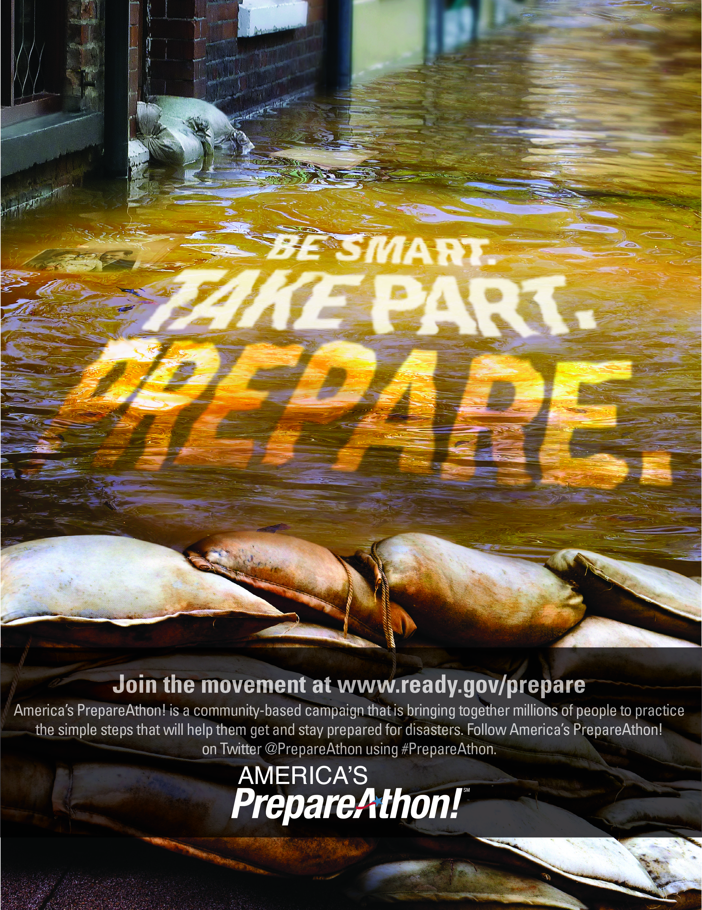

**Department Pictures**



(Rich Dewitt, above)

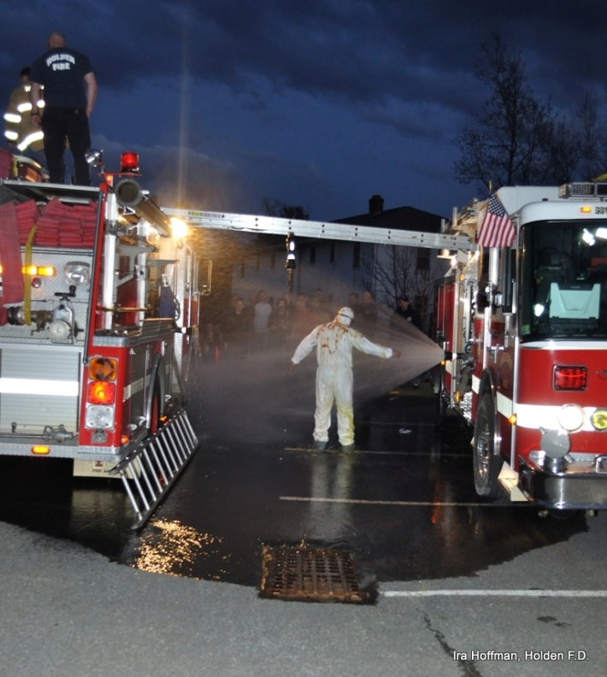

(Decon Training, Above, Photo by Ira Hoffman)

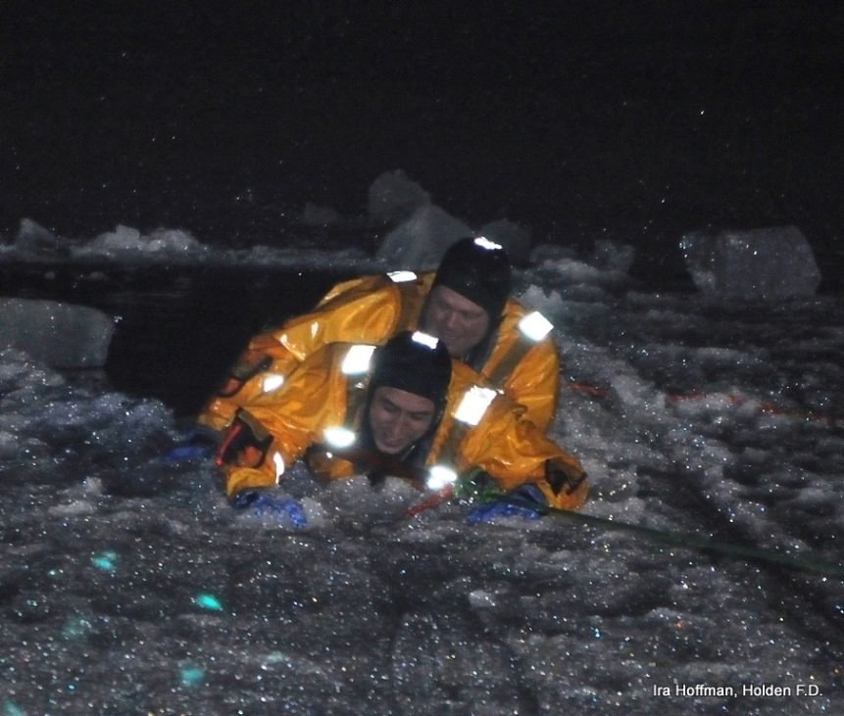

(Ice Rescue Training, FF Tyke Lothrop and Lt. David Chapin, above, Photo by Ira Hoffman)

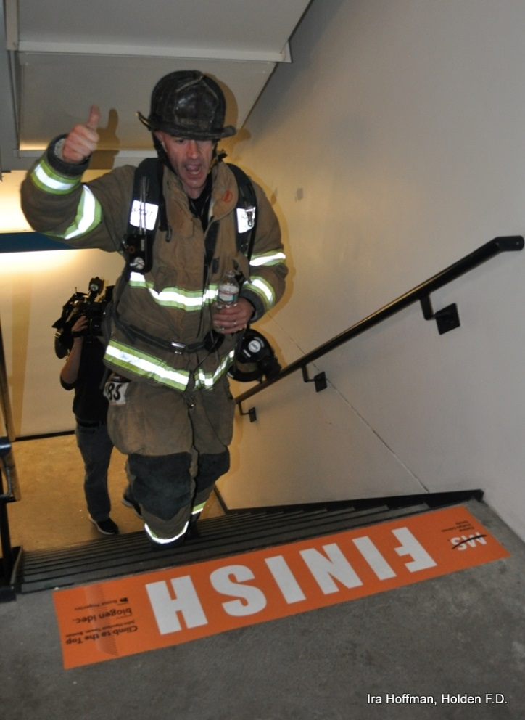

(FF Dave Russo, above, crosses the finish line as first Holden FF to finish MS Climb to the top)



**FIRE PREVENTION & TRAINING**

by Assistant Chief Russ Hall

**TRAINING:**

The training calendar is busy for the next couple of months. We have a mandatory training scheduled for 5/19, the topic of which is ladders. There is a possibility that we will be changing some items for May on the schedule as we are in the process of acquiring a house for live fire training. We meet with DEP this week to get final approval and at that time we will firm up the training dates. Once we have the schedule, it will be released to the department. We also will be making up the SCBA training from February. That date will be determined once the schedule is amended for the live burn training. As always, I encourage any member who has ideas for training topics to get in touch with a member of the training committee. The department also encourages all members to utilize the training resources offered by the MFA to enhance your training.

**FIRE PREVENTION:**

In January of this year, the state adopted a new fire code titled *527 CMR 1.00*. This code takes the national standard of NFPA 1 and amends it to fit in with Massachusetts specific codes. One of the newest additions to the code is the mandate that smoke detectors must be replaced if older than 10 years from date of manufacture. The current literature shows that detectors will lose their sensitivity and it could affect the proper operation in a smoke filled environment. This is something we all must pay attention to when responding to calls for service at alarm activations in residential occupancies. As most homeowners do not really pay attention to their smoke alarms other than changing the batteries, the idea that they would expire is a foreign concept. When responding to these calls we need to take the time to explain to residents and homeowners about the expiration of their detectors and the need to replace with new current models.