*C:\Users\jhanna\AppData\Local\Microsoft\Windows\Temporary Internet Files\Content.IE5\LE4P6T6Z\MC900340286[1].wmf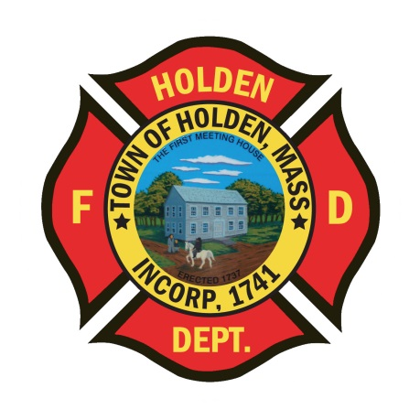* 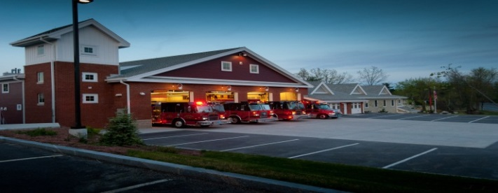

**The Extinguisher**

MARCH/APRIL 2015

**A Publication of the Holden Fire Department**

1370 Main Street, Holden, Ma 01520.  (508)210-5650.

# *Chief’s News* by Chief Jack Chandler

Newsletter Editor  
Leah Francese-wood

**DEPARTMENT SCHEDULE**

3/7-Firefighters Ball at the Manor

3/9-FFI/II class 18:00

3/12-EXPLORERS-Tool training

3/12-FFI/II class 18:00

3/16-FFI/II class 18:00

3/17-Dept. Training-Brush Fire Operations

3/19-FFI/II class 18:00

3/19-EXPLORERS-Salvage Covers & Overhaul

3/21-EXPLORERS-Bottle & Can Drive

3/23-FFI/II class 18:00

3/24-EMS training Rounds at 10:00

3/24-EMS vent training at 18:30

3/26-EXPLORERS-Obstacle Course

3/26-FFI/II class 18:00

3/28-HAFF Road Race 9:00am

3/30-FFI/II class 18:00

4/2-FFI/II class 18:00

4/2-EXPLORERS-knots with Mark Dubois

4/4-FF I/II CLASS

4/6-FFI/II class 18:00

4/7-Dept. Training-Ice Rescue Training Practical

4/9-EXPLORERS-Knots & Ropes

4/9-FFI/II class 18:00

4/13-FFI/II class 18:00

4/16-FFI/II class 18:00

4/16-EXPLORERS-Brush Fire Prep

4/18-EXPLORERS-Bottle & Can Drive

4/20-Patriots Day (town offices closed)

4/20-FFI/II class 18:00

4/21-Dept. Training Gross Decon/Multi Gas Metering

4/23-FFI/II class 18:00

4/27-FFI/II class 18:00

4/28-EMS 12 lead training

4/30-EXPLORERS-Ladders

4/30-FFI/II class 18:00

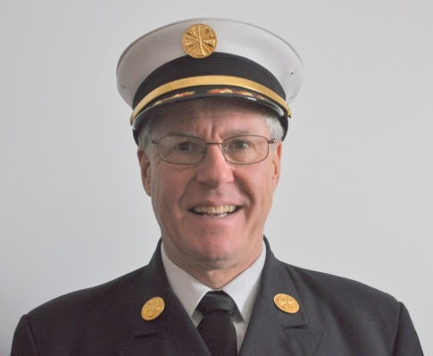

The Department lost one of our own recently and it was a very tough time for all of us. I would like to recognize and commend everyone on doing a very professional job in all of Captain Jim Oberg’s services. From the Chief, I thank you all during that difficult time for his family and our department. In recognition of Jimmy, and for all his service to Holden Fire, we are going to do a few things within the Department to recognize him and his dedicated 47 years as a member. First I would like to dedicate the next newsletter (May/June edition) to Jimmy and would ask anyone to submit stories, pictures or other thoughts about him to include in the newsletter. Second, we are going to “retire” the call sign 14C3 that Jimmy has had for as long as I have known him. We are then going to purchase and dedicate a plaque in honor of Jimmy and it will be hung in the administration office. If anyone has ideas on what the plaque should look like or contain please send your ideas to Leah.

We started an in house Firefighter I/II class on March 2nd that will be meeting every Monday and Thursday through the end of June. Headed up by Paul Pierce and Bob Connor, we will have about six people from Holden and six from other area towns. Please make these new recruits feel welcome and help Paul and Bob out whenever they need it.

Please join me in welcoming Chris Montiverdi to the department. Chris began in February as the Emergency Management Coordinator and will be working to improve the Town’s Emergency planning. Chris is a seasoned paramedic and will be attending the fire Academy next fall.

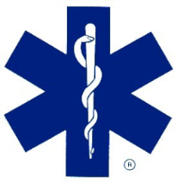**EMS Update** By EMS Director David Russo

The Department EMS staff conducted CPR recertification for all DPW staff, we also certified four new DPW staff members in CPR on Feb 24th.

Amanda Beahn has provided multiple CPR recertification classes and she recertified Dawson School teachers, as well as the Recreation Department staff.

We have placed our second Newport ventilator in service this month, giving our department the most up-to-date ventilators to care for our chronic vented patients. They are carried on our primary and secondary ambulances.

Our new A2 is on the assembly line at Horton Emergency Vehicles, expected arrival date late April. I will provide pics once I start receiving them.

I would like to congratulate Lt. Sean Smith, Robert Nickerson, Derek Hirons, and Rich Johnson on a job well done. They were dispatched to a man down at a local business last month. They arrived to find middle- aged male in cardiac arrest, with their experience and training they were able get the patient into (ROSC) return of spontaneous circulation. By the time they arrived at St. Vincent hospital the patient was speaking with the crew, thanking them for their efforts on saving his life! The patient was discharged from the hospital four days later with little to no life restrictions.

**EMS Training:**

March 24 - Rounds with Dr. Tennyson starting at 10:00 am

March 24 - EMS vent training with guest Speaker William Muskett from Life Star at 18:30

April 28 - EMS training 12 leads, with guest speaker Sean Trainor from Hartford Children's Hospital.

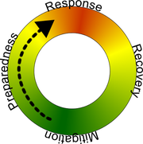Emergency Management News **By Chris Montiverdi**

So, as the “new guy” and my first article in the newsletter, Leah told me to introduce myself and tell everyone to stop by my office and give me a hug….not sure I buy into the hug part ….Anyway, I am the new guy. I started in the beginning of February as the Emergency Management Coordinator/FF/Paramedic. If I haven’t had the pleasure of meeting you yet on a call or at a training, please feel free to stop by my office (I sit across from Heidi) when you’re at the station and say “hi”, however, “NO HUGS PLEASE”.

For the past 7 years, I worked for the City of Worcester in both the Public Health Division and the Emergency Management Division. Prior to the City, I worked for UMassMemorial as a Paramedic. For this Department, I will be focusing a majority of my efforts on emergency management and preparedness planning.

In this newsletter, I wanted to focus on power outages as we are still knee deep in winter weather and outages are still a major concern. As having worked in public health, I wanted to focus on food safety during and after an outage. There is nothing worse than having to visit the bathroom multiple times by candle light because of GI illness after eating out of temperature chicken salad in your refrigerator that you thought was still okay to eat….. So, here are some things to think about for food safety during a power outage:

**Be Prepared**

**•**Make sure that you have appliance thermometers in both the refrigerator and the freezer. That’s the best way to be sure that your food is safe after a power outage.

•Know where you can get dry ice or block ice.

•Keep on hand a few days worth of ready-to-eat foods that do not require cooking or cooling

**When the Power Goes Out**

The most important thing to remember is: **keep the refrigerator and freezer doors closed!**

•A refrigerator will keep food cold for about **4 hours** if the door is kept closed.

•A full freezer will keep temperature for about **48 hours (24 hours if half-full).** If your freezer is not full, group packages so they form an “igloo” to protect each other. Place them to one side or on a tray so that if they begin thawing, their juices won’t get on other foods.

•If the power is going to be out for an extended period of time, buy dry or block ice to keep the refrigerator as cold as possible. Fifty pounds of dry ice should keep a fully-stocked 18-cubic-feet freezer cold for two days.

**When the Power Returns**

Check the temperature inside of your refrigerator and freezer. Discard any perishable food (such as meat, poultry, seafood, eggs, or leftovers) that has been above 40° F for two hours or more.

You will have to evaluate each item separately. Discard any food that has an unusual odor, color, or texture, or feels warm to the touch. When in doubt, throw it out! These charts help you evaluate specific foods:

•Refrigerated Foods: When to Save, When to Throw Out (<http://www.foodsafety.gov/keep/charts/refridg_food.html>)

•Frozen Food: When to Save, When to Throw Out (<http://www.foodsafety.gov/keep/charts/frozen_food.html>)

With frozen food, check for ice crystals! The food in your freezer that partially or completely thawed may be safely refrozen if it still contains ice crystals or is 40 °F or below.

Never taste a food to determine its safety!

**For more information about food safety in an emergency, check out these resources:**

* <http://www.fda.gov/Food/ResourcesForYou/Consumers/ucm077023.htm>

<http://www.foodsafety.gov/keep/emergency/index.html>



**Administration News** **By Leah Francese-Wood**

**January Anniversaries**

Deputy Chief Jack Cross-45 years

Derryl Dion-16 years

Bryan Patch-5 years

**February Anniversaries**

Derek Hirons-6 years

Tyke Lothrop-5 years

**March Anniversaries**

Charles Borowy-9 years

Brendon Connor-5 years

Leah Francese-Wood-8 years

Ryan Mouradian-9 years

Lt. Sean Smith-9 years

Lt. David Chapin-14 years

**April Anniversaries**

Assistant Chief Russ Hall-6 years

Rich Johnson-1 year

* The 3rd Holden Firefighters Ball will be Saturday March 7th at the Manor in West Boylston. We have a good turnout of members attending! In-house DJ, Chuck Borowy will be providing music. Class A’s & fancy dresses, lots of food, dancing, friends, and music………sounds like we will have a good time!



* Get your sneakers on! The HAFF is holding the 1st Annual Firehouse 5k Road Race on Saturday March 28th at 9:00. Registration fee is $25. Race is open to all levels and if you register before March 20th you get a free race shirt! Flyers are hanging at Headquarters for more information.

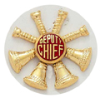**From The Deputies Desk**

By Deputy Chief Peter W. Bergstrom

We have recently added four new Auxiliary Call Firefighters. Two of the four have immediately started the FFI/II in-house class. The other two will attend a future class as their schedule allows.

Please welcome new members:

**John DiPerrio** – lives on Lincoln Ave. and works for the Holden Water Department

**Ryan Pescaro** – lives on Blair Drive, former Holden Fire Explorer. Currently splits his time between school in Connecticut and working for Vital EMS in Worcester, and is enrolled in the in-house FF I/II class.

**Derek Peto** – lives on Homestead Road, works for Holden Municipal Light, and is enrolled in the in-house FF I/II Class.

**Connor Shamlian** – Lives in Worcester by Indian Lake, works at C & R Tire, and is enrolled in the in-house FF I/II Class.

* As we welcome in new people, two Call Firefighters recently stepped away from Holden Fire. Eric Bishop and John Bain. Thanks to both for their past service.
* 2014 Call Firefighter response percentages are nearly complete and should be available soon.
* Recent events show us that life changes unexpectedly. Some things we can’t control, some things we can. One item in our control is Firefighter Safety. You have all heard of the *National Fallen Firefighters Foundation*, but have you visited their web site to take a look at the 16 Firefighter Life safety Initiatives? Take some time in your web surfing someday and visit [www.everybodygoeshome.com](http://www.everybodygoeshome.com/).

**EXPLORER POST 2012 NEWS!** By Dave Eddy

The Holden Fire Explorer Post 2012 members have been training diligently during the months of December 2014 through the beginning of February 2015. We have had guest speakers: Deputy Chief Jack Cross speaking about Chimney Fires and Mark Dubois for Wilderness Cold Training. The Explorers found both speakers informative and enjoyed the training. The Explorers also were preparing for *The Klondike: “Rush for Gold*.” This was held on February 7th at Treasure Valley in Rutland. They ran a Wilderness First Aid Station where they judged Boy Scout troops on their abilities to move and treat victims. By participating in this outing, the Explorers received a participant award and learned to work as a team without adult intervention. The advisors were very proud of the Explorers and how well they performed at this outing.

On the upcoming trainings, members will be focusing on the brush fire season.

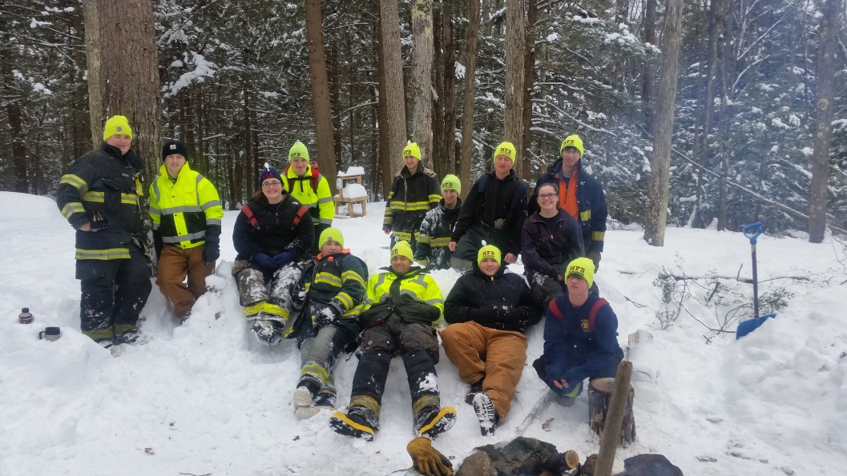

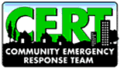

**The C.E.R.T. Spot** By Rebecca Evanoff

The Regional 3 - 4 MEMA Emergency Operations Center (EOC) in Agawam invited CERT members to start training. This is to staff the EOC during an emergency as community outreach. CERT members would go to the Agawam facility and assist the regional staff in coordinating equipment requests through Web EOC and reaching out to communities during an emergency.

**Department Pictures By Ira Hoffman**

Ryan Mouradian & Paul Pierce at 1689 Wachusett Street on 11/19/14

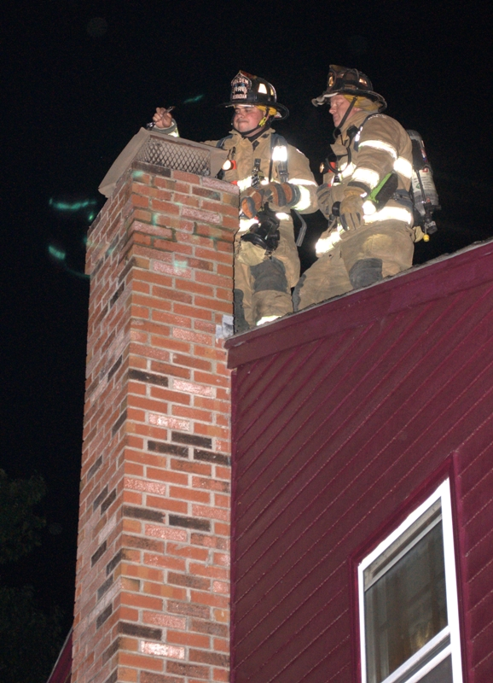

Ethan Naiman’s graduation in

December 2014

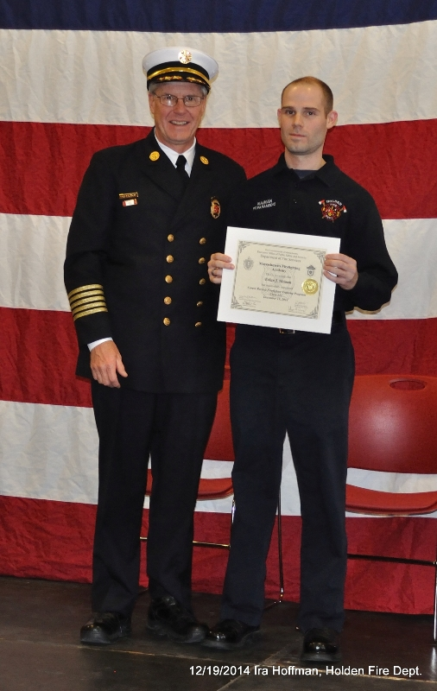

559 Wachusett Street Fire on 12/21/14

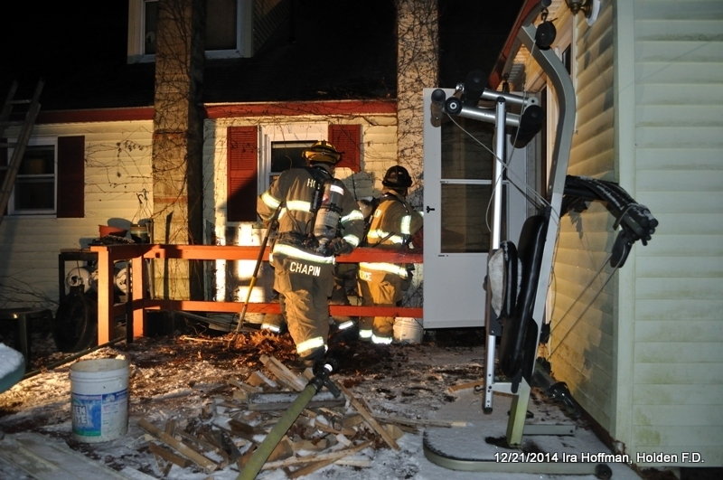

8 Fredrickson Ave. Fire on 1/6/15

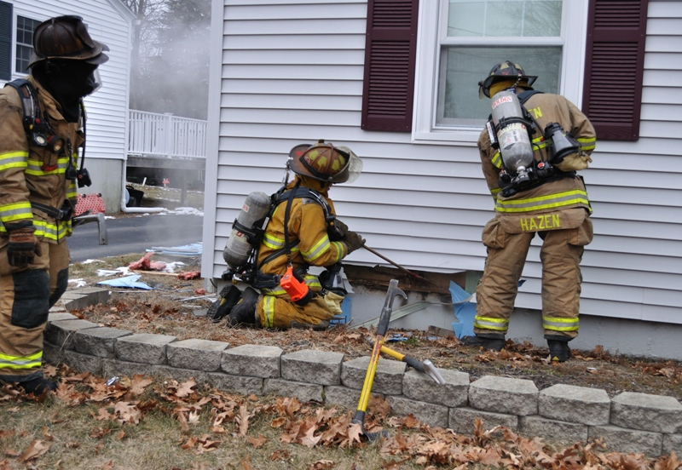

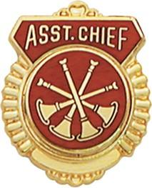

**FIRE PREVENTION & TRAINING**

By Assistant Chief Russ Hall

**FIRE TRAINING**

As we move forward with the training schedule, we will re-schedule the mandatory SCBA training for later in the spring. We will make sure to give everyone as much notice as possible but at least a minimum of 30 days. Just a reminder that the next mandatory training is 5/19 with the topic being ladders.

Below is an interesting article on testing that was done by FDNY and NIST on the flow patterns caused by ventilation during a fire. I attended a class by Deputy Chief George Healy who was in charge of the study. It proves to be a hot topic currently in the fire service as it contradicts some of the tactics and strategies that have been used fighting fires for many years. I have attached a link to a program that reviews the exercise or you can just google Governors Island FDNY study.

In the name of science, but with aim of saving lives, preventing injuries and reducing property losses, members of the New York City Fire Department (FDNY) spent much of the first two weeks in July setting fire to 20 abandoned townhouses on Governors Island, about a kilometer from the southern tip of Manhattan.

|  |
| --- |
|  |

In a series of “live burn” experiments, conducted in collaboration with the National Institute of Standards and Technology (NIST) and Underwriters Laboratories (UL), New York firefighters challenged the conventional wisdom on, and tested new tactics for, controlling fires and rescuing occupants inside burning homes.

“We studied these fires from start to finish,” explains NIST fire protection engineer Dan Madrzykowski, who led the NIST research contingent at Governors Island. “We turned these row houses into laboratories for real-life experiments that will provide guidance for improving fire-fighting tactics.”

An abandoned Coast Guard barracks built in the 1980s served as the proving ground for so-called positive pressure techniques and other potentially useful ventilation-control and exterior fire suppression methods. The row houses were among structures scheduled for demolition as part of efforts to transform the former Coast Guard regional headquarters into a park and for other civic uses. The townhouses—wood-framed with brick exteriors—were supplied with the same package of sofas, chairs, beds, and other furnishings for the experiments. Each townhouse also was outfitted with about 100 sensors to measure temperatures, heat flows, concentrations of toxic gases and other variables. Cameras were installed inside each row house, as well as in front and back, to monitor and record conditions.

The primary motivation for the live burn experiments are the changing dynamics of fires. The contents of American homes have changed significantly in the past few years. Plastics and other synthetic materials have replaced the natural materials that once made up the bulk of furniture items. In addition, modern living spaces tend to be more open, less compartmentalized.

As a result, interior house fires tend to burn faster and hotter today. The average time to flashover—the extremely perilous phenomenon that occurs when heat builds up in a burning structure’s contents and components to the point that they burst into flames simultaneously—has dropped dramatically since the 1980s.

The experiments evaluated individual and combinations of methods for strategically ventilating and isolating fires to prevent flashover—or at least delay it. In contrast, kicking a door open or breaking a window without knowledge of conditions inside could create a portal for air that can literally fan the flames.

“Fire consumes all the oxygen in a building, and when we ventilate the building, oxygen-induced flashover can occur,” explains Robert Maynes, FDNY deputy assistant chief. “That impacts the safety of our firefighters.”

Information gathered and lessons learned during Governors Island tests will be shared with fire departments throughout the nation. In addition, NIST will use the data to improve the accuracy and improve the capabilities of its widely used fire modeling software.

“These on-the-ground fire tests—in collaboration with FDNY and Underwriters Laboratories—provide a great opportunity for NIST to gather data at full-scale. The data will strengthen the scientific underpinnings of modern fire-fighting tactics and technologies, improve their effectiveness, enhance fire fighter safety, and lead to better building codes and standards,” said Shyam Sunder, the director of NIST’s Engineering Laboratory.

<http://www.firecompanies.com/modernfirebehavior/governors%20island%20online%20course/story.html>