*C:\Users\jhanna\AppData\Local\Microsoft\Windows\Temporary Internet Files\Content.IE5\LE4P6T6Z\MC900340286[1].wmf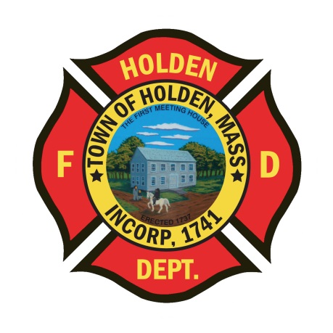* 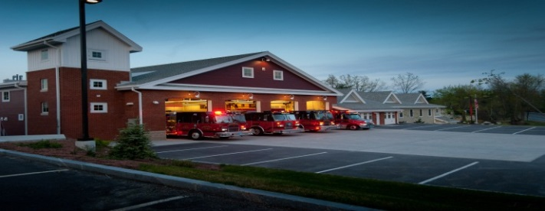

NOVEMBER/DECEMBER

2014

**The Extinguisher**

**A Publication of the Holden Fire Department**

1370 Main Street, Holden, Ma 01520.  (508)210-5650.

Newsletter Editor  
Leah Francese-wood

**DEPARTMENT SCHEDULE**

11/18 – Department Training

11/20 – EMT refresher 6:00 pm

11/21 – Mid State Seminar & Dinner

11/25 – Paramedic refresher 6:00 pm

11/27 – Thanksgiving (offices closed)

11/28 – Town offices closed

**December**

12/2 – EMT refresher 6:00pm

12/2 – Department Training

12/6 – HFD Kids Christmas Party

12/9 – Paramedic refresher 6:00 pm

12/15 – QAQI rounds at 10:00AM

12/16 – HFD Member Christmas Party

12/18 – EMT refresher 6:00pm

12/20 – Explorer Can Drive

12/23 – Paramedic refresher 6:00 pm

12/25 – Christmas (offices closed)

12/26 –Town Offices closed

# *Chief’s News* by Chief Jack Chandler

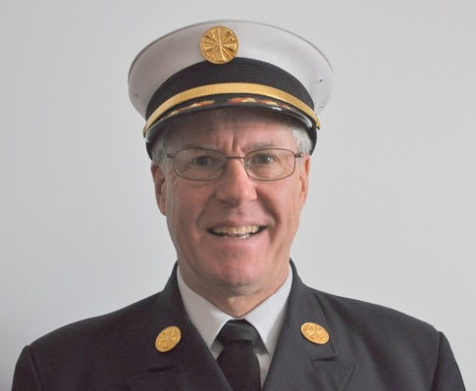

I would like to thank everyone who responded to the house fire on Farragut Way. It was a difficult fire, under difficult circumstances, and everyone did a great job! Special recognition goes to Captain Jim Oberg who ran the fire on his own.

Winter is just about here so please remember to dress appropriately for calls so you can keep warm. Also, get those ice scrapers out so you can be ready to respond!

Regional Dispatch is scheduled to begin December 2nd, 2014! The planning has been going on for years, training has taken place, lots of equipment is in place and all we need to do now is turn on the switch! You will notice some changes in IMC as we will be using a shared data base with Princeton. Other than that, there probably won’t be too many noticeable changes to us. One thing we will see which is very positive, is that there will be two dispatchers on duty from 7 AM to 11 PM. This will be a great help and should give us more responsive dispatching!

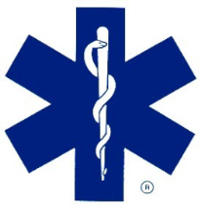**EMS Update** By EMS Director David Russo

We are going into our third week of NREMT refresher for our EMTs and Paramedics. Class is going very well for both groups with positive feedback. This is the first year we are hosting a refresher of this kind, in conjunction with WEMS training division. We have out-of-town service members taking both the EMT and Paramedic refresher, and they all are pleased with the refresher.

We plan on teaming together with WEMS training division in the near future to offer more training opportunities. Courses and dates will be announced on a later date. Currently, our NREMT refresher will go until the end of December for EMTs and second week of January for Paramedics. Our next QAQI rounds will be held on **December 15, 2014** in the conference room at 10:00AM, all EMTS and Paramedics welcome.

I would like to thank Lt. Dave Chapin and Firefighter/Paramedic Derek Hirons for helping me prepare (should the need arise) for a possible Ebola patient transport. We have made Ebola kits for staff and patients. They are located on A3 and A1 with full instructions and flow sheets to follow to keep us safe and for patient safety.

**Administration News** By Leah Francese-Wood

**HAPPY BIRTHDAY TO YOU….**

**November**

Kevin Fagerquist – 11/7, Paul Pierce – 11/7, Eric Fasshauer – 11/9

Derryl Dion - 11/11, Dan Hazen – 11/11, Bob Connor – 11/17

**December**

Chief Chandler – 12/13, Sean Smith – 12/16,

Nicholas Kakalecz – 12/24, David Chapin – 12/28

***Department Anniversaries***

**November**

Peter Bergstrom - 36 yrs

Steve Dewitt-20 yrs

Andrew Miller-14 yrs

Rob Nickerson-5 yrs

Joshua Poznanski-8 yrs

Michael Rosen-36 yrs

**December**

Kevin Fagerquist-22 yrs

Michael Himmer-15 yrs

John Whipple – 22 yrs

* For fall or winter clothing and hats to be purchased, see/call Heidi (508-210-5656) OR [hmcalice@holdenma.gov](mailto:hmcalice@holdenma.gov)
* For fulltime members, as a reminder, when purchasing on line from GALLS or THE FIRE STORE, please put your last name as the PO. So that if there are questions Heidi can contact the correct person.
* For On-Call Firefighters, ANY shift you work, please sign in on the payroll sheet hanging in hallway at HQ. Remember to sign out as well!



**Holden Fire Children’s Christmas Party**

**Saturday, December 6th**

**The annual Christmas Party for department members children and grand children will be at the Holden Senior Center. Meet at Headquarters at 4:30 to ride on the fire trucks to the Senior Center. There will be appetizers and pizza, AND most importatly- Santa Claus. If you would like your child to receive a present from “Santa,” please bring a wrapped present with their name on it. Please see Leah to sign up. If you can bring a dessert, that would be great!**

**Department Member Christmas Party**

**Tuesday, December 17th**

The department member party will be held at the Nimord Club, Mason Road. Cocktails will be at 6:30pm with dinner at 7:00pm. The dinner will be prime rib and chicken buffet. There will be a slideshow of events through the year. For all members including auxiliary, price is $20 per person and $5.00 for retirees. All members welcome as this is a department-wide event. If you can, please pay before the party, please drop off payment to Leah.

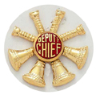

**Deputies Desk** By Deputy Chief Peter W. Bergstrom

* We have started the interview process to add Auxiliary Call Firefighter positions. The goal is add new members at the start of next year. The current Auxiliary Firefighters are doing well in their continued training. They have done training on hydrant operations, equipment awareness, SCBA introduction and use, and are currently training on ladder operations. We are reviewing possible in-house options to get the Auxiliary Firefighters FFI/II training.
* More information will be made available as we look at some training options.

Reminder, EDispatch is not to be relied upon as the primary means of call notification. For the fire on Farragut Way, the EDispatch system was offline and notifications for that working fire were not sent out. Your pager is and should be the primary means to receive call dispatches.

* I have a small supply of winter hats and will order more if needed. See me if you need one. Winter is almost here so prepare for the cold.

**EXPLORER POST 2012 NEWS!** By Dave Eddy

Currently, the Holden Explorer Post 2012 has 22 Explorers. We started off September with 14 returning Explorers and have increased weekly. The new recruits were brought on by word-of-mouth, which is great!

The Explorer Post members have worked hard on learning SCBA. Training is important to get Explorer youth comfortable with donning and doffing. On October 25th they visited Princeton Fire for a smoke house drill, which the Post excelled in. Save those cans……the next bottle & can drive is December 20th.

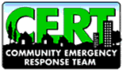

**The C.E.R.T. Spot** By Rebecca Evanoff

For those who don’t know……Holden’s Community Emergency Response Team has 30 adult CERT members and 6 teen CERT members. Currently, there are 4 members in training. CERT began regionally in 2006 and The Team Director, Rebecca Evanoff took over CERT as a member in 2007. In 2008, they were recognized by the town Selectmen as a group.

Members are trained by using the FEMA curriculum, but also add CPR/AED training. They are trained on disaster preparedness, disaster fire suppression, disaster medical operations, light search and rescue operations, disaster psychology, team organization, and review & disaster simulation.

CERT members during training (left to right) - Jim Schakenbach, Jen Hanson, Kirsten Peterson, Renee Marion, Bob Waite, Kimberely Green, Richard Clark (on stretcher).

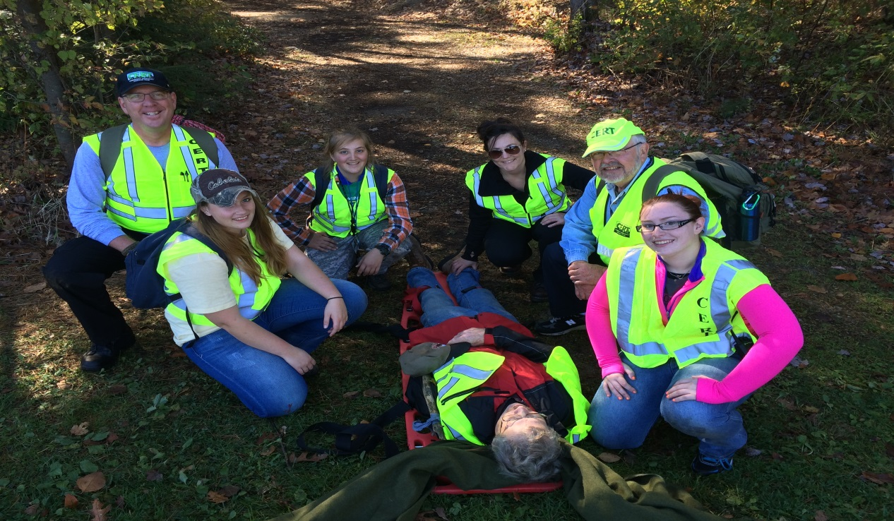

**Department Pictures**

Congratulations to Lt. Dave Chapin and his

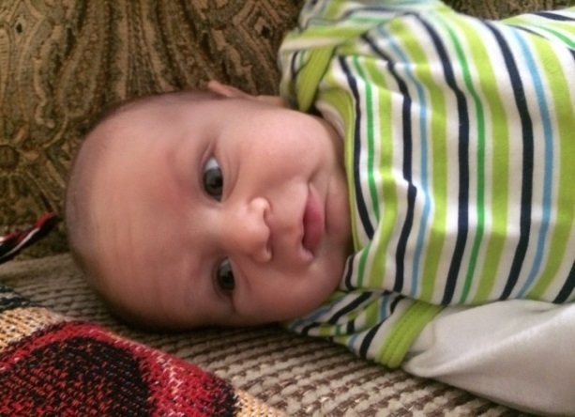wife Jessica, on the birth of their son Jake

Chapin on September 22nd.

10/26/14 Farragut Way House Fire

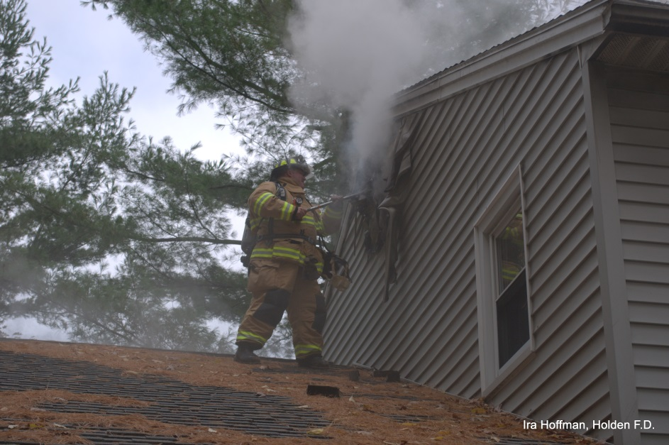

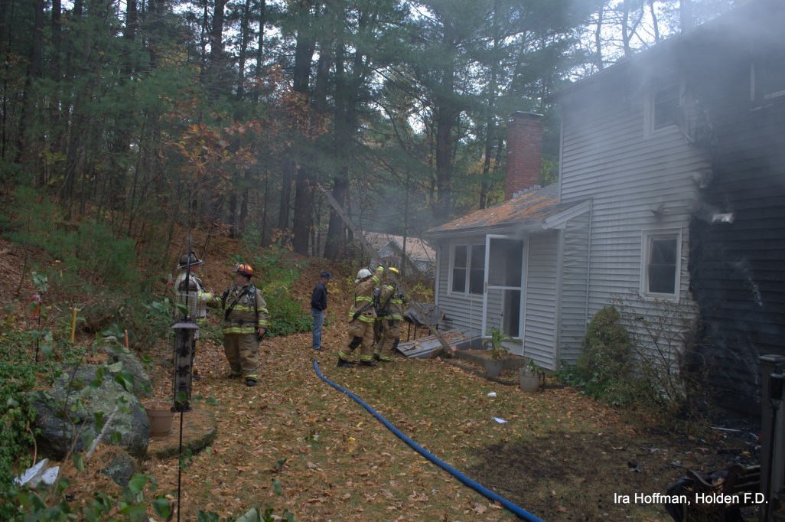

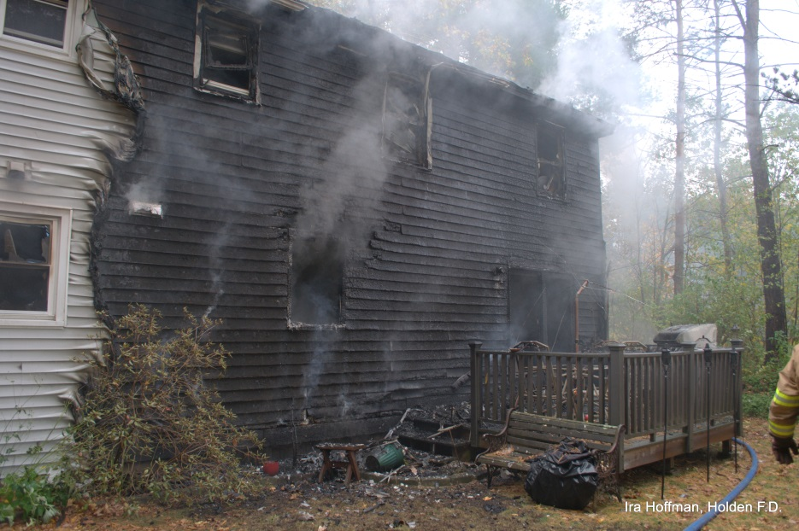

**10/5/14 Dryer Fire. Reservoir Street**

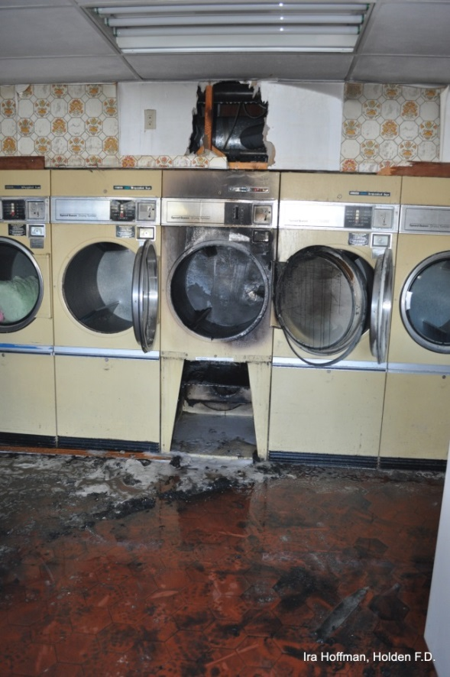

**9/29/14 768 Main Street accident**

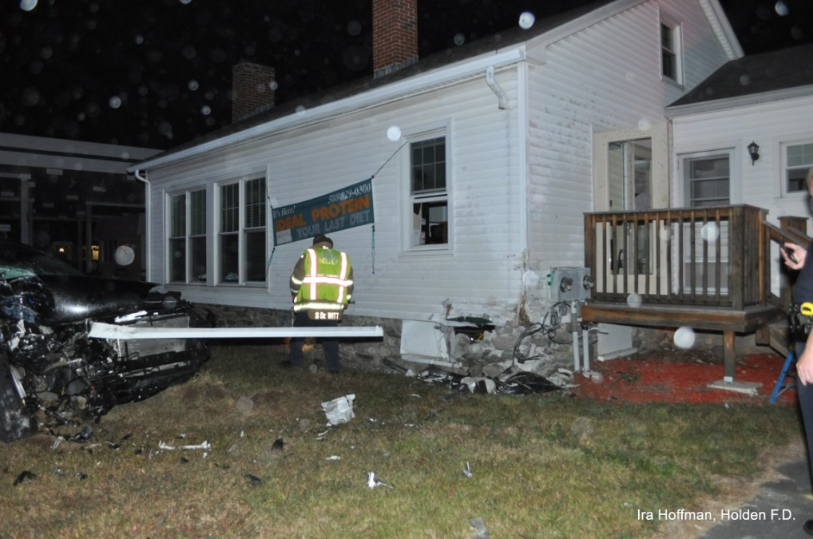

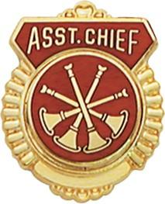**FIRE PREVENTION** By Assistant Chief Russ Hall

The training committee has finalized the training schedule for 2015.

We will maintain the core mandatory trainings which were put in place

last year. These trainings are important for all firefighters and necessary

for the department to continue in providing our core mission. These

trainings are SCBA, Ladders, Live Fire Evolutions and

Search/Rescue-SCBA Confidence. The training committee decided to

keep these trainings in the same Month as last year to make it

easier for department members to plan for attendance. We also have

a whole host of new topics including some provided by the Department

of Fire Services.

As some of you have noticed, the department has taken delivery of

a new forestry vehicle. The new “Forestry 1” will be replacing the current

2002 F450. The 2008 Squad was taken out of service and the skid unit

removed. As the Squad had been deemed unsafe to operate, I would like

to report that LT. Charbonneau made the final journey to MHQ without

being asphyxiated by the exhaust blowing into the cab. The new truck was

built by MHQ and is a Ford F450 4X4 with a gas V10 engine. The body

is an aluminum stake body. Members will be working over the winter to

refurbish the skid unit from the old squad and will be purchasing and

mounting toolboxes for tools and equipment. By the next brush season

we should have the vehicle up and running.