*C:\Users\jhanna\AppData\Local\Microsoft\Windows\Temporary Internet Files\Content.IE5\LE4P6T6Z\MC900340286[1].wmf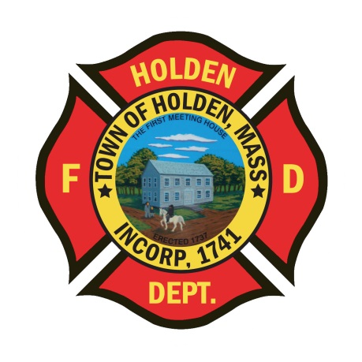* 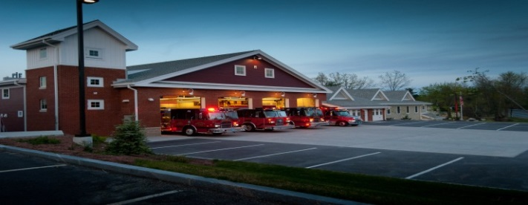

September/October

2014

**The Extinguisher**

**A Publication of the Holden Fire Department**

1370 Main Street, Holden, Ma 01520.  (508)210-5650.

# *Chief’s News* by Chief Jack Chandler

Newsletter Editor  
Leah Francese-wood

**DEPARTMENT SCHEDULE**

9/22 – M&M Rounds for EMT/Medics @ 10:00AM

10/5 – Public Safety Day 12:00-3:00

10/7 - Training

10/13- Columbus Day (offices closed)

10/14-NREMT Medic Refresher @ 18:00

10/21-NREMT refresher @ 18:00

10/24 – Flu Clinic for town employees 1:30-3:30 @ Senior Center

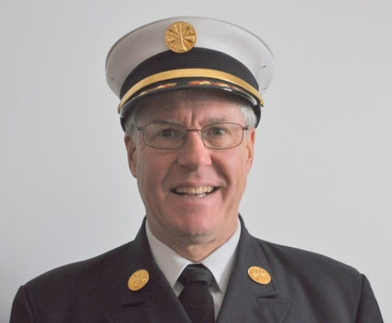

Please join me in welcoming our new Chaplain, Pastor John Barber from the First Congregational Church in Holden. John grew up the son of a congregational minister and has lived in Massachusetts since he was 5.  He attended the University of Massachusetts in Amherst where he received his bachelor’s degree in Electrical Engineering and worked for New England Telephone in Worcester (now Verizon) for most of the 1990s. John felt the call to go into full-time ministry and eventually he decided to go for it!  He graduated from Gordon-Conwell Theological Seminary in 2000 and became pastor of the First Congregational Church later that same year. John and his wife Kathy have two children, Tim and Katie. John says, “I love to sing. I love to talk, I love to hand out and have fun.”

* We had a great send off for Reverend Jerry Heslinga and he will be truly missed. Jerry and his wife moved to Virginia to be closer to their grandchildren.
* Also, Bang Nguyen and John Beattie have both announced that they will be leaving the area for new job opportunities. We wish them well in their new positions!
* The brush season is upon us and with the weather being relatively dry we should be **prepared** for a busy season. Please make sure your gear is ready to go! Remember that structural gear is not to be worn for brush fires.
* I would like to thank the Horrigan Family for designating the Fire Fighter Memorial Fund as the recipient of donations in Bob’s honor. Bob was a well-respected and well-liked by all who knew him. We greatly appreciate their thinking of us at such a sensitive time.
* The new training program is continuing and is working well. Only a few firefighters received reminders to make up classes. If you want some additional training or just hands on practice, stop by the station and we’ll help you out!

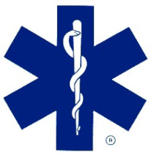**EMS News** by EMS Director David Russo

The EMS service has continued to be busy over the last few months with both calls and training. We took delivery of a new ventilator to assist in transporting patients from Wachusett Extended Care. The new vent is state of the art technology and has been well received by both the patients and staff at Oriol Healthcare. Along with the new vent, EMS providers were in-serviced on its operation by a Respiratory Therapist at one of our monthly training sessions and the EMT’s and Paramedics continue to train on it weekly.

The department has upcoming National Core Competency refresher courses scheduled to start in the Fall for both EMT’s and Paramedics. The courses will be held in-house and taught in conjunction with Worcester EMS. Any EMT or Paramedic who has not signed up please contact me ASAP.

As most of you know, we have been working on the purchase of a replacement ambulance for A2. We recently entered into an agreement with Greenwood Emergency Vehicles to purchase a 2015 Ford F550 4X4 Horton Ambulance. The ambulance committee decided to go with the Ford chassis rather than the current International we have because of its smoother ride, the four wheel drive option and the ease of repair having a Ford dealer in town. The vehicle is scheduled to arrive to the department in early 2015. I would like to thank the ambulance committee for all their hard work in putting the specification together.

***Administration News*** By Leah Francese-Wood

**HAPPY BIRTHDAY TO YOU….**

**September**

Jack Cross, Derek Hirons, Rich Johnson, Andy Miller, Bryan Patch, Barry Tupper

**October**

John Bain, Steve Dewitt

***Department Anniversaries***

**SEPTEMBER**

Dave Eddy – 22 yrs

Eric Fasshauer – 14 yrs

Ira Hoffman – 4 yrs

Barry Tupper – 22 yrs

**OCTOBER**

Rob Beer – 14 yrs

Chief Chandler – 8 yrs

Nicholas Kakalecz – 12 yrs

Jim Oberg – 46 yrs

* For fall or winter clothing and hats to be purchased, see/call Heidi (508-210-5656). She will be placing an order in late October so if you want clothing as gifts for the holidays please let her know.
* For On-Call Firefighters, ANY shift you work, please sign in on the payroll sheet hanging in hallway at HQ. Remember to sign out as well.
* When there are Monday holidays, please note that payroll must be submitted to Town Hall the Friday morning before the holiday (sometimes Thursday afternoon). Calls, shifts, and overtime worked on that Thursday, Friday, and Saturday will be included on next paycheck.



**Deputies Desk** By Deputy Chief Peter W. Bergstrom

* A couple of separations to let you know about. Jason Mathews has resigned from the Department for personal reasons, Bang Nguyen has accepted a new job in Georgia and will be moving in the near future, and John Beattie has also accepted a new job and will be moving also. We thank each of them for their service during their time here and wish them well in their new endeavors.
* MFA is experiencing some delays to offer additional Call / Volunteer Recruit classes. We are discussing possible in-house options to get the Aux. Firefighters FFI/II training. More information will be made available as we look at some training options.
* We currently have some new applications for Call Firefighter positions and will be starting the process to possibly add additional Call Firefighters at the start of next year. If you know of anyone interested in becoming a Call Firefighter, friends, family, neighbors, let them know and have them complete and submit a Holden employment application.
* Though some got caught in a late day storm, the golf tournament went well and everyone enjoyed a good day and great dinner. Thanks to all the Association and Department members, along with family and friends, who helped bring this together again this year.
* **REMINDER! They can be a nuisance, but……automatic fire alarms sometimes do indicate actual fires!**

**Have a safe fall season.**

**Department Pictures**

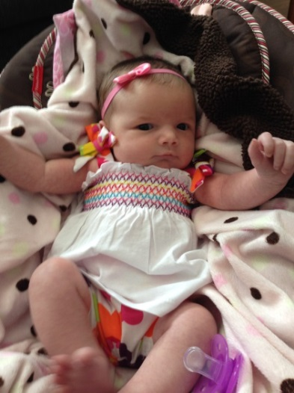

*Congratulations to Erik & Lynn Bishop on the birth of their*

*daughter Kadence on June 22nd*



*Congratulations to Bob & Michelle Connor on the birth*

*of their son Bronson on August 25th*

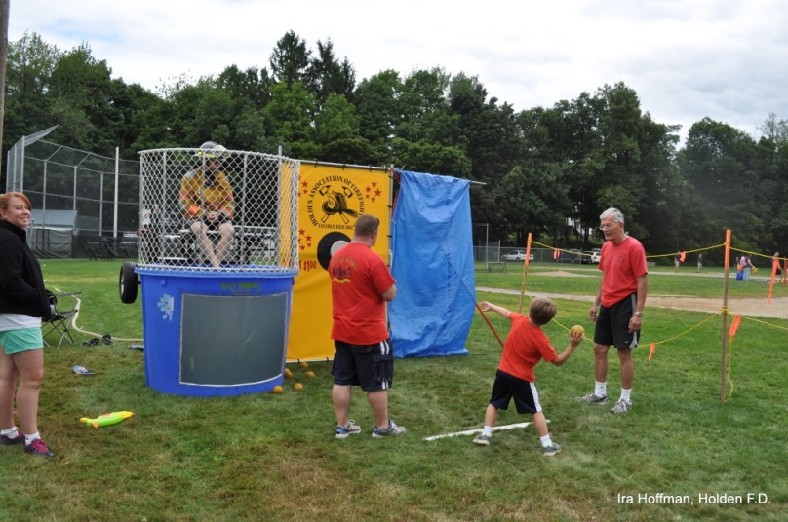

*“Having a little fun at Holden Days”*

*Lt. Barry Tupper in the dunk tank! Left to right, wife Laura Tupper, Rob Beer, Landon Tupper, and retired Chaplain Jerry Heslinga.*

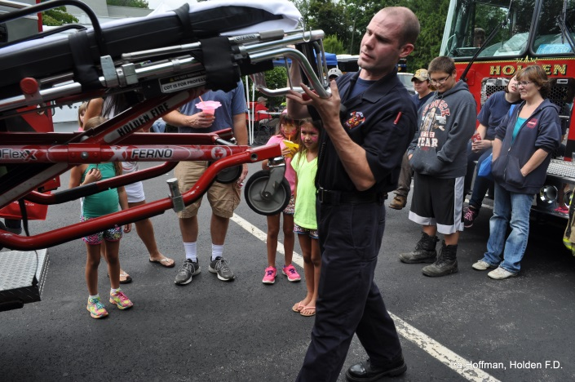

*Firefighter/Paramedic Ethan Naiman demonstrates how to operate*

*the stretcher to a crowd at Holden Days – August 2014*



*Presenting……Mr. & Mrs. Ryan Mouradian*

*Congratulations to Firefighter Ryan Mouradian and his new bride Jess who were married on August 30th*

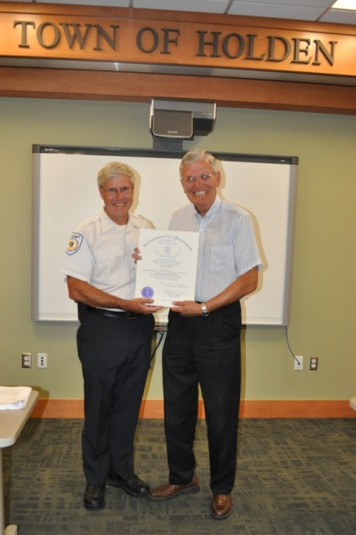

*Reverend Jerry Heslinga and Chief Chandler at the Chaplain’s retirement party. He retired after 10 years of service to HFD.*

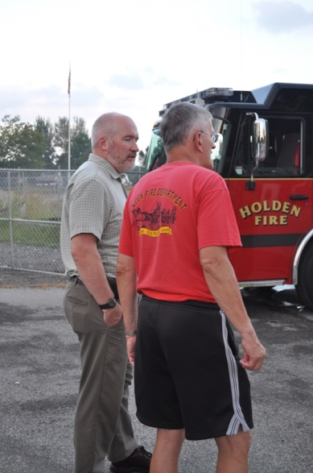

*The new Chaplain John Barber, and Jerry Heslinga,*

*during training. Jerry seems to be showing him “the*

*ropes!”*

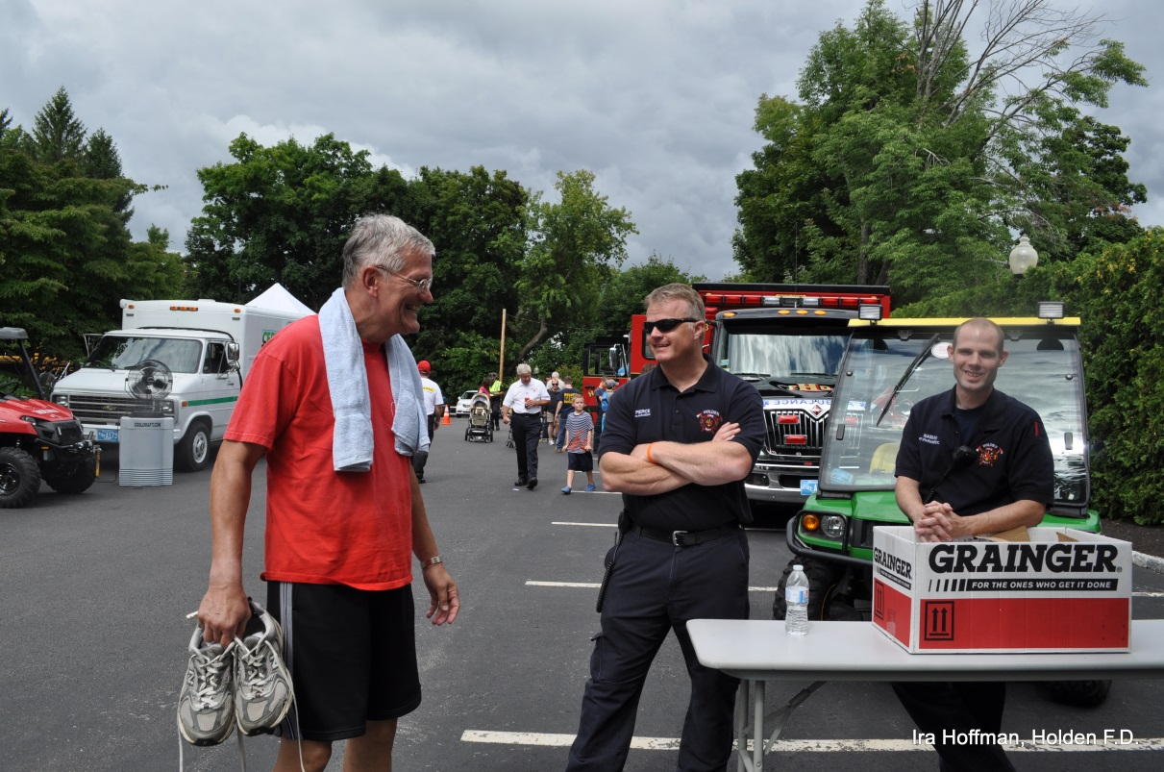

*The Rev stops by the HFD information booth at Holden Days to chat with the guys….. or give confession?*

*Paul confesses he didn’t to anything wrong, while Ethan is praying the Rev doesn’t ask him!*

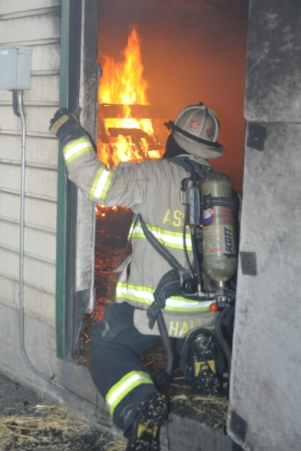

*Assistant Chief Russ Hall during live burn training*

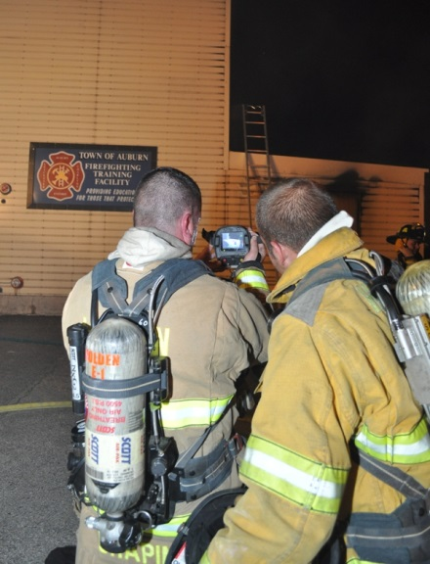

*Lieutenant Dave Chapin explains the use of the thermal image camera*

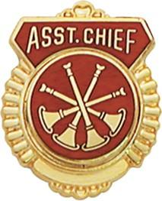**FIRE PREVENTION** By Assistant Chief Russ Hall

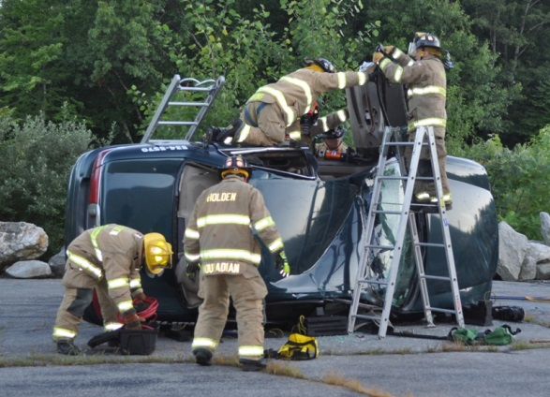

**TRAINING:**

As we close in on the final months of 2014, the department training programs continue to have strong attendance and participation from the majority of our members. To this point it appears that the curriculum change and added practical training has been a positive for the department.

As we get set to plan for 2015, if there are any topics members would like to see covered, please reach out to the training committee.

As a department we always encourage our firefighters to seek training outside the department. This will expose you to different topics and instructors than you get at our department trainings. It will also allow you to train with firefighters from across the state. The Massachusetts Firefighting Academy puts on multiple classes on a variety of topics throughout the year. If interested in registering for any of these courses or viewing the schedule, go to the following link: <http://www.mass.gov/eopss/agencies/dfs/dfs2/mfa-trng/the-massachusetts-firefighting-academy.html>

**FIRE PREVENTION:**

Since Nicole’s Law was implemented in 2006, many Massachusetts homes have installed carbon monoxide (CO) alarms and many lives have been saved and injuries prevented. I am sure every fire department has a CO alarm success story from one of the extended power outages we’ve had these past few years. However, CO alarms only last 5-7 years and many are now coming to the end of their useful lives. No appliance lasts forever. We must encourage residents to continue to have working CO and smoke alarms in their homes.

Firefighters need to know that many CO alarms are reaching this end of life stage soon. When responding to homes where the CO alarm is beeping, it’s important to check the age of the detector. The entire alarm and not just the batteries may need replacing in non-emergency cases.