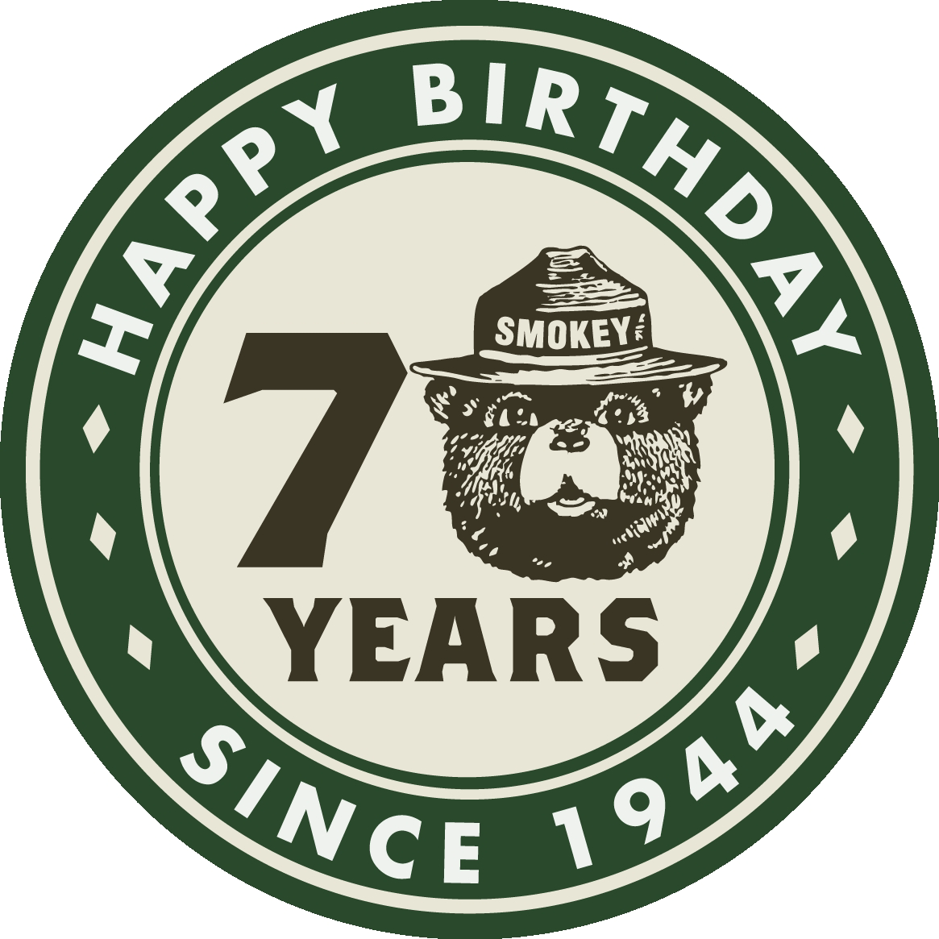

HAPPY BIRTHDAY SMOKEY BEAR

Smokey has protected our forests for 70 years, come join us in wishing Smokey Bear a Happy 70th Birthday
When: Saturday August 9th
Where: Summit of Wachusett Mountain State Reservation, Princeton
Time: 11AM to 2 PM
What: Visits by Smokey Bear, Brush Trucks on display by Fire District 8, Tours of the Princeton Fire Tower
For more information, please contact DCR Fire District 8 at 978-874-0112
