*C:\Users\jhanna\AppData\Local\Microsoft\Windows\Temporary Internet Files\Content.IE5\LE4P6T6Z\MC900340286[1].wmf* 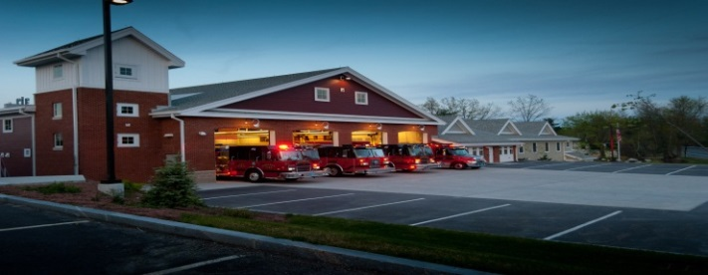

JUNE/JULY/AUGUST

2014

**The Extinguisher**

**A Publication of the Holden Fire Department**

1370 Main Street, Holden, Ma 01520.  (508)210-5650.

# *Chief’s News* by Chief Jack Chandler

Newsletter Editor  
Leah Francese-wood

**Department Schedule**

6/24 – Mandatory ALS/BLS Interface Class for EMT/Medics @ 18:30 OR class on 7/22

7/1 - Driver Op Competency Training

7/1 – Department PHOTOS at HQ @ 18:30 (make up day to be announced)

7/15 – Open Water Rescue

7/22 – Mandatory ALS/BLS Interface Class for EMT/ Medics @ 18:30

8/5 – Hose lines/Hydrants Ops

8/19 – Vehicle Extrication

8/22 – Fireworks & Cookout at HQ

8/26 – Mandatory protocol update for EMT/Medics who operate on the ambulance

****Now that summer is here please remember safety at home and on the job! Many of us are attacking a long list of projects at home. Be sure not to take any short cuts that could get you injured!

The summer weekend and afternoon shifts are filling up nicely. Thanks to everyone who is signing up for these! It is a great opportunity to get more hands-on time with equipment and apparatus, get to know some of the fulltime firefighters better and to help provide coverage to the town.

The vacation schedules are posted. Please note when you will be unavailable so the officers have some idea of what they can expect for responses.

Save The Date! **August 22nd**, the night before Holden Days, the Oriol Family is hosting fireworks that will be set off at Wachusett High School. Members of the Department are invited to watch from the station and we plan on having a cook out as well. Stay tuned for more information!

The Town Meeting approved the replacing of Ambulance 2 and Squad 1. Committees are currently putting together the specifications for these new trucks which we expect will be here in six to nine months. We also received funding for a new Emergency Management Coordinator position. This will be a full-time daytime Firefighter/EMT position that will focus on preparing the Town for Major Emergencies. The position will be posted in the near future. Please have an enjoyable and Safe summer!

**EMS News** by EMS Director David Russo

* Congratulations to Amanda Beahn who has been cleared to operate as an EMT on the ambulance.
* We are finishing up the final details on the specs for the new ambulance. Details are to be safer, user friendly, and better patient care operations while in transit to hospitals.
* Mandatory ALS/BLS Interface class for all EMTS and Paramedics who operate on the ambulance are June 24 and July 22nd at 18:30 hrs. You only need to attend 1 (one) of the dates.
* On August 26 at 18:30 , there will be mandatory protocol update for all EMT and Paramedics who operate on the ambulance

***Administration News*** By Leah Francese-Wood

* If you are interested in working on the department website and editor of the newsletter, see Leah!
* For new emails, certifications, phone numbers, and licenses give copies to Leah.
* If you have need clothing/hats/uniforms to be purchased, see/call Heidi.
* For On-Call Firefighters, ANY shift you work, please sign in on the payroll sheet hanging in hallway at HQ. Remember to sign out as well.
* When there are Monday holidays, please note that payroll must be submitted to Town Hall the Friday morning before the holiday (sometimes Thursday afternoon). Calls, shifts, and overtime worked on that Thursday, Friday, and Saturday will be included on next paycheck.

***Department Anniversaries***

**JUNE**

Matt Benoit – 22 yrs

Kevin Harmon – 3 yrs

Adam Hickey – 10 yrs

Mark Ponte – 5 yrs

**JULY**

Peter Lacy-11 yrs

Jeremy LaFlamme-5 yrs

Heidi LaFleur-7 yrs

David Russo-3 yrs

**AUGUST**

Dan Deptula-13 yrs

**HAPPY BIRTHDAY TO….**

**JUNE**

*Erik Bishop, Peter Lacy, Jim Oberg*

**JULY**

*Ira Hoffman, Ryan Mouradian, Rob Nickerson*

**AUGUST**

*Chuck Borowy, Russ Hall, Jeremy LaFlamme, Jason Matthews, Michael Rosen*



**Deputies Desk** By Deputy Chief Peter W. Bergstrom

* Four new Auxiliary Firefighters joined us in mid-April. They have begun their basic training and are now responding to calls. Please say hello and welcome these members:
  + - Nicholas Gezotis – Lives in the South Main Area, responds in to Chaffins.
    - John Beattie – Lives off West Mountain Street, responds in to Chaffins.
    - Andrew Rodriguez – Lives off West Boylston Street in Greendale, responds in to Chaffins.
    - Max Jette – Live in the center area and responds in the HQ.
* Auxiliary Firefighter Ryan Murphy will be starting the MFA Recruit Academy in July. Ryan’s class will be the first E-Blended class where part of his classroom work will need to be done online outside of the MFA classroom environment. Please offer Ryan any support he may need as he attends the MFA recruit Academy.
* I am now collecting Mass Call Association dues for this year, due July 1. Annual dues will remain at $15 and any member of the Department is eligible to join. See me if you are interested or have questions on the benefits of joining.
* Planning is in full swing for The Holden Association’s 7th Golf Tournament to be held on Saturday, September 6th, Holden Hills Country Club. Registration starts 12 noon. Shotgun starts at 1:00. Prizes, awards, and raffles with prime rib dinner.
  + - Best Ball-Shotgun Start Teams (4 player)
    - $90 per player or $360 per team with cart (18 holes)
    - For more information contact Holden Association of Firefighters email at [holdenaff@gmail.com](mailto:holdenaff@gmail.com). Or call Ryan Mouradian at 508-868-7847. Make checks payable to Holden Association of Firefighters.

Open to everyone so ask your friends and family to put together teams for this fun event.

* It’s the summer season and response to calls typically drops off for vacations and time away. If you are around, please respond to any and all calls.

**Department Pictures……**

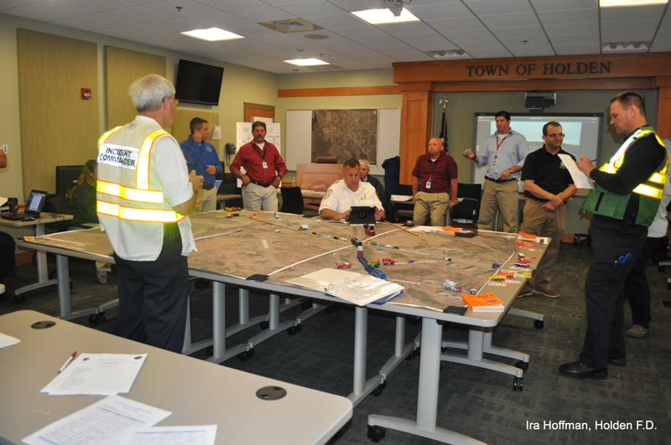

Incident Commander Chief Chandler at MEMA drill on June 12th



Throwback Pic! Landen (7 yrs) & Ryan (9 yrs) Tupper on the Ahrens Fox at the 2011 Holden Muster. 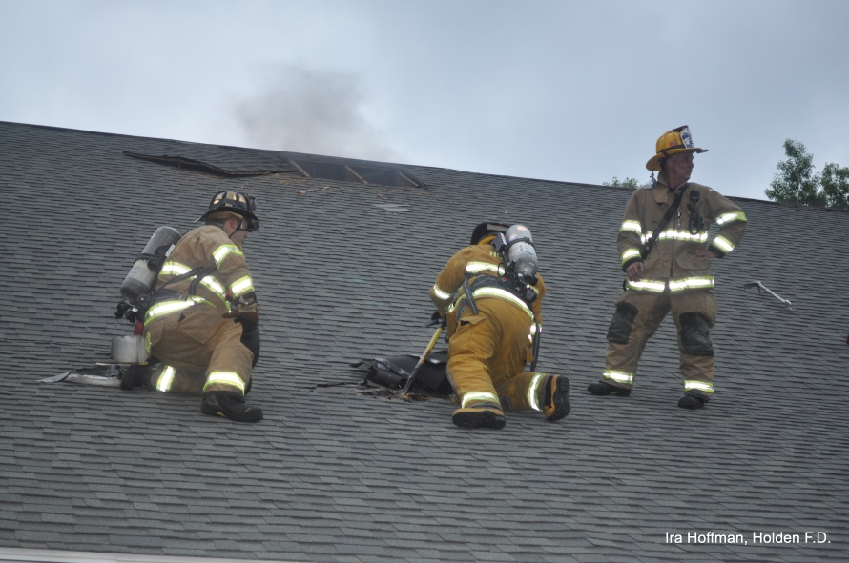 Which son is most like Barry in this picture?   
Lt. Scott Charbonneau strikes a pose at the Bullard St. training on June 10th

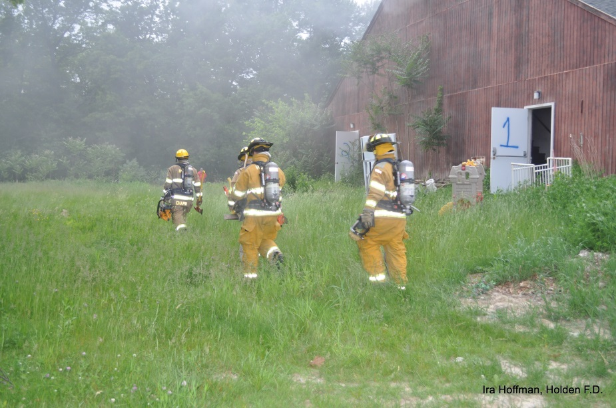

Lt. Dave Chapin and Auxiliary Members during 325 Bullard Street training on June 10th

Firefighter Nicholas Kakalecz opens up roof supervised by Lt. Scott Charbonneau at

325 Bullard Street training on June 10th

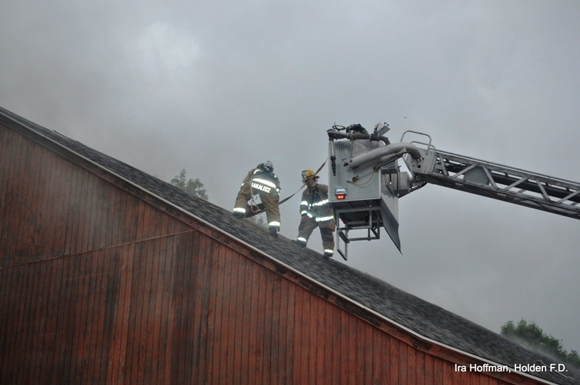

Reverend/Fire Chaplain Jerry Heslinga’s church service on June 22nd

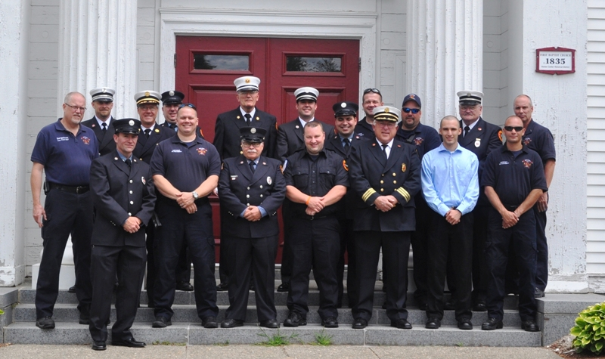

Lt. Fasshauer working at the 36 Birchwood Drive chimney fire on April 29th

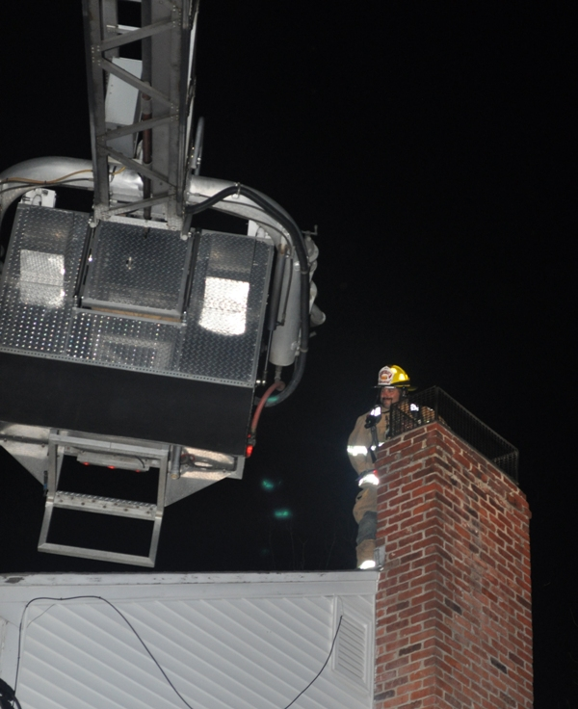

**FIRE PREVENTION** By Assistant Chief Russ Hall

**TRAINING**

Department training is in full swing and will continue during the summer months. For July, one of the sessions will be for driver competency. This program is setup to check off all department drivers on the apparatus and serve as a refresher or review of the pump, tools and equipment on each vehicle. This should be a good opportunity for all members to review the department fleet and all of the specialized tools and equipment that are housed on them.

**FIRE PREVENTION**

Below is a review of the newest mulch application for large residential and commercial buildings. As we see commonly see smoldering mulch fires in and around town, it will be helpful for all department members to understand the code requirements and be able to observe violations during calls for service.

**New Regulation on Mulch Safety -** The new regulation, 527 CMR 17, took effect September 2012 and prohibits the new application of mulch within 18” around combustible exteriors of buildings, such as wood or vinyl but not brick or concrete. Residential buildings with six units or less are exempted from this regulation, but all homeowners may also wish to adopt these safety practices. The regulation applies to all other buildings including commercial properties.

**Tips for Property Managers, Building Owners & Landscapers-**Provide a minimum of an 18-inch clearance between landscape mulch beds and combustible building materials, such as wood, vinyl siding and decks. Use non-combustible mulch such as rock or pea stone around gas meters and combustible portions of the structure. Provide proper receptacles for smoking materials at all entrances to public buildings and in designated smoking areas. Place them at least 18" away from the building, do not mulch in these areas and remember to regularly empty smoking receptacles. Grounds and maintenance crews should be aware when conditions are favorable for mulch fires and increase surveillance of mulch beds. Keep mulch beds moist when possible.

**Million Dollar Mulch Fire -** The most notable event occurred at a Peabody apartment complex in May 2008. A cigarette-lit mulch fire caused a $6.7 million loss, displaced 750 people temporarily and 36 permanently. In April 2012, improperly discarded smoking materials ignited mulch outside an assisted living center in Braintree. The fire forced the early morning evacuation of many older adults, some of whom suffered smoke inhalation injuries.

**Report Mulch Fires -** If you see anything smoking in a landscape bed, put it out if you can and report it, if the burning material is not thoroughly wet or removed it might re-ignite. Report any smoke or fire via 9-1-1.

**How Mulch Fires Start. *Care must be taken to prevent mulch fires*** - In many mulch fires, the smoldering mulch tunnels under the surface and then breaks out into open flame. Mulch that is piled too deeply, more than a few inches, can build up heat and spontaneously catch fire. Mulch fires start more readily when the weather is hot and it has been dry for an extended time. Factors such as below-average rainfall, dry conditions, warm temperatures, and high winds increase the risk of mulch fires.

**Storage and Manufacturing of Mulch-**The new regulation has safety requirements for those who store or manufacture mulch. It limits the size of mulch piles and requires a distance of 30-feet between piles and 25-feet from the lot line. Large piles of mulch can easily spontaneously combust with all the heat they generate, so it’s important to be vigilant and employ good housekeeping. The distance between piles keeps a fire from easily spreading from one pile to another or to a building.

**C:\Users\LFWood\AppData\Local\Microsoft\Windows\Temporary Internet Files\Content.IE5\MX9QS596\MC900057050[1].wmf**

**MUSTER UP!**

The ***Wachusett Fire Muster*** this year was held in Harvard, MA on Father’s Day.

Participants from Holden Fire were Dave Chapin, Sean Smith, Mark Ponte, Ryan Mouradian, Rob Beer, Brendon Connor, Kevin Harmon, Barry Tupper, Bang Nguyen, Derryl Dion, and Peter Bergstrom. The Women’s Team was made up of Amanda Beahn, Kim Connor, Laura Tupper, Tiffany Kowal, and Jessica Dunigan.

The standings that Holden placed in each event were:

Tower-3rd place

Broken Hose-1st place

Bed-2nd place

Pump Event-8th place (penalty)

Old Timers-4th place

Women’s Team-5th place

A good time was had by all! This is always a fun event and ends with a cookout and a muster banquet. We are always looking for participants to keep this tradition going. If interested in joining next year, please talk to one of the participants!

C:\Users\LFWood\AppData\Local\Microsoft\Windows\Temporary Internet Files\Content.IE5\SW2C4AB2\MC900105218[1].wmf

Congratulations to the following members who were recognized by the Selectmen and Town Manager at the Annual Employee Picnic at Trout Brook on June 19th. This cookout is in appreciation to employees who serve the town of Holden in all capacities.

Derek Hirons – 5 years

Rick McGinn – 5 years

Peter Bergstrom – 35 years

Derryl Dion – 15 years

Russ Hall – 5 years

Adam Hickey – 10 years

Peter Lacy – 10 years

Jim Oberg – 45 years

Michael Rosen – 35 years