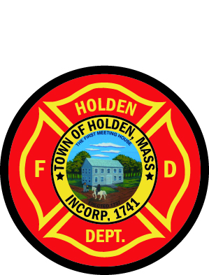
Our Fire Department Chaplain
Reverend Dr. Jerry D. Heslinga
is retiring after 10 years as our Chaplain
He has always supported us on our turf, it’s time we went to his to recognize his service to the Department.
Please join us to attend his church service on Sunday, June 22, 2014, 10:00 AM at the First Baptist Church of Holden.
Dress for the day will be Class A uniforms, hats, no gloves. Class B or appropriate attire is acceptable.
A reception with light refreshments will be held after the service in the church hall.
Spouses, family members and friends are invited to attend with us.
