*C:\Users\jhanna\AppData\Local\Microsoft\Windows\Temporary Internet Files\Content.IE5\LE4P6T6Z\MC900340286[1].wmf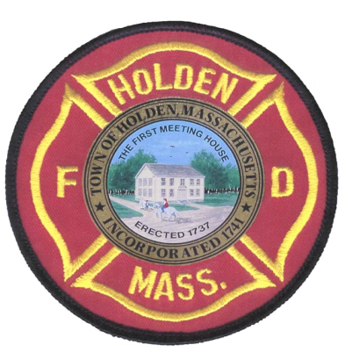* 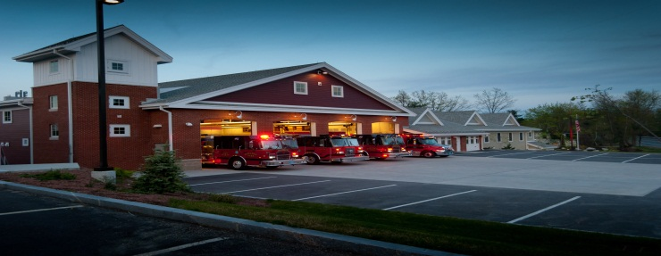

APRIL/MAY

2014

**The Extinguisher**

A Publication of the Holden Fire Department

1370 Main Street, Holden, Ma 01520.  (508)210-5650.

Newsletter Editor  
Leah Francese-wood

**Dept. Schedule**

4/20 – Easter

4/21 – Patriots Day (town offices closed)

4/24 - CPR/AED training for little league coaches

4/24 – Alternative Heating Seminar at Senior Center at 18:00

4/29 - 19:00 Training for new standards for CPR & C-spine immobilization.

5/6 - 18:30 Training (RIT Operations)

5/20 - 18:30 Mandatory training (Ladders)

5/20 - 17:30 UMASS stroke lecture

5/11 – Mother’s Day

5/26 – Memorial Day (town offices closed)

# Chief’s Corner

By Chief Jack Chandler

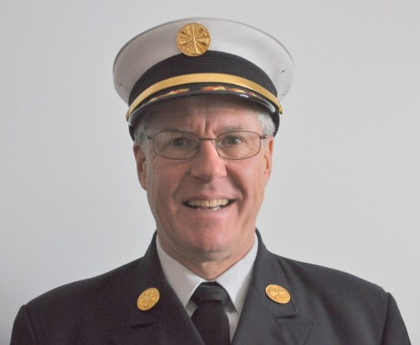   
Hopefully Spring is going to bring some better weather; it seems like Winter just won’t end! One thing that spring is bringing us is some new firefighters which we are always glad to see! On the fulltime side we are welcoming Richard (Rich) Johnson and Ethan Naiman and on the call side we are welcoming John Beattie, Nicholas Gezotis, Max Jette and Andrew Rodriguez.

Rich comes to us from Sturbridge Fire where he was a fulltime firefighter/paramedic and he was also a member on Spencer Fire, North Brookfield fire and paramedic for Leicester EMS. Ethan comes to us from Webster EMS where he has been a paramedic and from Sherborn Fire where he was the EMS Lieutenant. Please join me in welcoming both Rich and Ethan.

On April 24 the Holden Fire Department is sponsoring a seminar at the Senior Center on Heating Alternatives, trying to show Holden residents ways to safely heat or otherwise keep their homes warmer. It begins at 6 PM and refreshments will be served. Please join us for this event!

Save the date!! If you like fireworks please save the evening of August 22nd for fireworks and a cook out at the Public Safety Building! (No, the fireworks won’t be here but you’ll be able to see them from here!)

**EMS News** by EMS Director David Russo

* 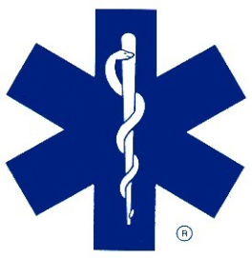Amanda Beahn will be teaching the Holden Little League coaches CPR/AED and first aid on April 24th. I am assisting Holden Little League in purchasing there first AED for the baseball field.
* UMASS Memorial Hospital neurological group is coming to teach a stroke lecture on Tuesday, May 20 at 17:30 hours at Headquarters in the public safety training room.
* We are moving forward with the new standards for CPR & C-Spine immobilization. Training will be held on Tuesday, April 29 at 19:00 hours at Headquarters in the public safety training room. ***All EMTs and Paramedics who are signed off to work on the ambulance need to attend to perform the new state guidelines for CCR & SSI.***

**Administration News** By Leah Francese-Wood

* I will be working on the Newsletter now that Jim Hanna has gone. If you are interested in taking it over, see Leah!
* For new emails, certifications, phone numbers, and licenses give copies to Leah.
* Remember to date all suppression sheets.
* Please include MILEAGE on all run reports!
* To order shirts and uniforms, please see Heidi

.

**APRIL Anniversaries**

Andrew Miller-12 yrs

**MAY Anniversaries**

John Bain-6 yrs

Amanda Beahn-2 yrs

Erik Bishop-3 yrs

Dennis Carlson-2 yrs

Scott Charbonneau-37 yrs

Dan Hazen-6 yrs

Rick McGinn-5 yrs

Adam Parslow-2 yrs

Brian Rushlow-6 yrs

**HAPPY BIRTHDAY TO….**

**APRIL**

Peter Bergstrom, Scott Charbonneau, Brendon Connor, Michael Himmer,

Adam Parslow, Mark Ponte

**MAY**

Rob Beer, Matt Benoit, Peter Benoit, Adam Hickey, Tyke Lothrop, John Whipple



**Deputies Desk**

By Deputy Chief Peter W. Bergstrom

* A new group of four Auxiliary Firefighters-*John Beattie, Nicholas Gezotis, Max Jette, and Andrew Rodriguez*-will be on-board to begin training beginning April 16th. They will begin with basic training and work up to joining the regular department drills.
* It is now time to start collecting Mass Call Association dues for this year. As of now, annual dues will remain at $15. Any member of the Department is eligible to join. See me if you are interested or have questions on the benefits of joining.
* Plans are underway to recognize Reverend Jerry for his upcoming retirement. Details will be coming soon.
* Spring means brush fires. Is your gear ready?
* Mark your calendar and get a team together. The Holden Association Golf Tournament will be held on Saturday, September 6th.

**Images over the last few months…**

Below left is “Lieutenant” Garrett Poznanski telling the staff about 3 elements of fire (fuel, oxygen & heat). Below right little Lieutenant is getting ready to do a fire search.

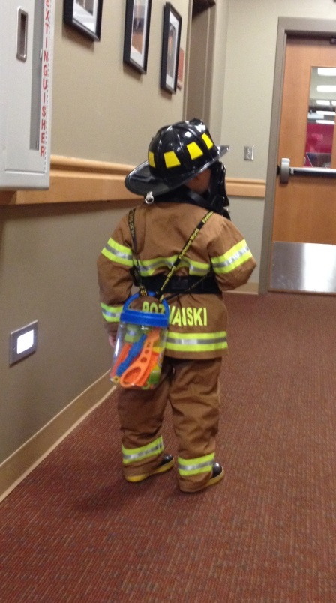He’s ready for the next open position!

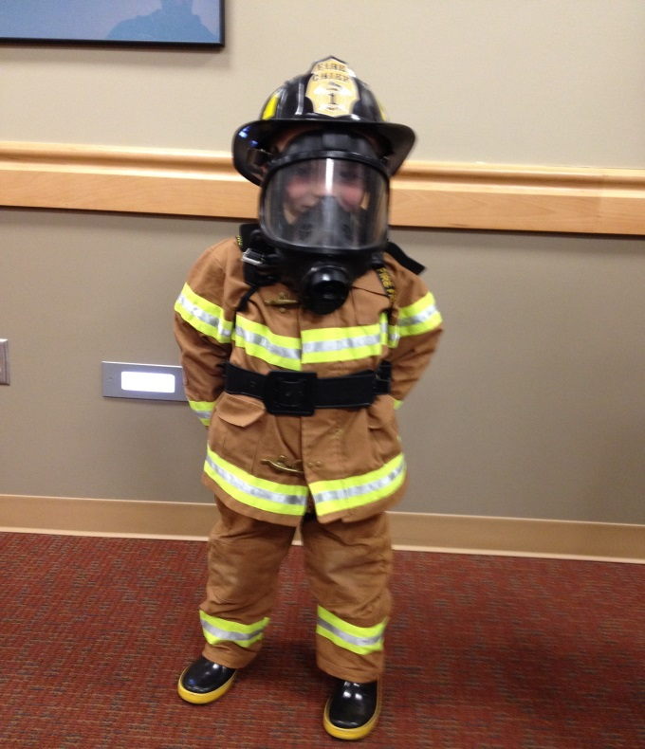

Members gather to say goodbye to Rich Dewitt on his retirement of 42 years of service to the Town of Holden Fire Department.

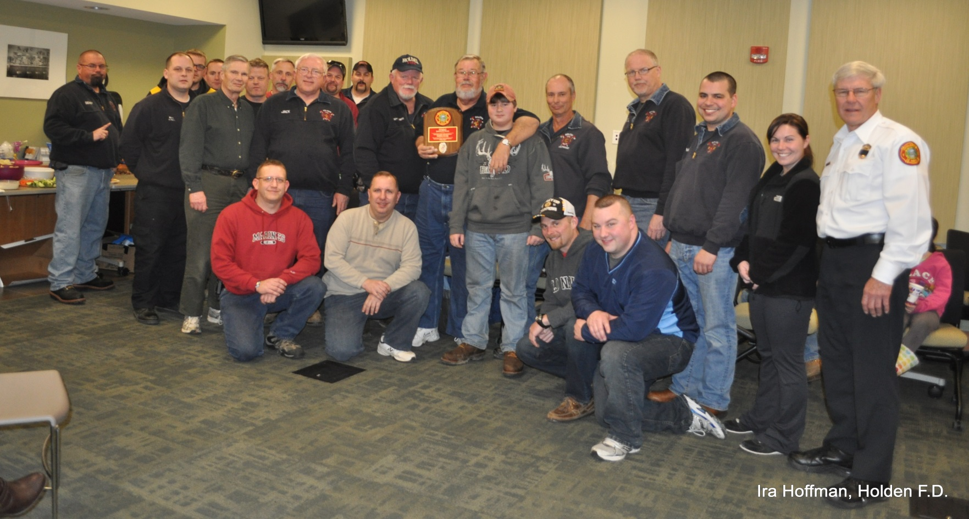

Rich “Papa” Dewitt and Chief Chandler at Rich’s retirement party on April 1st.

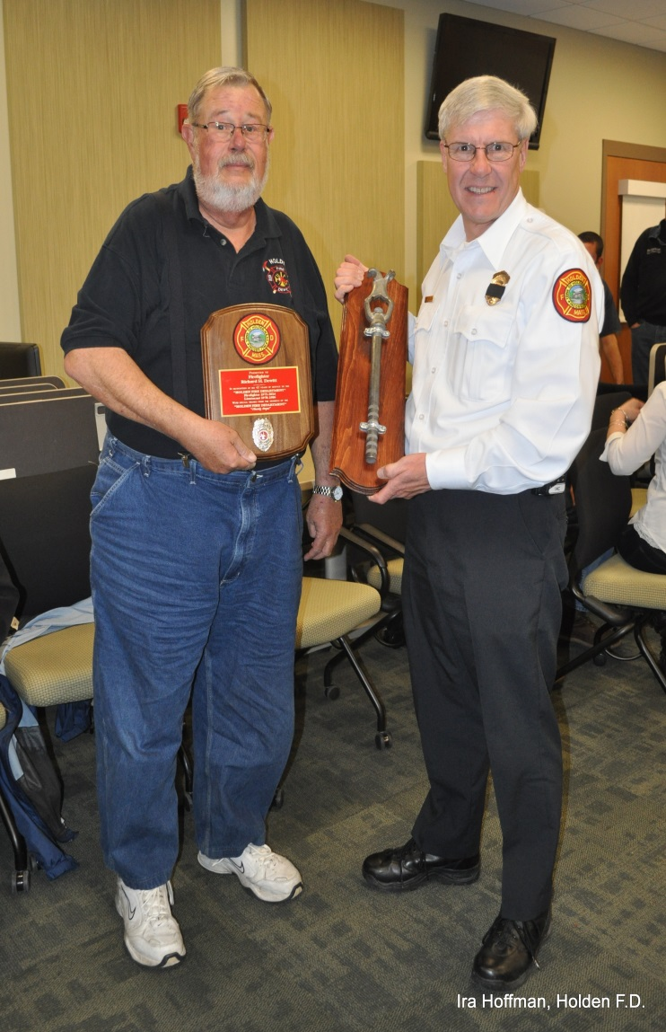

Lt. Barry Tupper instructing on the use of SCBA during March training.

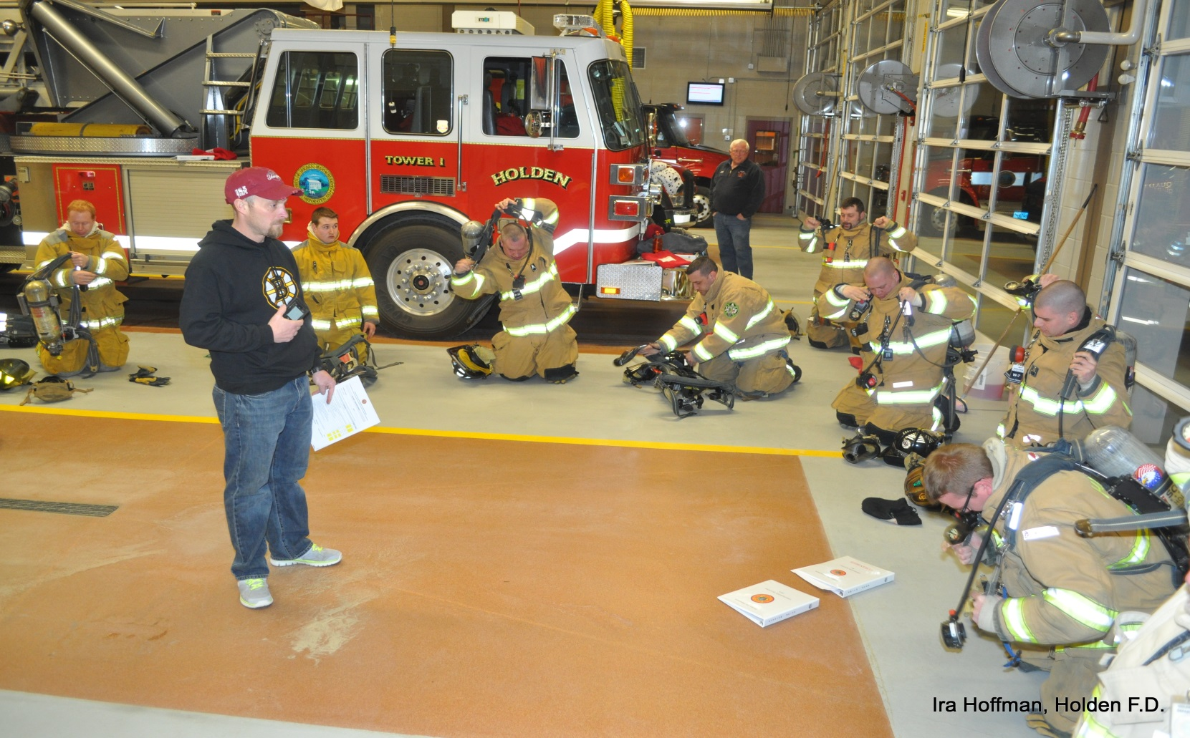

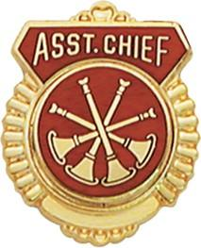 **FIRE PREVENTION**

By Assistant Chief Russ Hall

Since the start of the new training program we have seen a good increase in attendance and participation at both sessions each month. I would like to congratulate everyone for their hard work and dedication in making the department training successful. As always, if anyone is interested in teaching or has a topic they would like covered, please see a member of the training committee. Also as a reminder, we will have a mandatory ladder training drill for all department members on May 20. Any member who needs to make up a missed skill session, please see me or a department officer to set up a time to do the training. We will keep a spreadsheet of all the skills and who has completed what in the hallway outside the report room at headquarters.

On the fire prevention side of the department, large commercial development has slowed over the last 6 months. With the Reserve complex winding down and the Mountview project just getting started, we are working on and inspecting mostly residential homes.

One type of residence that you should become familiar with in town are the group homes. Currently we have 9 group homes functioning within the town and 1 currently under construction. With healthcare cost cutting the wave of the future, we will see more and more of these private residences which house clients who have a host of medical problems.

Each of the residences have different fire suppression systems either fire alarm, sprinkler system, both or none. All group homes are staffed 24 hours per day and they are trained to remove the residents in case of an emergency. These homes will typically have 4 – 5 residents and 1 – 2 staff members residing there. When responding to these types of residences for fire calls you will need to remember that most residents have developmental or physical disabilities which cause their ability to be evacuated in an emergency to be slowed. Some are wheelchair bound, some cannot deal with the sound of the fire alarm and others will not understand what the alarms mean. These types of residences present a challenge in life safety should a fire ever happen.

The construction of these homes is the same as any residential home. Most of the newer constructed buildings are setup the same way with a large living space in the center and the bedrooms located on the “B” and “D” walls. The older homes are usually converted ranch style homes so the bedrooms could be located anywhere on the main floor.

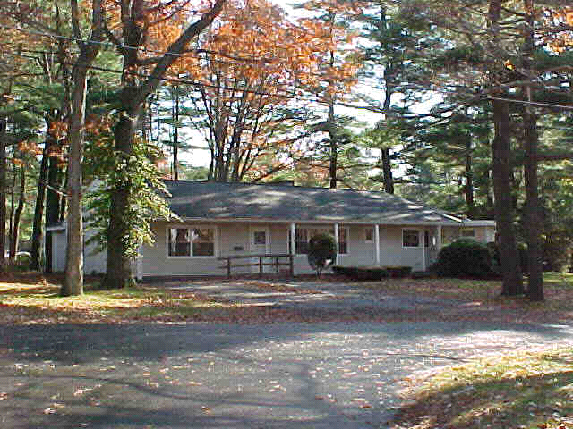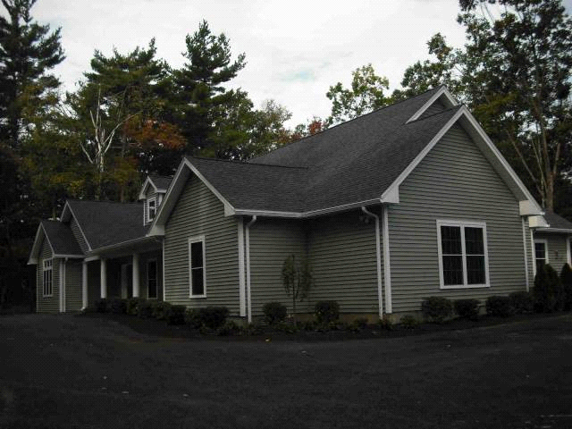

**140 Mixter Road-built in 2010 23 Fairchild Drive – built in 1948**

**Converted to group home 1990**