*C:\Users\jhanna\AppData\Local\Microsoft\Windows\Temporary Internet Files\Content.IE5\LE4P6T6Z\MC900340286[1].wmf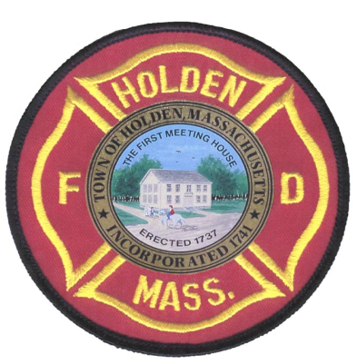* 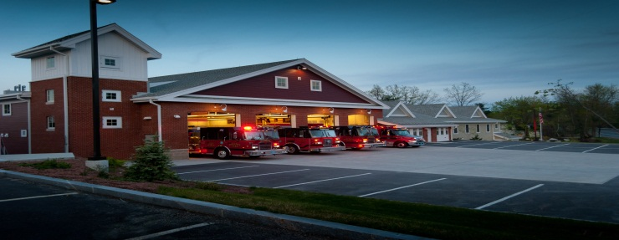

January/February

2014

**The Extinguisher**

A Publication of the Holden Fire Department

1370 Main Street, Holden, Ma 01520.  (508)210-5650.

# Chief’s Corner

Newsletter Editor  
FF/EMT James Hanna

Training Schedule

March 4th *MANDATORY* 19:00

March 18th 19:00

April 1st 19:00

April 22nd 19:00

By Chief Jack Chandler

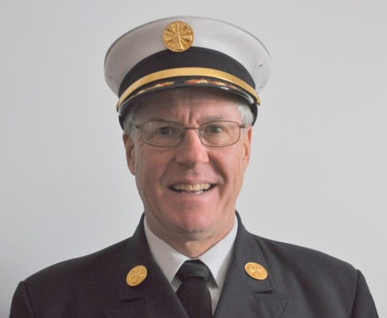   
**Communications!!** All through life communications is very important and that applies to Holden Fire as well! We have a number of ways that we try to communicate with all our members, including this Newsletter! Other ways we communicate are the I Am Responding system. You should be getting messages about open shifts, coverage needed, and coming soon, real time information about calls. The SafAlert system will also send you actual recordings of toned out calls. If you are not getting either of these please talk to 14C, C2 or C4 and we will get you set up! The CodeRed system is used by the Town for both emergency and non-emergency messages. You can sign up for CodeRed by going to the Town web site and following the instructions there. We also send many messages to your E-mail. At the Nightly Tone Test we also make important announcements. If have not gotten a message in a while we may not have your current email address, cell phone number, etc. Please check with Leah and make sure we have your correct information!

Another great tool for keeping in touch is an APP called Scanner Radio Deluxe. This APP for Smartphones allows you to listen to actual radio communications with a short delay. It’s a good way to keep in touch if you are out of the radio communications area!

In order to make sure you are getting the latest information make sure you are signed up for these systems and that Leah has all your current information!

**Doing the Right Thing** I’m sure we all want to do this but sometimes it takes a little more effort and a little more time, but it shows a lot more integrity! Please review the Golden Rules attached to the newsletter and think about how you can make a difference by putting in just a little more effort! I like to think we run a very professional service and these Rules will just help us to do a better job!

New Improved Training! The training Committee has rolled out a new training program which I expect will improve the level of the classes and also the availability of the classes. Everyone is expected to take part in the training and to make up training that they have missed. This is particularly true of any ‘Mandatory’ training sessions. These sessions are on subjects that the department officers feel are vitally important that everyone needs to do. As we have less real fires we must improve our training quality and quantity to make sure that we are keeping our skills up to date! I’d like to thank the training committee for the work they put into this updated program!

# EMS News

# s

All call-FF/EMT are encouraged to work the weekend shifts (0700-1400 and 1400-2100). Sign-up sheets are at headquarters.

Recently an EMS class was held at HFD HQ where Rebecca Russo, wife of Dave Russo, instructed a class on Human Trafficking. The class was very informative and was well received by all who attended.

Recently there was a three car accident on Main St @ Princeton St. One patient was transported to UMass, who sustained critical injuries. The crew on duty did a great job in extricating the patient and providing excellent care in a very brief time. The patient is currently improving at Spaulding Rehab. This is a testament to our department functioning as a team with a positive result.

By EMS Director David Russo

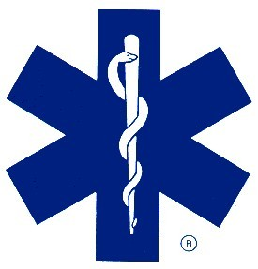

* Please give Leah new emails, certifications, phone numbers, and licenses.
* ALL SUPRESSION PAYROLL SHEETS MUST BE DATED!
* Please include MILEAGE on run reports!

.

**Administration Staff News**

By Leah Francese-Wood



**Coming Events:**  
Alternative heating seminar: 6pm April 24 at the Senior Center - all are invited  
Holden Fire Department history project - date/time to be announced. Help identify fire department members in photos.  Have old photos of people/fires/incidents? Drop them off with Chief Chandler.  
2nd Annual Recognition / Remembrance breakfast:  It will be in the fall this year. Anyone who can help in any way please contact Ira.

**January Anniversaries**

Cross-44 yrs

Dion-15 yrs

Matthews – 4 yrs

Patch – 4 yrs

**February Anniversaries**

Jack Bryan – 6 yrs

Hirons – 5 yrs

Lothrop – 4 yrs

Pierce – 3 yrs

**January Birthdays**

Dave Eddy, Kevin Harmon, Brian Rushlow, Dave Russo

**February Birthdays**

Dennis Carlson

***Recent Dept News:***

*Derek Hirons and Paul Pierce became Haz-Mat Technicians recently. Join me in congratulating these two FF/Medics!*

*Derryl Dion and Rob Nickerson became certified ice recue trainers recently. Congratulations Rob and Derryl.*

*Russ Hall and Pete Bergstrom became accredited in Massachusetts as Chief Officers. Congratulations Russ and Pete!*

***Departures:***

*Fulltime FF/EMT-P Colin Haynes recently accepted a position with the Massachusetts Environmental Police.*

*Fulltime FF/EMT James Hanna and Call FF Ryan LaPrade recently accepted positions with the Worcester Fire Dept.*

*Chief Chandler passed on his congratulations to these members!*

**Deputies Desk**

By Deputy Chief Pete Bergstrom

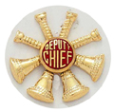

We should have a new group of Auxiliary Firefighters on-board to begin training in the March. Anyone interested in helping with training for new Call Firefighters, please contact me or any of the other Chiefs.

I have completed the response numbers for 2013. If you are interested in how you finished, please let me know. Response recognition will be processed soon.

After a long delay, the Mass Call member cards are finally in and have been put in your mailboxes. Now it is already time to start collecting for next year. As of now, annual dues will remain at $15.

**Images over last few months…**

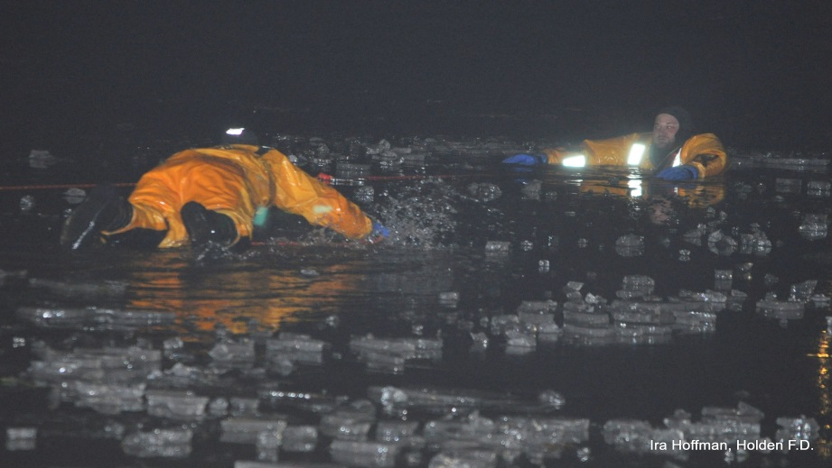At left is image from recent Ice Water Rescue training. Firefighter **Kevin Harmon** (facing camera) is simulating a victim in the water.

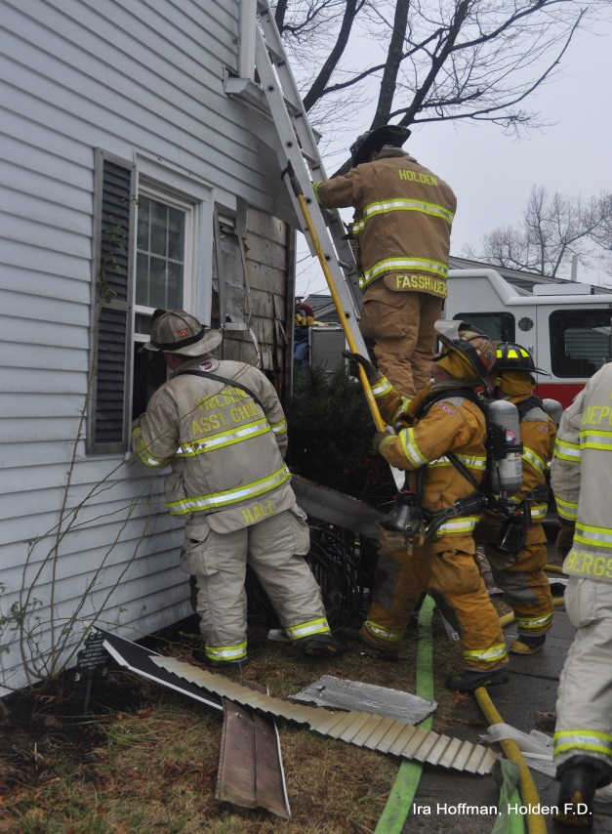

At right recently promoted **Lt. Fasshauer** ascending a ladder at a house fire on Main Street. Also pictured is **Assistant Chief Hall** and Engine 3’s crew.

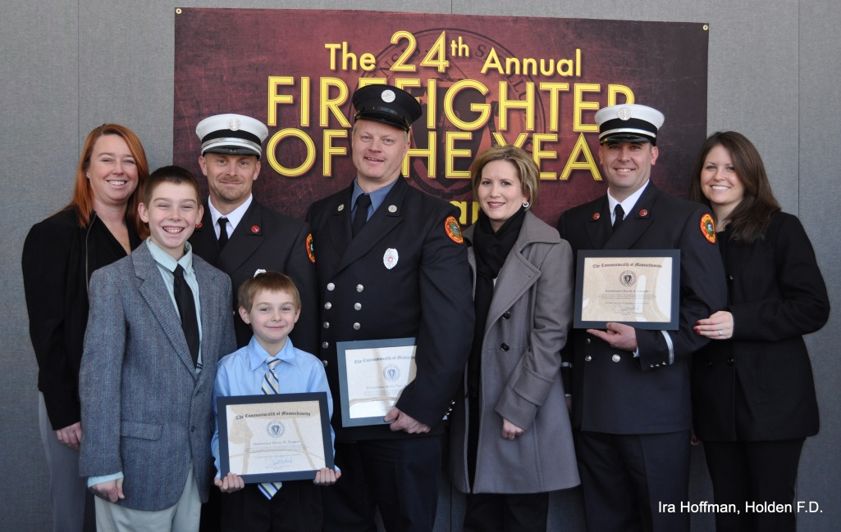

Above are the recipients and their families at the 24th annual Firefighter of the Year Awards, held in Cambridge. **Lt Dave Chapin, Lt. Barry Tupper and Firefighter/Paramedic Paul Pierce** received the awards for the Silo Tech Rescue at Paquette Construction in summer 2012.

**Fire Prevention**

By Assistant Chief Hall

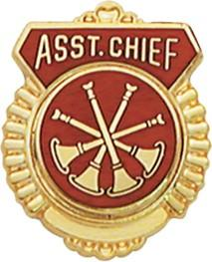

The 2014 Brush burning season is right around the corner!

Brush season began January 15th and will conclude May 1st. Please come in to outfit and prepare your brush gear in your lockers. Make sure you have all necessary equipment and make sure to keep the areas of your gear lockers clean and organized. Also make sure to familiarize yourself with Forestry’s 1 and 2. If you have any issues with the gear, both structural and brush, pleased talk to **Chuck Borowy**.

Some of you may have noticed some old equipment organized on the floor in the rear of the station. This equipment will now be donated to the Dominican Republic.

As the Chief mentioned above, there is a new training program. This program was implemented in a particular fashion to have an inventory of each individuals training records. This program should not be looked at in a negative way; it is to help improve in areas where an individual may not be strong in. As we have noted at the past few trainings each member will have a 3-ring binder with skill sheets kept in the report room at Headquarters. These sheets are to be filled out by the instructor of the assigned task and kept organized and up to date. If there are any questions regarding this policy please refer to members of the training committee.

*The Golden Rules…*

*If you open it, close it.*

*If you turn it on, turn it off.  
If you unlock it, lock it up.  
If you break it, admit it.  
If you can't fix it, call in someone who can.  
If you borrow it, return it.  
If you value it, take care of it.  
If you make a mess clean it up.  
If you move it, put it back.  
If it belongs to someone else and you want to use it, get permission.  
If you don't know how to operate it,*

*leave it alone.  
If it's none of your business, don't ask questions.  
If it ain't broke, don't fix it.  
If it will brighten someone's day, say it.  
If it will tarnish someone's reputation,*

*keep it to yourself.*